Protocols for Republic of Ireland clubs as part of COVID-19: Reframing the Challenge, Continuing Our Recovery and Reconnecting.

The Government and Sport Ireland have published updated guidance to National Governing Bodies in response to the COVID-19 pandemic.
Throughout the COVID-19 pandemic our clubs, volunteers, athletes, and parents/ carers have worked diligently to keep themselves and others safe by adhering to the COVID-19 protocols. In our efforts to keep aquatic sports going we are asking you to review the risk assessments you have in place and remind your club members to continue:
- Practising good hygiene
- Observe social distancing
- Wear face coverings
- And avoid attending training if they feel unwell
These measures will enable clubs to continue to run their training sessions, and to host or attend competitions throughout the winter months whilst continuing to operate within best safeguarding practices.
The following protocols are in effect until approximately February 2022. Click on the topics below to skip directly to a section:

1. General Overview 2
2. EU Digital COVID Certificate 2
3. Club Activity (Swimming) 2
4. Club Activity (Water Polo) 3
5. Club Activity (Diving) 4
6. Club Activity (Open Water Swimming) 4
7. Swimming competitions 4
8. Spectators 5
9. Swimming Lessons 5
10. Facility Guidance 6
11. Face Coverings 7
Appendix A – Pool Layout for over 18’s swimming with mixed immunity status 8
Appendix B - COVID-19 and Safeguarding protocols for Regional Competitions 11
Appendix C - Template letter for clubs hosting competitions 12

General Overview
- Where car-pooling or public transport is being used individuals must take protective measures such as wearing face coverings.
- A register of attendance is required for every session for contact tracing and safeguarding purposes. The coach on duty must also have access to emergency contact details for all participants.
- Clubs must have a COVID-19 Officer on duty at every training session (COVID-19 Officer requirements). Clubs with under 18’s must have a person on duty. One person may fulfil both roles if they meet the COVID-19 Officer requirements. In adult only clubs/ sessions the coach or a nominated athlete may act as the COVID-19 officer as part of their normal duties/ activities if they meet the COVID-19 Officer requirements.

EU Digital COVID Certificate
- The EU Digital COVID Certificate (DCC) is proof (in digital or paper format) that you have either:
  - been vaccinated against COVID-19 or
  - received a negative COVID-19 test result (RT-PCR valid for 72 hours, Antigen valid for 48 hours)
  - recovered from COVID-19 in the last 6 months
- Individuals vaccinated in Northern Ireland or Great Britain, who are over 18 and hold a valid
Irish Passport can apply for a DCC through the Self-Service Portal.
- Individuals from Northern Ireland may also present their COVID-19 certificate as proof of immunity (vaccinated or recovered from COVID-19).
- For more information on the DCC go to the Gov.ie website.
- The use of the DCC or NI COVID-19 certificate will be required for accessing indoor sporting activities and events.

Club Activity (Swimming)
- Clubs should engage with their facility in advance to understand and agree procedures for the club. Members should be advised of any changes.
- Social distancing must be maintained, and face coverings worn when swimmers and coaches are not engaged in activity, i.e., while on poolside, changing rooms etc.
- Clubs and coaches must communicate any change to the current set up with their swimmers in advance.
- Personal training equipment must not be shared with others and must be clearly labelled.
- Shared equipment such as diving blocks must be cleaned between swimmers using them (chlorinated water will suffice).

Under 18’s
- Clubs must conduct a risk assessment to decide how many swimmers are suitable to be in each lane. This may vary between squad and sessions depending on:

    - Age of athletes
    - Ability of athletes
    - No. of coaches on deck
    - Type of session
    - Length of pool
    - Width of lanes

Over 18’s
- Where all swimmers can provide DCC clubs should follow full immunity protocols.
- Where swimmers have mixed immunity status clubs must follow mixed immunity protocols.

Full immunity (all swimmers) | Mixed immunity
Clubs must conduct a risk assessment to decide how many swimmers are suitable to be in each lane. This may vary between squad and sessions depending on:  - Age of athletes  - Ability of athletes  - No. of coaches on deck  - Type of session  - Length of pool  - Width of lanes | Clubs must operate on the following protocols (see Appendix A):  - 20 metre pool – option 1: 2 pods of 3, option 2: 1 pod of 6  - 25 metre pool – option 1: 2 pods of 4, option 2: 1 pod of 6  - 50 metre pool – option 1: 2 pods of 5, option 2: 1 pod of 6

Club Activity (Water Polo)
- Clubs must engage with their facility in advance to understand and agree procedures for the club. Members must be advised of any changes.
- Social distancing must be maintained, and face coverings worn when players coaches and officials are not engaged in activity, i.e., while on poolside, changing rooms etc.
- Bench Officials must always wear a face covering.
- Referees are permitted to remove their face covering during match play but must wear a face covering at all other times.
- Personal training equipment must not be shared with others and must be clearly labelled.
- Guidance on spectators at competitions is provided in section 9.

Under 18’s
- Skills and drills training activities should be practiced in pods of 6.
- Competitive Games (Matches) and competitive intra club activities may continue.
- The use of the pod system for more frequent skills and drills training activities will assist in minimising the overall risk and facilitate contact tracing.
- Under 18’s are not required to present DCC for training and match play.

Over 18’s
- Where all players can present a DCC contact training and match play are permitted.
- Where players cannot present a DCC, skills and drills must be practiced in pods of 6 (no contact or competition permitted).

Match play
- Where players are under 18, match play is permitted, DCC is not required.
- Where players are over 18 and can provide a DCC, match play is permitted.
- Where players are over 18 and cannot provide a DCC, match play is not permitted.
- All players over 18 from Northern Ireland, playing a match in the Republic of Ireland must present their DDC or NI COVID-19 certificate.
- Social distancing must be maintained, and face coverings worn when players coaches and officials are not engaged in match play activity, i.e., while on poolside, changing rooms etc.
- Face coverings can be removed at the start of a match and held by the Assistant Coach/Team Manager during activity.
- COVID-19 compliance at all National League and Regional Competitions is the responsibility of each individual club.
- COVID-19 compliance during a National Cup Competition is the responsibility of the Tournament Director/COVID-19 Officer.

Club Activity (Diving)
- Clubs must engage with their facility in advance to understand and agree procedures for the club. Members must be advised of any changes.
- Social distancing must be maintained, and face coverings worn when divers and coaches are not engaged in activity, i.e., while on poolside, changing rooms etc.
- Clubs and coaches must communicate any change to the current set up with their swimmers in advance.
- Shared equipment such as diving platforms must be cleaned between divers using them (spray bottle with chlorinated water is recommended).
- Where divers are over 18 and are mixed, i.e., not all have proof of immunity, pods of 6 divers must be implemented.

Club Activity (Open Water Swimming)
- There are no restrictions on outdoor group activities
- Swimmers must continue to exercise caution both in relation to COVID-19 and open water swimming when engaging in open water swimming.

Swimming competitions
- COVID-19 and Safeguarding protocols for regional competitions are available in Appendix B.
- Clubs must engage with their facility in advance to understand and agree procedures for the club, including requirement to present DCC and identification.
- All clubs/ individuals over 18 from Northern Ireland attending competitions in the Republic of Ireland must present their DDC or COVID-19 certificate.
- Guidance on spectators at competitions is provided in section 9.
- Competition organisers must appoint a COVID-19 Officer for the duration of the event. The COVID-19 Officer must be present throughout the competition.
- Clubs attending a competition are not required to bring a nominated COVID-19 Officer.
- Competition organisers should notify all attending clubs in advance of the following (template letter in Appendix C):
  - COVID-19 Officer on duty
  - Warm up protocols
  - Access to facility arrangements
  - Allocated team areas
  - Line up/ call room arrangements
- Competition organisers must conduct a risk assessment in advance to ensure adequate space is provided for athletes, coaches and supporting personnel.
- Warm up protocols must be put in place to minimise risk to athletes. Staggering of warm up times, allocating lanes to individual clubs, swimmers per lane should be limited to a maximum of 6.
- Where competition organisers have limited spectator space available, priority must be given to appropriate support personnel in line with safe supervision guidelines (under 12 years 8:1, 12 and over 10:1, adult: child ratio). Support personnel must meet their role requirements and include but are not limited to:
  - Coach
  - Team Manager
  - Parent/ carer in the absence of coach and team manager
- Face coverings must be worn by all individuals, including but not limited to coaches, team managers, officials, spectators, athletes.
- Athletes may remove their face covering when engaged in warm up activities or when competing. Face coverings must be worn in line up area/ call room and until swimmer is at the starting block.
- Social distancing must be maintained, and it is the responsibility of each visiting club to manage their own athletes.

Spectators
- Clubs and event organisers must engage with their facility to agree how spectator access will be managed.
- Clubs and event organisers may choose to limit the number of spectators permitted based on their risk assessment. Priority should be given to athletes and qualified support personnel.
- Spectators must familiarise themselves with Swim Ireland’s Spectator Behaviour Policy in advance of attending an event or training session.
- Spectators (over 18) must present their DCC to access an event or training session. Facilities and clubs may also ask for Photo ID for verification purposes.
- Accompanied minors (under 18) are not required to present their DCC to access an event.
- Unaccompanied minors (under 18) are required to present their DCC to access an event.
- Spectators must be fully seated and wear face coverings. Parents/ carers have a responsibility to ensure minors remain seated and wear face coverings (where required).
- The use of wristbands to facilitate repeated entry and exit of the facility is recommended to manage flow of spectators through the entries and exits.

Swimming Lessons
- Swimming lesson providers can revert to pre-COVID-19 procedures, based on a 3-metre squared per swimmer bather load calculation and must risk assess accordingly.
- All lesson capacities must be based on a facility specific risk assessment considering the protocols for under 18’s and over 18’s.
- Social distancing is not required for children under 18 whilst participating in the swimming lessons.
- Swimming teachers who can present a DCC may work in closer proximity with swimmers.
- Teachers who cannot present a DCC must remain 2m socially distanced and continue teaching from the pool deck.
- Facilities are advised to continue staggered start times to ensure customers can move easily around the facilities whilst socially distanced.
- Lesson providers must continue to have a COVID-19 Officer on duty at all times.

Facility Guidance

General
- Most risk in facility/pool setting is linked to time spent out of the pool (arrival, registration, changing, showering, exiting etc.) compared to time spent in the pool. Clubs and individuals must minimise their time out of the pool, limit interactions, remove potential for congestion etc.
- Where possible, a one-way system should be implemented for transit through the facility (facility dependent)
- Access to changing rooms is permitted, with protective measures in place, such as wearing face coverings and maintaining social distancing (facility dependent)

Entry and exit
- Clubs should formulate a staggered entry and exit system with their participants.
- Sufficient buffer time should be planned between different participants entering & exiting facility.
- Adhere to social distancing requirements on entry and exit.
- Avoid loitering or congregating at facility entrance.
- On entry & exit, individuals should use the hand sanitizer provided.

Changing Rooms and Showers
- Where possible participants should arrive ready to train, with swimwear on underneath clothes.
- Transit through changing rooms should be staggered and social distancing should be adhered to.
- COVID-19 officer must ensure shower protocols are fully communicated to all members where facility is allowing the use of showers
- Clubs should engage with their facilities to agree a well-managed, appropriate, and safe use of changing rooms.

Face Coverings
- COVID-19 is mainly spread through close contact and droplets that come from your nose and mouth. For example, when you cough, sneeze, or talk loudly. Wearing a face covering reduces the spread of these droplets and aerosols. It also helps stop the spread of the virus from people who may not know they have it.
- Face coverings are not recommended for children under the age of 13, but some children may choose to wear one.
- Any individual (13 years +) entering a facility must wear a face covering until they at the side of the pool and ready to commence training/ competition. Some facilities may require all individuals to wear face coverings. Contact your facility in advance to ensure you understand their requirements.
- Coaches should wear face coverings until all participants have entered the water.
- All persons on deck to wear face coverings until all participants have entered the water.
- Participants must wear a face covering if leaving the pool to use the toilet etc.
- It is recommended that participants bring a small zip lock or clip seal bag with their name printed on to store their face covering whilst in the pool.

Appendix A – Pool Layout for over 18’s swimming with mixed immunity status

20 metre pool set up

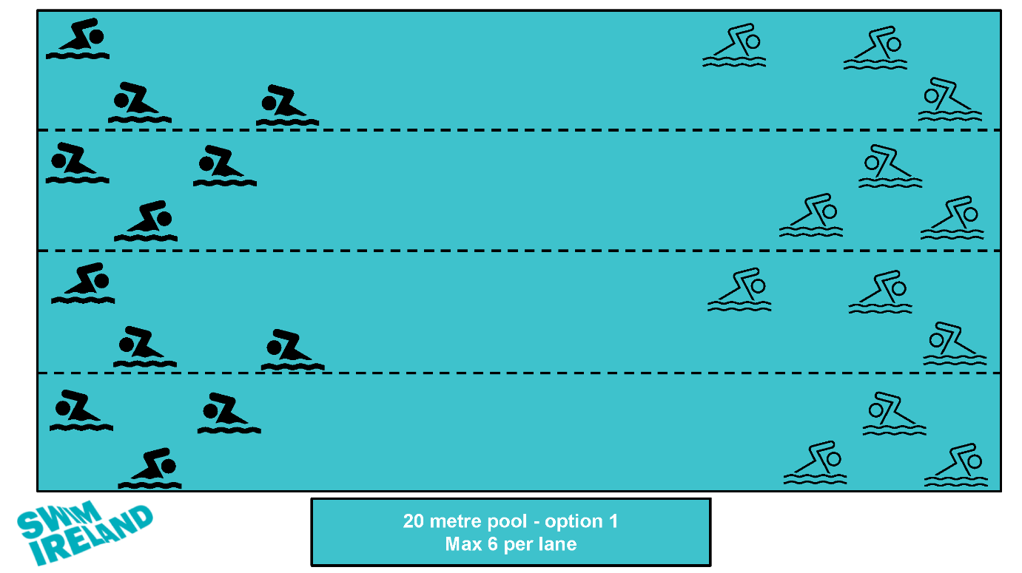

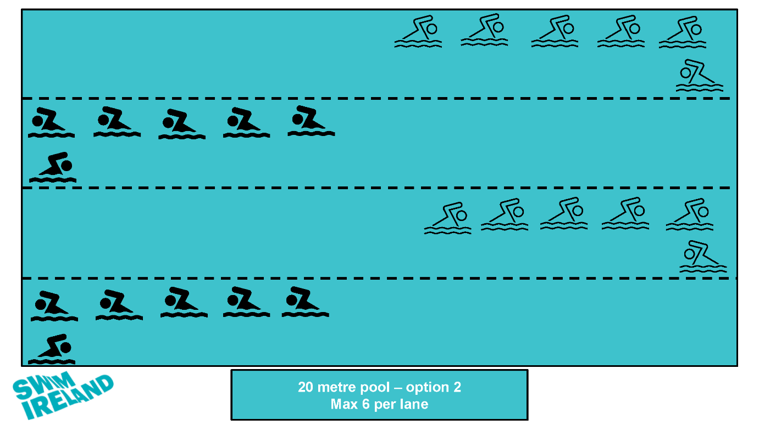

25 metre pool set up
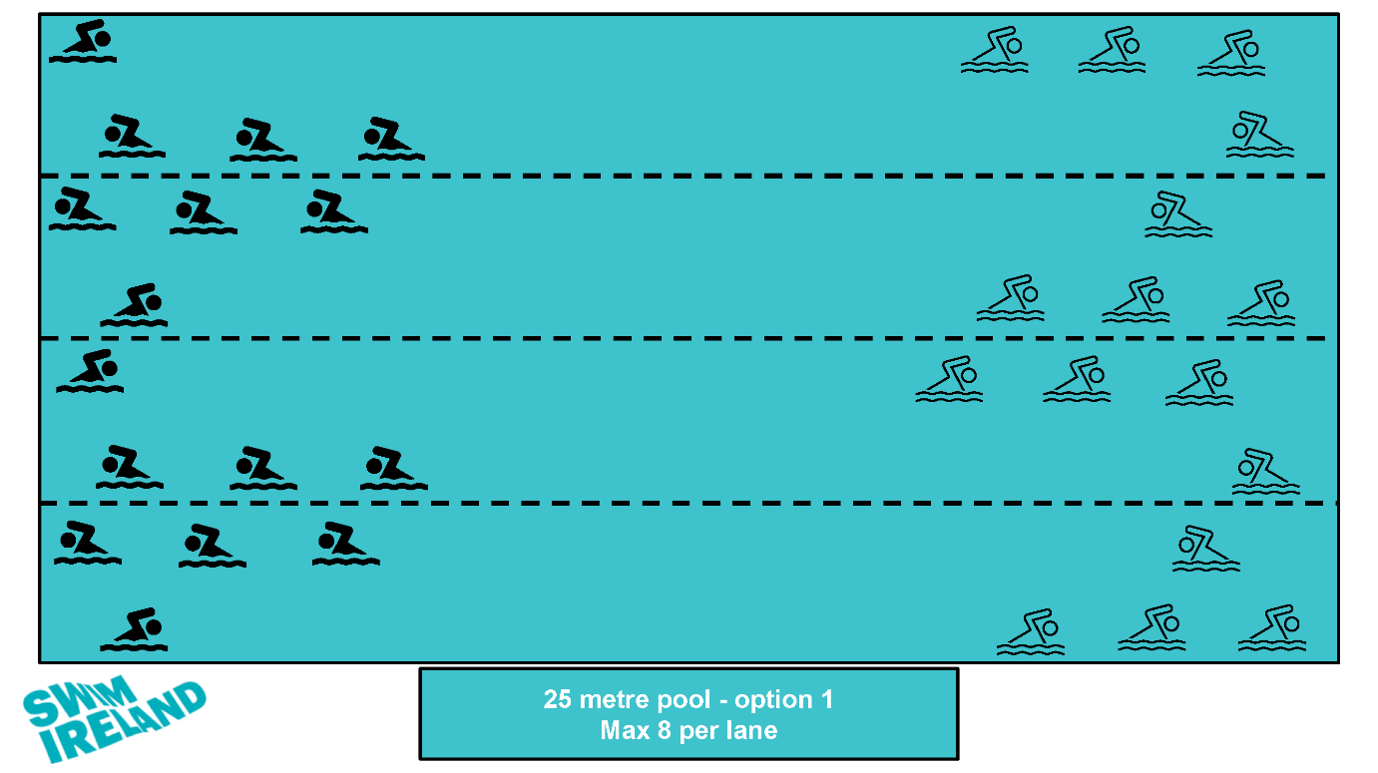

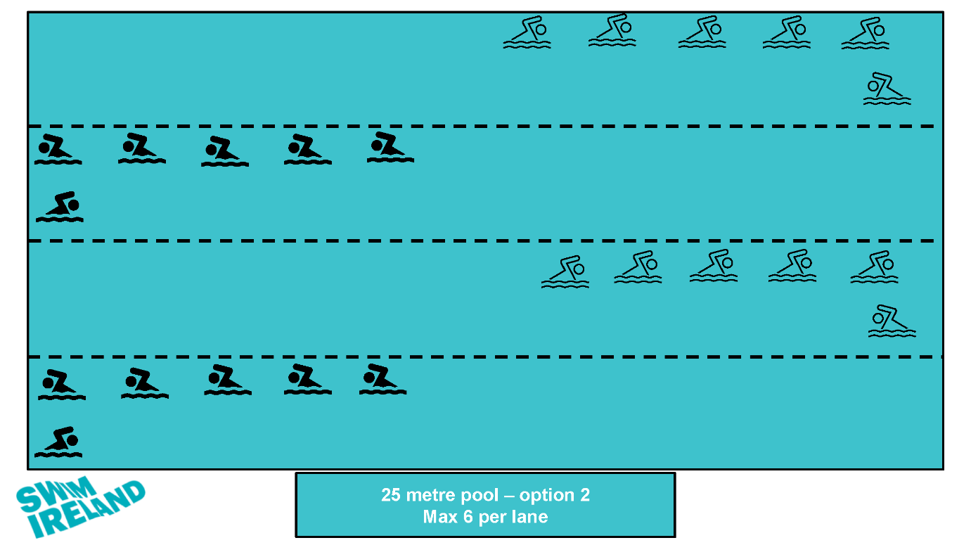

50 metre pool set up
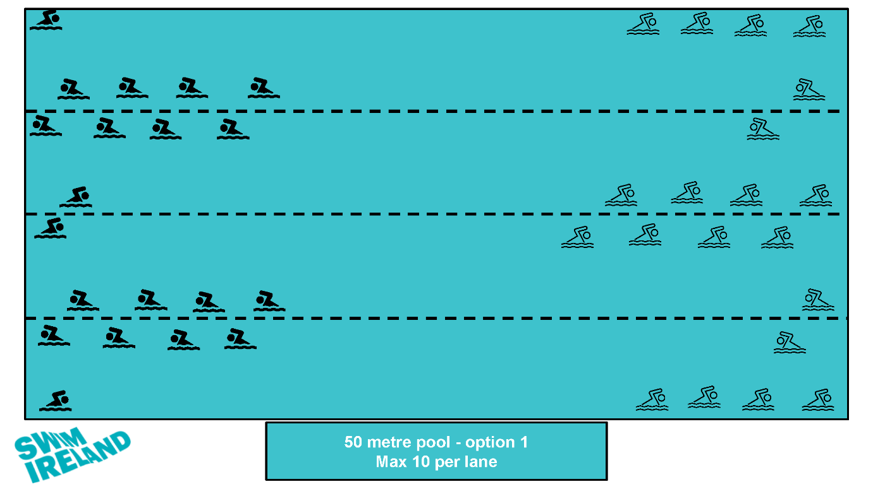

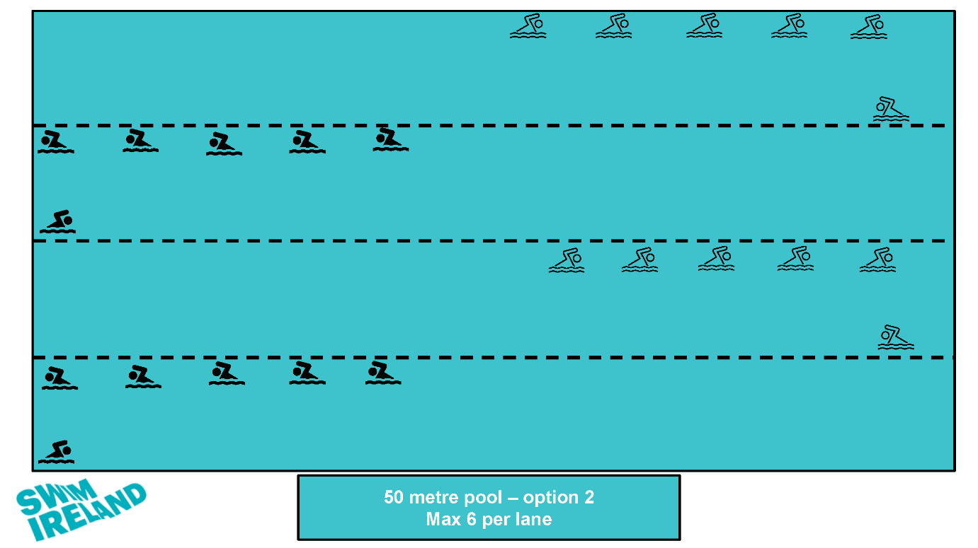

Appendix B - COVID-19 and Safeguarding protocols for Regional Competitions

We recognise the challenge on the regions for ensuring the correct protocols are in place to keep young people safe whilst participating in competition. Swim Ireland have put together advice for the Regional Competitions that bring together safeguarding requirements and COVID-19 requirements:
Separate Team areas
Where separate team areas are being planned either for accreditation purposes or to restrict numbers in a venue for COVID-19 purposes the following should apply:
- A Club needs to provide team staff who meet the vetting and safeguarding training requirements for being responsible for young people.
- An adequate ratio of team staff to athletes is necessary depending on the duration of the meet (at least 1 adult per 10 athletes aged 12 and over or 1 adult per 8 athletes aged under 12), with a minimum of two adults required.
- Parent/carers bringing their own child/children where these are the only athletes attending from a club should be afforded space to attend with their child; parents must remain with their child but will not be permitted access to the pool deck.
- COVID-19 protocols must be applied according to Swim Ireland guidance.

Mixed spectator /Team areas
If COVID-19 protocols allow and the venue can afford general attendance, it is still recommended that Regions provide a specific team area with restricted access and follow the guidance for Separate Team areas, as above. However, if general access is allowed, the following should apply:
- Access to the pool deck should be restricted to appropriately vetted and safeguarding trained team staff.
- Clubs should inform parent/carers and anyone attending with a team that there will be a mixture of adults present i.e., there are no safeguarding restrictions for general attendance areas.
- COVID-19 protocols must be applied according to Swim Ireland guidance.

Parent/Carers attending
Prior to the competition, parent/carers should be informed of the protocols in place, and they are encouraged to discuss these with their athlete(s) before attending.
Parent/carers should be aware that only adults (Over 18) with an EU Digital COVID Certificate will be allowed entry to facilities, if seeking entry, the adult must be prepared to show their DCC.

This guidance has been prepared in consultation with the Swim Ireland Competitions Officer and the Head of Safeguarding, Ethics and Youth Development.

Appendix C - Template letter for clubs hosting competitions

Note – delete or replace text in red
(Insert competition name) COVID-19 Protocols
Dear clubs,
We look forward to welcoming your athletes, coaches, team managers and supporters to our upcoming competition in (insert venue name) on (insert date).
The following protocols have been agreed by (club name) and (facility name) to ensure that the event is held in compliance with Irish government guidelines. Note – agree with facility in advance
Our COVID-19 Officer(s) on duty for the competition is/ are (list as necessary). If you have any queries or concerns related to COVID-19, please approach the COVID-19 Officer who will be located (indicate where they will be).
Athletes
- Athletes will enter through (indicate entry point and explain any checks the facility have in place).
- Upon entry athletes should proceed to changing room and change into their swimming/ water polo/ diving togs.
- After changing, athletes should go to (explain where they should go and if they should bring their bags with them)
- Athletes must remain in their designated team areas unless directed by their coaches/ team managers to go poolside for warm up or for their event/ match.
- Following their event/ match, athletes should change as necessary and then return immediately to their designated team area.
- Athletes (over 13) must wear face coverings while in the facility, including whilst in changing rooms, on poolside and in spectator area. Athletes may remove face coverings for warm up and once they are at the starting block/ entering the pool (edit as per discipline). Athletes may also remove face covering whilst eating or drinking.
Officials/ Coaches/ Team Managers (Team Staff):
- All team staff (aged 18 or over) will be required to present their EU Digital COVID certificate (DCC) to gain access to the facility.
- Team staff will enter through (indicate entry point and explain any checks the facility have in place).
- They should then proceed to their designated team area (explain where this will be).
- Team staff should ensure athletes adhere to relevant COVID-19 protocols including:
  - Practising good hygiene
  - Observing social distancing
  - Wearing face coverings when not in the pool
- Team staff must wear face coverings at all the time while in the facility, except when eating or drinking.
- Should a member of your team become unwell please inform the COVID-19 Officer on duty.
Spectators (including parents/ carers)
- Spectators must familiarise themselves with Swim Ireland’s Spectator Behaviour Policy in advance of attending (club name) competition.
- (Club name) may limit the number of spectators permitted based on facility capacity. Priority will be given to athletes and qualified support personnel. (If limiting or requesting that spectators limit the number of family members attending, please explain here)
- Spectators aged 18 or over will be required to present their EU Digital COVID certificate (DCC) to gain access to the facility.
- Accompanied minors (under 18) are not required to present their DCC to access an event or training session.
- Unaccompanied minors (under 18) are required to present their DCC to access an event or training session.
- Spectators must be fully seated and wear face coverings. Parents/ carers have a responsibility to ensure minors remain seated and wear face coverings.
- Spectators should avoid congregating in walkways and passages and follow the instructions of club volunteers.
- Spectators should stay in their family/ group and should find seats at suitable social distance from other families/ groups.

Warm-Up Protocols:
Swimming - No more than 6 (six) swimmers per lane are allowed during warm-up. A schedule of warm-up times / lanes per club will be circulated in advance.
Water Polo – (clubs should add cup competition specific information here)
Line up/ call room Protocols:
Athletes should attend line up/ call room approximately 5 minutes prior to their event. Athletes should wear face covering whilst in line up/ call room and until they are standing at their block.

