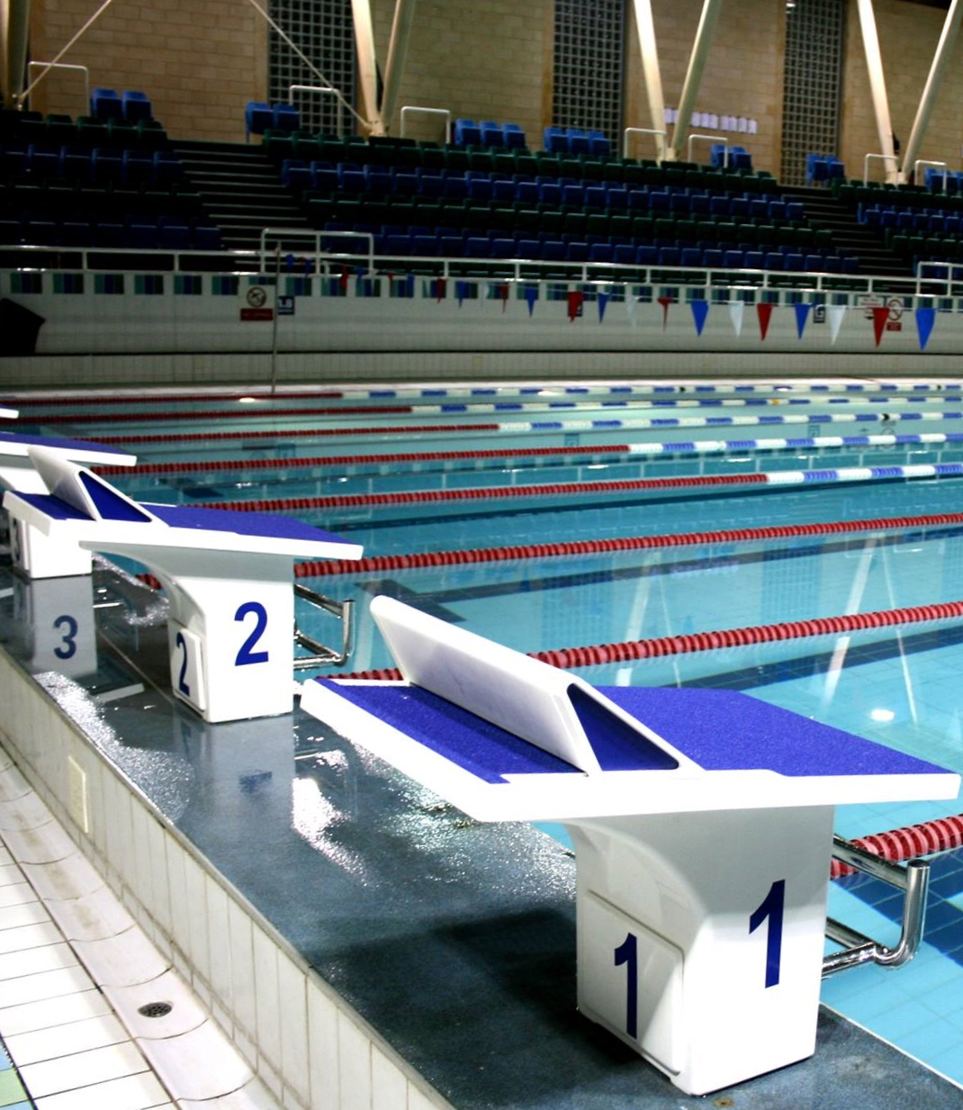



City of Cambridge Swimming Club

Parkside Swimming Pools, Cambridge.

**Jeanne Barker   
Open 2022   
Level 3 No. 3ER220836**

16th and 17th July 2022

## City of Cambridge Swimming Club

## Cambridge Spring Open 2022

## (License Number: 3ER220836)

## Saturday 16th and Sunday 17th July 2022

Affiliated to the Swim England East Region

Under Swim England Laws and Regulations and Swim England Technical Rules of Swimming

Venue: Parkside Swimming Pool, Gonville Place, Cambridge, CB1 1LY

Pool: 8 Lane, 25m Pool, Electronic Timing, Olympic standard blocks.

A secondary strobe will be available at this meet.

Age Groups: 9, 10, 11, 12, 13, 14, 15, 16 and 17+years. Age as at 17/7/22.

For event restrictions see qualifying times table.

Awards: Heat Declared Winners with awards to top three in each age group.

Heats will run fastest to slowest seeded times.

Spot prizes will be given in each event

Events: 50m, 100m and 200m all strokes, 100m and 200m IM.

Fees: Race Entry Fee: £6.00 per event for entries via Sportysys, £7 per event for individual online entries

Spectator Entry £5.00 per session or £8.00 all day. Programmes £3.00.

Entries to: Entries will be accepted via Sportsys file or online form ONLY.

Entries with NT will be accepted, estimated times will not be accepted.

This is a first come first serve meet.

Please address any questions to Meets Secretary at the email address below,

Closing Date for Entries: 12.00 Midnight on 25th June 2022.

*Please note that we hope and intend to run this gala without any COVID restrictions. However we will need to fully comply with any guidance from UK Government, Swim England or our Pool Operator that is applicable at the time of the meet. Any amendments to our Meet Conditions will be communicated on our website as soon as we learn of them.*

*You can enter the gala in confidence – should we have to cancel or reduce swimmer numbers at a later date then we guarantee a full refund of any payment.*

Enquiries can be e-mailed to [meets@cocsc.org.uk](mailto:meets@cocsc.org.uk)

Meet Programme

|  |  |  |  |  |  |
| --- | --- | --- | --- | --- | --- |
| Session 1 Saturday 16th July  Warm-up 12pm  Start 1pm | | | Session 3 Sunday 17th July  Warm-up 12pm  Start 1pm | | |
| 1  2  3  4  5  6  7 | 200m IM 50m Breaststroke  50m Butterfly  200m Backstroke  200m Breaststroke  100m Butterfly  100m Freestyle | Female  Male  Female  Male  Female  Male  Female | 15  16  17  18  19  20  21 | 200m IM 50m Breaststroke  50m Butterfly  200m Backstroke  200m Breaststroke  100m Butterfly  100m Freestyle | Male  Female  Male  Female  Male  Female  Male |
|  |  |  |  |  |  |
| Session 2 Saturday 16th July  Warm-up tbc  Start tbc | | | Session 4 Sunday 17th July  Warm-up tbc  Start tbc | | |
| 8  9  10  11  12  13  14 | 50m Freestyle 50m Backstroke  100m IM  200m Freestyle  200m Butterfly  100m Breaststroke  100m Backstroke | Male  Female  Male  Female  Male  Female  Male | 22  23  24  25  26  27  28 | 50m Freestyle  50m Backstroke  100m IM  200m Freestyle  200m Butterfly  100m Breaststroke  100m Backstroke | Female  Male  Female  Male  Female  Male  Female |

***Timings noted above are indicative and may alter slightly.   
Final timings will be confirmed shortly before the meet.***

|  |  |  |  |  |  |  |
| --- | --- | --- | --- | --- | --- | --- |
|  | | | | | | |
|  | |  | | |  | |
|  | | |  | | | |
|  |  |  |  |  | |  |
|  | | |  | | | |
|  |  |  |  |  | |  |

**Meet Rules and Information**

1. This Competition is licensed by Swim England and will be held under Swim England Laws and Swim England Technical Rules.
2. Entrants must be Swim England registered Category 2, belong to an affiliated club and enter in the name of one club only.
3. All entry times must meet the qualifying times and criteria stated on the qualifying times table.
4. Swimmers in possession of a Swim England Certificate of Swimming Disability or whose Swim England membership record details a disability sport class are welcome to enter the competition with a time slower than the lower limit standard. An entry time must be provided.
5. This is a first come first served meet. The promoter reserves the right to limit entries. Competitors may be rejected if the meet is oversubscribed in order to meet license time guidelines.
6. Club/Group entries can be made via SPORTSYSTEMS Entry Manager files are available on request by e-mail to [meets@cocsc.org.uk](mailto:meets@cocsc.org.uk) or from the club website at [www.cocsc.org.uk](http://www.cocsc.org.uk). Entries via Sportsys will be charged at £6 per event.
7. Individual entries must be made via an online form, the link for which can be found here <https://swim-meet.com/Entry/Cambridge/> . Due to administration costs individual online entries will be charged at £7 per event.
8. Entries will only be accepted once payment has been received.
9. Entry forms and payment must be received by the Promoters before midnight on 25th June 2022 and must be fully and correctly completed, or else they may be rejected.
10. The list of accepted and rejected entries will be published/available for download on the club website ([www.cocsc.org.uk](http://www.cocsc.org.uk)) Approximately two weeks prior to the competition. It is the competing club/swimmer’s responsibility to check this list for accuracy and advise immediately of any mistakes or changes that are required.
11. Competitors’ ages shall be as of 17th July 2022
12. Swimmers **must** withdraw from events that they no longer wish to swim. All swimmers informed of having accepted entries will be deemed as competing unless they have informed the promoter that they do not wish to swim.
13. CoCSC welcome all officials including trainees. Officials can register directly on line at <https://swim-meet.com/OfficialsSignup/Cambridge/>
14. Swimmers withdrawing from events: Each Club should have their own record of swimmers entered. Swimmers unable to compete must be withdrawn. Withdrawal will be made by coaches or the club representative using the Swim-Meet link sent out prior to the gala and must be submitted anytime upuntil 5 minutes after the start of each Warmup for the relevant session.
15. Refunds are not available for withdrawals, other than injury with a medical certificate. Any competitor that withdraws on medical grounds will not be able to participate in any events for the remainder of that session.
16. Awards will be made for the top 3 swimmers in each age group. Spot prizes will be awarded for each event.
17. The pool length is 25 metres, 8 lanes with anti-wave ropes and electronic timing and the depth of the pool is 1.2m at the shallow end and 1.8m at the deep end.
18. Backstroke start devices may be used.
19. A secondary strobe will be available at this meet.
20. Any swimmer not reporting to the marshalling area in a timely manner, normally one event in advance of their own, may be deemed to have withdrawn from that event.
21. All events will be seeded on submitted times, fastest first, and all heats will be spearheaded. The first three swimmers in each event in each age group will receive awards.
22. Coaches/Team Managers will be allowed on poolside if wearing a pre-purchased pass. Coaches and Team Managers must be club trained personnel and clubs are asked to maintain the recommended ratio of helpers to swimmers. Untrained parents without DBS clearance are not allowed poolside.
23. Over the top starts may be used at the referees’ discretion.
24. The promoters do not accept responsibility for any property.
25. For Health and Safety reasons only small rucksack bags will be allowed poolside. Lockers are available (refundable £1 coin required). Pool staff will remove any large obtrusive bags.
26. Limited seating poolside will be available for Coaches and swimmers. No additional seating is permitted.
27. No person will be allowed on poolside without a pass.
28. There will be no glass items allowed on poolside.
29. The promoters reserve the right to refuse admission to any competitor, participant, coach or spectator.
30. By submitting and accepting entries to the meet, consent is hereby given, as required by the Data Protection Act 2018, to the holding of personal information on computer. Personal data handled such as name, club, recorded and entered times may be made public during or after the meet.
31. Spectator fees £5.00 per session or £8.00 per day, Programmes £3.00,
32. Coach/Team Manager Passes can be applied for using the form in this document and will cost £12.00 per day (including lunch and a programme).
33. In accordance with Swim England Child Safety Procedures and Policies all parents or carers of swimmers under the age of 18 who wish to take photographic, or video images are requested to focus on their own child as much as reasonably possible and to avoid including other children in those images, particularly if those images are being shared with family and friends through social media platforms. Should you have any concerns about photography or filming at this event then please bring them to the attention of the Meet Promoter, Catherine Pearson.
34. Warm up protocol: Strictly no diving during any warm-up sessions, except in the designated sprint lanes, odd lanes will swim clockwise (1, 3, 5, 7) even lanes (2, 4, 6, 8) will swim counter clockwise. All swimmers must leave the water by the side of the pool and not over the timing pads. Coaches must manage the lanes their swimmers are using during the warm-up sessions. Guidance will be given by the meet announcer.
35. Any matter not covered by these conditions will be determined by the Promoter and Referee, subject to Swim England Laws, Regulations and Swim England Technical Rules of Racing.
36. The overall meet promotor is Catherine Pearson however a different person may be designated as promotor for each session on the day.

## Para Swimming Conditions

The conditions outlined above shall apply to all para swimmers except were varied by any of the following conditions.

1. Swimmers with S1- S15 classifications will be accepted.
2. All para swimmers must have an internationally authorised classification.
3. Competitors must be registered members of Swim England.
4. Personal care attendants will be permitted for swimmers in all disability classes.
5. A swimmer may have both a coach and a personal care attendant present.
6. The competition format will be based on disability inclusion within the able-bodied programme. Swimmers will be integrated on a time-banded basis in all events.
7. Positions will be determined by each swimmer’s times relative to the world record in their own classification.
8. Para swimmers will be included but not placed within the results for the appropriate age group in the able-bodied competition unless their entry times meet the qualifying times for the able-bodied competition. They will also be included in the multi-class results and placed within those results according to their equivalent times.
9. Competition to be run under IPC Swimming swim rules.
10. Medals shall be awarded on a multi-class basis to 1st, 2nd and 3rd place in each event.

## Qualifying Times

Qualification times must have been achieved at any meet since the 1st Jan 2018, converted to 25m pool if necessary.   
All entry times will automatically be checked against British Rankings for validity.

If the meet is oversubscribed your entry may be rejected even if meet the qualifying times.

Entries with “No Time” will be accepted, estimated times will not.



Club Summary Entry Form

Please return this completed form by e-mail to [meets@cocsc.org.uk](mailto:meets@cocsc.org.uk).

**ENTRY DEADLINE: MIDNIGHT ON 25th JUNE 2022**

|  |  |  |  |  |
| --- | --- | --- | --- | --- |
| Club Name: | |  | | |
| Contact Name: | |  | | |
| Postal Address: | |  | | |
| Email Address: | |  | | |
| Telephone No: | |  | | |
| Entry Details: | | | | |
|  |  | | No. of Entries/Passes | Cost |
| Swimmers | @ £6 per event | |  | £ |
|  |  | |  |  |
| Coach/Team Manager Passes | @ £12 per person per day | |  | £ |
|  |  | |  |  |
|  | | | TOTAL | £ |

Please make payment by BACS to the following account:

Account Name: City of Cambridge Swimming Club

Account No.: 03013626

Sort code: 20-17-19

Your payment reference should be “CLUB NAME/JB22”

Checklist – **By the Closing Date of 25th June 2022** please ensure you have e-mailed the following information:

* Club Summary Entry Form (this form)
* Coach/Team Manager Form
* SportSys Entry File
* SportSys Meet Entry Report
* BACS transfer details

## 

### Coach/Team Manager Pass Application Form

Club Name:___________________________________________________________________

**Closing date 25th June 2022**

|  |  |  |
| --- | --- | --- |
|  | Saturday  (£12 PER PERSON) | Sunday  (£12 PER PERSON) |
| Full Name: |  |  |
| Position (e.g. Coach): |  |  |
| Telephone No: |  |  |
| Email Address: |  |  |
| DBS Certificate No.: |  |  |
| Full Name: |  |  |
| Position (e.g. Coach): |  |  |
| Telephone No: |  |  |
| Email Address: |  |  |
| DBS Certificate No.: |  |  |
| Full Name: |  |  |
| Position (e.g. Coach): |  |  |
| Telephone No: |  |  |
| Email Address: |  |  |
| DBS Certificate No.: |  |  |
| Full Name: |  |  |
| Position (e.g. Coach): |  |  |
| Telephone No: |  |  |
| Email Address: |  |  |
| DBS Certificate No.: |  |  |
| Number of passes @ £12 per person per day. Total: £ | | |

The above named person(s) is (are) authorised to hold a pass for this club:

Signed ______________________________________Club Representative

Coach/Team Manager Passes will not be available on the day. There will be no access to poolside without a pass.

Passes include entry to poolside, programme and meal on Saturday and Sunday.

All completed forms to be returned by e-mail to [meets@cocsc.org.uk](mailto:meets@cocsc.org.uk).

# Officials Request Form

CoCSC welcome all officials including trainees.

We have an on-line signing up page, you just need your Swim England number:

[https://swim-meet.com/OfficialsSignup/Cambridge/](https://protect-de.mimecast.com/s/Hk_wC99JyjSz1XAZ5hoQti5?domain=swim-meet.com/)

Please click on the link above to select the sessions that you can help with. 

Add any mentoring requests and we will do our best to accommodate.

We provide lunch and refreshments for those doing more than one session and payment for expenses incurred in travel if you do not have a competing swimmer.

Car parking can be a problem around the pool, but we may have parking spaces allocated locally for officials - this will be advised nearer the time.

Any additional questions please email [officials@cocsc.org.uk](mailto:officials@cocsc.org.uk)