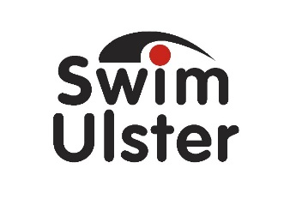

AGE GROUP SKILLS CAMP

Joey Dunlop Leisure Centre (Ballymoney)

26th TO 31st October 2015

Swim Ulster are pleased to announce the Pre-Season Age Group Skills Camp at Joey Dunlop Leisure Centre, Ballymoney from Monday 26th to Friday 30th October 2015.

The Camp will be divided into Junior and Intermediate groups and will be delivered by Swim Ulster Talent ID Coach Mark Craig.

The Junior group is open to competitive Swimmers born 2004-2006
The Intermediate group is open to competitive Swimmers born 2001-2003

The Junior Camp will focus on all four strokes including starts & turns with a series of drills and skills being taught to the swimmers over the 5 days. The Intermediate Camp will focus on light aerobic development with a heavy focus on maintaining technique and skills.

- Cost of the camp is £50 per swimmer (payable by BACS Transfer to Swim Ulster Ltd).
- Spaces are limited to 24 Junior and 18 Intermediate and allocated on a first come, first served basis. The closing date is Thursday, 22nd October 2015.
- Please e-mail Mark Craig to book your place and include your date of birth, club and level of competition.

Camp Timetable

 | Monday | Tuesday | Wednesday | Thursday | Friday
Junior | 9.30am-11am | 9.30am-11am | 9.30am-11am | 9.30am-11am | 9.30am-11am
Intermediate | 11am-1pm | 11am-1pm | 11am-1pm | 11am-1pm | 11am-1pm

Please note that Club Coaches are very welcome to attend part or all of the camp if they wish. Further information can be obtained by contacting Mark Craig, Swim Ulster Talent ID Coach.

Email : talentid@swimulster.net

Mobile : 07834 556442

