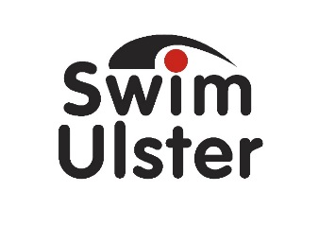

SWIM ULSTER HALLOWEEN SKILLS CAMPS

Ballymoney

SWIM ULSTER BANK DETAILS

PLEASE SEND THE CAMP FEE BY BACS TRANSFER TO :

BANK : DANSKE BANK
ACCOUNT NAME : SWIM ULSTER
SORT CODE : 950132
ACCOUNT NO : 22780453

BIC : DABAGB2B
IBAN : GB79 DABA 9501 3222 7804 53

PLEASE REFERENCE CHILDS NAME OR CLUB NAME IF MAKING A COLLECTIVE PAYMENT WHEN MAKING A BANK TRANSFER.

OR POST YOUR CHEQUE (PAYABLE TO SWIM ULSTER) TO :

SWIM ULSTER
AURORA AQUATIC & LEISURE COMPLEX
3 VALENTINE ROAD
BANGOR
BT20 4TH

Cost for the course is £45 or €55 for the week

