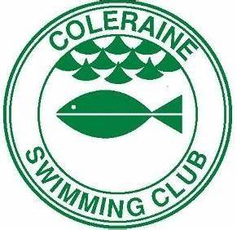

SAFEGUARDING IS OUR RESPONSIBILITY

Safeguarding is a priority here. We are committed to following Swim Ireland guidelines on safeguarding children and young people and good working practice, including safe recruitment of volunteers.

We work to a formal safeguarding policy and procedure it can be found on our web site here :
https://uk.teamunify.com/team/colerainesc/page/about-us/rules
USEFUL CONTACTS

Childline (for children)
0800 1111

NSPCC
0808 800 5000

Lifeline
0808 808 8000

Stop it Now
0808 1000 900

Domestic Violence Helpline
0808 2000 247

MindinfoLine
0300 123 3393

Self harm support
www.selfharm.co.uk/#help

If you have any concerns regarding your safety or the safety or welfare of a child or young person you can speak to:

Karen Marran Mark Lynch
(CCO Coleraine swim club) (CCO Coleraine swim club)

Swimcolerainechildrensofficer@gmail.com
If a child is in immediate danger, call the police on 999 straight away.

