Connecting the Laptop to the ARES 21 Timing System

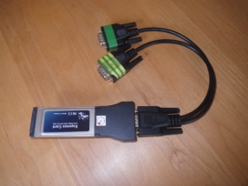
- Insert the PCMCIA card into the laptop – this gives you two serial ports on the laptop

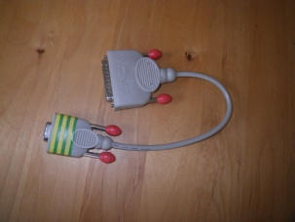
- Connect the serial 9-25 pin adapter to the marked serial port (shown with stripped tape).

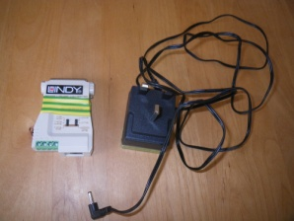
- Connect the Lindy RS 232 to RS485 converter to the 25 pin serial cable. Connect the converter’s power supply to the converter and to a power source.

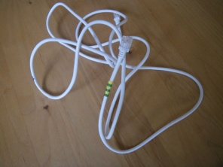
- Connect the white modem lead to the Lindy RS 232 converter

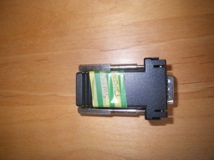
- Connect the modem cable to the Swiss Timing ARES connector and fit the connector to the serial port at the back of the Red ARES 21 box. You can now test the connection in Meet Manager.

Testing the Connection between the Laptop and the ARES 21 Timing System
Check Connection
- Check the port number on the laptop to see which COM port is being used: Start-Devices and Printers, and note what COM port the PCMCIA card is in – usually Com 4 or 5
- In Meet Manager Open the Port: Run – Interfaces – Timer (ARES) – Open/Close Serial Port for ARES and enter the serial port number into the ‘Serial Com Port for ARES’ field
- The system now checks the connection & reports on either success or failure. If the connection fails move the Serial 9-25 adaptor to the other serial port and try again.
Download Events
If the events haven’t been set up in the ARES system you can download the events using Run – Interfaces – Timer (ARES) – Download event to ARES and Y to confirm download

You are now ready to receive results from the ARES system using the F3 – Get Times button on the Run Screen in Meet Manager.

Best of Luck.

