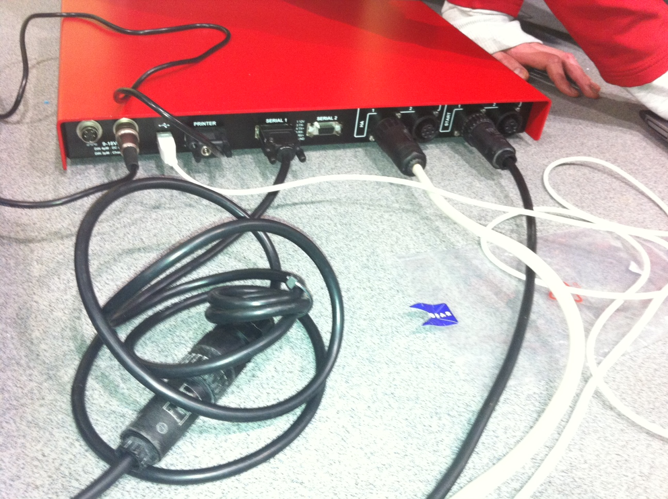

CoStA’s 10m M-F 4 pin extension cable to connect to Scoreboard port under seats

Start cable.Use CoStA’s 10m M-F 4 pin extension cable to connect to Start port under seats

Harness 10m cable to Harness port under seats

Connecting cables to Quantum AQ box at Westminster Lodge

Use centre’s 4 pin to serial lead to connect to CoStA’s 10m M-F 4 pin extension cable below

KEY CABLE. Connects to Quantum laptop to make system live

Printer connection – link to thermal roll printer

Power lead for Quantum box – plugged into power socket