COPS DISTANCE TIME TRIALS
Licensed meet
Friday 25th November & Friday 2nd December 2022
License Level 3

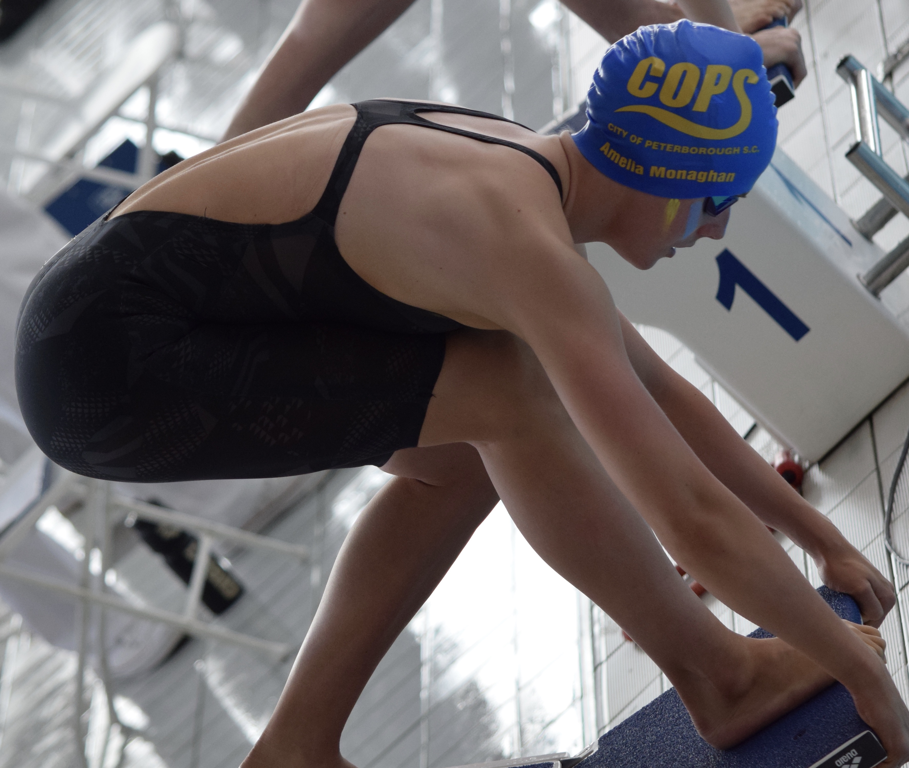

Regional Fitness & Swimming Centre
Bishops Road, Peterborough. PE1 5BW.
Short Course (25m)

COPS DISTANCE LICENSED TIME TRIALS

FOR FURTHER DETAILS VISIT: www.copsclub.co.uk

MEET PROMOTOR: Anna Bertou (on behalf of City of Peterborough Swimming Club)

CONTACT DETAILS: Galas@copsclub.co.uk
POSTAL ADDRESS: COPS, Regional Fitness & Swimming Centre, Bishops Road, Peterborough. PE1 5BW.

Venue: Regional Fitness and Swimming Centre, Bishops Road, Peterborough. PE1 5BW.

Affiliation: City of Peterborough Swimming Club is affiliated to Swim England East Region. The meet will be held under Swim England laws and Regulations and Swim England Technical Rules of racing. The meet is licensed at Level 3 under licence no. 3ER222336 and 3ER222337.

Age-groups:
11-12yrs, 13-14yrs, 15-16yrs & 17 yrs and over
Category ages are based on age as at 31.12.2022.

Events: 800m & 1500m freestyle.

The events will be heat declared winner.

Events will be seeded into heats from submitted times with slowest heats swum first. Heats will be swum in a spearhead formation and will be mixed gender.

It is the responsibility of swimmers to report to the stewarding area in sufficient time for each event. City of Peterborough SC cannot be held responsible for any swimmer missing the start of their particular heat.

Awards: Medals will not be awarded.

Entries: Entry Times must be published on British Swimming Rankings or coach estimated times will be accepted. Entries must be slower than the published upper cut off times and all such entries will be considered. NO TIME entries will not be accepted.

Following the entry deadline, the event promoters will review all entries in accordance with the capacity of the meet permitted at the time, this may result in some swimmers being rejected from the meet despite being inside the qualifying times. See paragraph below for rejection rules. The promoter will determine accepted entries on a first come first served basis.

Entries will be accepted from 20th October 2022
The closing date for entries: 8th November 2022

City of Peterborough SC reserves the right to close the meet or individual events within the meet earlier than the specified closing date. Details of accepted and rejected entries will be posted on our website at 8am 15th November 2022.

Rejected entries will be refunded and will be on a first come, first served basis. There will be no refunds for withdrawals after the closing date other than withdrawals for medical reasons that are accompanied by the appropriate certification.

The submission of entries, will either be electronically on teamunify for COPS members or by using the Hy-tek electronic entry file which will be available to download via www.copsclub.co.uk. No paper entries allowed for this meet.

A Start list will be available for printing at 8am on 25th November 2022.

ENTRY FEES: £3.00 per event

Payment to be in accordance with the instructions on our website. The entry fee includes a levy of 20p per event payable to Swim England South East Region. It also includes spectator entry (see below).

Individual entries will be charged at £3.00 per event to take in to account administration costs.

Results: Results will be posted on the COPS website.

Safeguarding the running of the meet: All clubs submitting entries are requested to assist in the running of the meet by supplying details of any Licensed officials who are willing to assist at this Gala.

Poolside passes: Poolside passes for Coaches are FREE. However, coaches must register with COPS Head Coach, Ben Negus via ben.negus@copsclub.co.uk

Officials: Names and contact details for officials should be provided by the person responsible for submitting the entries and forwarded to Galas@copsclub.co.uk

Parking: There is limited parking space at the facility. Address: 19 Bishops Road, Peterborough. PE1 5AP. Parking charges are in place. Other parking options will be circulated in advance of the meet.

Spectators: There is ample spectator seating at the Regional Fitness and Swimming Centre. Admission for Spectators will be £2.

Administration: For all information regarding this meet, please see www.copsclub.co.uk For queries and submission of electronic entries, individual Entry Forms, payments and application for poolside passes should be sent to: Anna Bertou at Galas@copsclub.co.uk

Health & Safety: No outdoor shoes to be worn poolside. Swimmers must not leave poolside without wearing clothes and suitable footwear.

Security: Persons are requested not to leave belongings unattended. There is plenty of space poolside for bags and kit, however, if you wish to use the facility lockers belongings can be placed in the lockers in the changing area (£1 charge which is refunded on leaving).

Data Protection: Entries and results will be managed via computer and available via the internet. By submitting entries, consent is thereby given, as required by the Data Protection Act, to the holding of personal information on a computer. Personal data, including submitted and recorded times, will be available during the meet. Any matter not covered by these conditions or by Swim England laws or technical rules will be at the Promoter’s discretion. Where the personal data of competitors, officials and coaches/team managers has been passed to us by a third party such as a club rather than by the individuals themselves, we rely on the third party to ensure that consent has been obtained.

Schedule of Events

 | Friday | Friday
 | 25th Nov | 2nd Dec
Warm up | 5.30 – 6.00pm | 5.30 – 6.00pm
Start | 6.10pm | 6.10pm
 | Mixed 800m FR | Mixed 1500m FR

- All events are open age (11yrs+)
- Warm up will take place in lanes 1-6. The last 5mins of each warm up will be 4 lanes sprint (one way only), 2 lanes pace swimming (clockwise)

Qualification Times

- All swimmers must be registered cat 2 members of Swim England
- Category ages are based on age as at 31.12.2022
- Entry times can be from short course or long course converted times or coach estimated
- All events will be seeded by submitted times
- No entry times will not be accepted

FEMALE QUALIFYING TIMES (Entry times must be slower than)

Event |  | 11/12yrs | 13/14yrs | 15/16yrs | 17+
800m Freestyle | Slower | 9.20.0 | 8.55.0 | 8.45.0 | 8.30.0
1500m Freestyle | Slower | 18.30.0 | 18.00.0 | 17.45.0 | 17.15.0

MALE QUALIFYING TIMES (Entry times must be slower than)

Event |  | 11/12yrs | 13/14yrs | 15/16yrs | 17+
800m Freestyle | Slower | 9.20.0 | 8.45.0 | 8.30.0 | 8.20.0
1500m Freestyle | Slower | 18.30.0 | 17.55.0 | 16.50.0 | 16.30.0

MANUAL ENTRY FORM

Entries should be submitted by clubs electronically. This form should be used for individual entries, which will incur a £1 administration fee

Swimmers Name |  | Date of Birth
Club |  | Swim England Number
Email Address |  | Gender | Male / Female

Event | Entry Time | Event | Entry Time
800m Freestyle |  | 1500m Freestyle
 |  | Total Number of Entries
 |  | Total Entry Fee £3.00 per event + £1 Admin Fee

Forms should be sent to:
COPS Open Meet
City Of Peterborough Swimming Club.
The Regional Fitness & Swimming Centre,
Bishops Road,
Peterborough.
PE1 5BW.

OFFICIALS

This gala can only run if visiting clubs are able to provide officials. We would request that clubs endeavour to provide officials to allow the competition to run efficiently.

Name

Address

Qualification

ASA Registration Number

Email Address

PLEASE COMPLETE AND RETURN TO Galas@copsclub.co.uk.

ALTERNATIVELY, PLEASE GO TO THE COPS WEBSITE EVENTS PAGE AND GO TO THE JOB SIGN UP SECTION OF THIS EVENT TO SIGN UP TO ASSIST.

