COPS Last Chance Regional Qualifier
Saturday 1st & Sunday 2nd April 2023
License Level 3

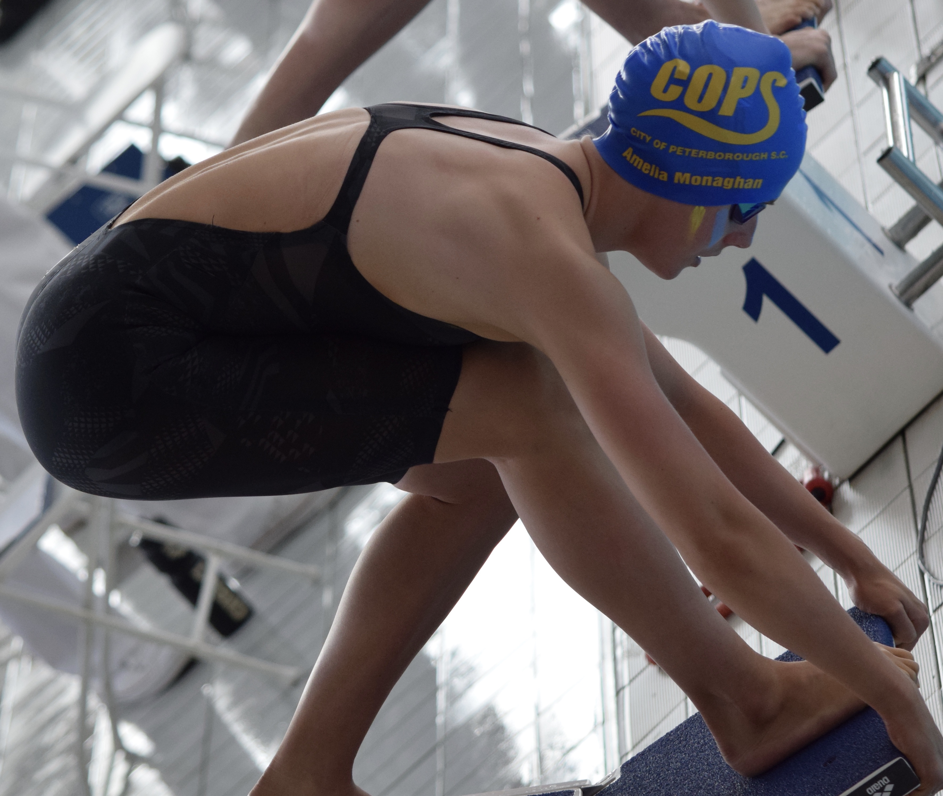

Regional Fitness & Swimming Centre
Bishops Road, Peterborough. PE1 5BW.
Short Course (25m)

FOR FURTHER DETAILS VISIT: www.copsclub.co.uk

MEET PROMOTOR: Anna Bertou (on behalf of City of Peterborough Swimming Club)

CONTACT DETAILS: Galas@copsclub.co.uk
POSTAL ADDRESS: COPS, Regional Fitness & Swimming Centre, Bishops Road, Peterborough. PE1 5BW.

Venue: Regional Fitness and Swimming Centre, Bishops Road, Peterborough. PE1 5BW.

Affiliation: City of Peterborough Swimming Club is affiliated to Swim England East Region. The meet will be held under Swim England laws and Regulations and Swim England Technical Rules of racing. The meet is licensed at Level 3 under license number 3ER230495

Age-groups: 10yrs & under, 11-12yrs, 13-14yrs & 15yrs & over

Events: 50m, 100m and 200m of all four strokes, 200m and 400m Individual medley, and 400m freestyle.

The events will be heat declared winner.

Events will be seeded into heats from submitted times with slowest heats swum first. Heats will be swum in a spearhead formation.

It is the responsibility of swimmers to report to the stewarding area in sufficient time for each event. City of Peterborough SC cannot be held responsible for any swimmer missing the start of their particular heat.

Awards: Medals will be awarded for the 1st, 2nd and 3rd place finishes in each event/age-band. There will also be spot prizes for the winners of each heat.

Entries: Entry Times must be swum at a Licensed (level 1 – 4) meet and published on British Swimming Rankings. Entries must meet the published minimum qualifying standards and all such entries will be considered. Times need have been achieved from 1st September 2021.

Following the entry deadline, the event promoters will review all entries in accordance with the capacity of the meet permitted at the time, this may result in some swimmers being rejected from the meet despite being inside the qualifying times. Entries will be considered on a first come, first served basis.

Entries will be accepted from: 8am 1st February 2023
The closing date for entries: 6pm 1st March 2023

City of Peterborough SC reserves the right to close the meet or individual events within the meet earlier than the specified closing date. Details of accepted and rejected entries will be posted on our website at 8am 15th March 2023.

Rejected entries will be refunded. There will be no refunds for withdrawals after the closing date other than withdrawals for medical reasons that are accompanied by the appropriate certification.

Competitors that do not intend to compete in an event must notify their withdrawal from the event by the commencement of warm-up for each session.

The Promoter reserves the right to allow additional entries that are slower than the qualification times if the meet is not full by the closing date for entries.

The submission of entries, either electronically or by entry form indicates acceptance of the Meet Conditions. Entries with long course times (short course conversions will be accepted) should be submitted using the Hy-tek electronic entry file available to download via www.copsclub.co.uk.

Individual entries may also be accepted using the Individual Entry Form also available on our website.

A Start list will be available for printing at 8am on 30th March 2023.

ENTRY FEES: £7.50 per event

Payment to be in accordance with the instructions on our website. The entry fee includes a levy of 20p per event payable to Swim England East Region. It also includes spectator entry (see below).

Safeguarding the running of the meet: All clubs submitting entries are requested to assist in the running of the meet by supplying details of any Licensed officials who are willing to assist at this Gala.

Poolside passes: Poolside passes for Coaches are available at a cost of £10 per coach/team manager for the 2 days. Poolside passes include admittance to all sessions, programmes, food/refreshments and results. A free poolside pass will be provided to any club entering 30 swimmers or more or providing licensed officials for all 4 sessions.

Officials: Names and contact details for officials should be provided by the person responsible for submitting the entries and forwarded to admin@copsclub.co.uk

Parking: There is some parking space at the facility. Address: 19 Bishops Road, Peterborough. PE1 5AP. Other parking options will be circulated in advance of the meet.

Spectators: There is ample spectator seating at the Regional Fitness and Swimming Centre. Admission for Spectators will cost £5 per session or £15 for the weekend.

Administration: For all information regarding this meet, please see www.copsclub.co.uk For queries and submission of electronic entries, individual Entry Forms and application for poolside passes should be sent to: Anna Bertou at Galas@copsclub.co.uk

Health & Safety: No outdoor shoes to be worn poolside. Swimmers must not leave poolside without wearing clothes and suitable footwear.

Security: Persons are requested not to leave belongings unattended. There is plenty of space poolside for bags and kit, however, if you wish to use the facility lockers belongings can be placed in the lockers in the changing area (£1 charge which is refunded on leaving).

Data Protection: Entries and results will be managed via computer and available via the internet. By submitting entries, consent is thereby given, as required by GDPR, to the holding of personal information on a computer. Personal data, including submitted and recorded times, will be available during the meet. Any matter not covered by these conditions or by Swim England laws or technical rules will be at the Promoter’s discretion. Where the personal data of competitors, officials and coaches/team managers has been passed to us by a third party such as a club rather than by the individuals themselves, we rely on the third party to ensure that consent has been obtained.

Schedule of events

Saturday 1st April 2023

Session One 8.00-8.45am warm up (Est finish 12.00pm)

M 50m Butterfly
F 50m Butterfly
M 100m Backstroke
F 100m Backstroke
M 200m Breaststroke
F 200m Breaststroke
M 200m Butterfly
F 400m Freestyle

Session Two 1.00-1.45pm warm up (Est finish 5.00pm)

F 50m Backstroke
M 50m Backstroke
F 100m Breaststroke
M 100m Breaststroke
F 200m Freestyle
M 200m Freestyle
F 200m Butterfly
M 400m Freestyle

Sunday 2nd April 2023

Session Three - 8.00-8.45am warm up (Est. finish 12.00pm)

M 50m Breaststroke
F 50m Breaststroke
M 100m Freestyle
F 100m Freestyle
M 200m Backstroke
F 200m Individual Medley
M 400m Individual Medley

Session Four – 1.00-1.45pm warm up (Est. finish 5.00pm)

F 50m Freestyle
M 50m Freestyle
F 100m Butterfly
M 100m Butterfly
F 200m Backstroke
M 200m Individual Medley
F 400m Individual Medley

Qualification Times

- All swimmers must be register cat 2 members of Swim England
- Category ages are based on age as at Sunday 2nd April 2023
- Entry times can be from short course or long course converted times
- All events will be seeded by submitted times
- A swimmer’s entry time must be recorded in the British ranking system. Entries with incorrect times will be rejected.

FEMALE QUALIFYING TIMES (Entry times must be slower than)

Event |  | 10 & U | 11/12yrs | 13/14yrs | 15+
50m Freestyle | Slower | 30.0 | 28.50 | 27.00 | 26.00
100m Freestyle | Slower | 1.08.00 | 1.05.00 | 1.00.00 | 57.00
200m Freestyle | Slower | 2.25.00 | 2.20.00 | 2.10.00 | 2.03.00
400m Freestyle | Slower | 5.10.00 | 5.00.00 | 4.30.00 | 4.15.00
50m Breaststroke | Slower | 39.00 | 38.00 | 34.00 | 32.00
100m Breaststroke | Slower | 1.25.0 | 1.21.00 | 1.14.00 | 1.10.00
200m Breaststroke | Slower | 3.05.00 | 2.59.00 | 2.40.00 | 2.30.00
50m Fly | Slower | 33.00 | 31.00 | 29.00 | 27.00
100m Fly | Slower | 1.20.0 | 1.15.00 | 1.05.00 | 1.00.00
200m Fly | Slower | 3.00.00 | 2.50.00 | 2.28.00 | 2.12.00
50m Backstroke | Slower | 33.00 | 32.00 | 28.00 | 27.00
100m Backstroke | Slower | 1.13.00 | 1.10.00 | 1.05.00 | 1.01.00
200m Backstroke | Slower | 2.40.00 | 2.34.00 | 2.22.0 | 2.10.00
200m Individual Medley | Slower | 2.38.00 | 2.33.00 | 2.21.00 | 2.18.00
400m Individual Medley | Slower | 5.30.00 | 5.20.00 | 5.10.00 | 4.50.00

MALE QUALIFYING TIMES (Entry times must be slower than)

Event |  | 10 & U | 11/12yrs | 13/14yrs | 15+
50m Freestyle | Slower | 29.00 | 28.50 | 27.00 | 25.90
100m Freestyle | Slower | 1.10.00 | 1.02.50 | 55.09 | 52.10
200m Freestyle | Slower | 2.30.00 | 2.15.00 | 2.03.00 | 1.55.00
400m Freestyle | Slower | 5.10.00 | 5.00.00 | 4.25.00 | 4.10.00
50m Breaststroke | Slower | 39.00 | 37.50 | 33.00 | 28.00
100m Breaststroke | Slower | 1.25.00 | 1.18.00 | 1.10.00 | 1.06.00
200m Breaststroke | Slower | 3.20.00 | 2.50.00 | 2.39.00 | 2.20.00
50m Fly | Slower | 33.00 | 29.50 | 27.50 | 25.00
100m Fly | Slower | 1.20.00 | 1.10.00 | 1.01.00 | 57.00
200m Fly | Slower | 3.00.00 | 2.40.00 | 2.20.00 | 2.05.00
50m Backstroke | Slower | 32.50 | 31.50 | 28.50 | 25.50
100m Backstroke | Slower | 1.12.00 | 1.10.00 | 1.04.00 | 56.00
200m Backstroke | Slower | 2.40.00 | 2.30.00 | 2.18.00 | 2.00.00
200m Individual Medley | Slower | 2.45.00 | 2.33.00 | 2.18.00 | 2.08.00
400m Individual Medley | Slower | 5.30.00 | 5.20.00 | 4.50.00 | 4.30.00

MANUAL ENTRY FORM

Entries should be submitted by clubs electronically. This form should be used for individual entries, which will incur a £1 administration fee

Swimmers Name |  | Date of Birth
Club |  | Swim England Number
Email Address |  | Gender | Male / Female

Event | Entry Time | Event | Entry Time
50m Freestyle |  | 50m Breaststroke
100m Freestyle |  | 100m Breaststroke
200m Freestyle |  | 200m Breaststroke
400m Freestyle |  | 50m Butterfly
50m Backstroke |  | 100m Butterfly
100m Backstroke |  | 200m Butterfly
200m Backstroke
200m Individual Medley |  | Total Number of Entries
400m Individual Medley |  | Total Entry Fee £7.50 per event + £1 Admin Fee

Forms should be sent to:
COPS Open Meet
City Of Peterborough Swimming Club.
The Regional Fitness & Swimming Centre,
Bishops Road,
Peterborough.
PE1 5BW.

OFFICIALS

This gala can only run if visiting clubs are able to provide officials. We would request that clubs endeavour to provide officials to allow the competition to run efficiently.

Meals are provided for those officials covering both sessions in the day

Please tick box for all sessions you are available
Session 1 | Saturday 1st April
Session 2 | Saturday 1st April
Session 3 | Sunday 2nd April
Session 4 | Sunday 2nd April

Name

Address

Qualification

SE Registration Number

Email Address

PLEASE COMPLETE AND RETURN TO Galas@copsclub.co.uk

Coaches/Team Managers Passes

Coaches’ passes are available to coaches supporting competing swimmers at a cost of £10. It is recommended that clubs maintain a ratio of 1:10 Coaches to Swimmers.

Coaches passes will only be awarded to those that are DBS Checked.

Club Name
 | Pass 1 | Pass 2 | Pass 3
Full Name
Position at Club
Coach/Team Manager
SE Number
DBS Check Number

