COPS Season Opener
Invitational only meet
Saturday 2nd & Sunday 3rd October 2021
License Level 3

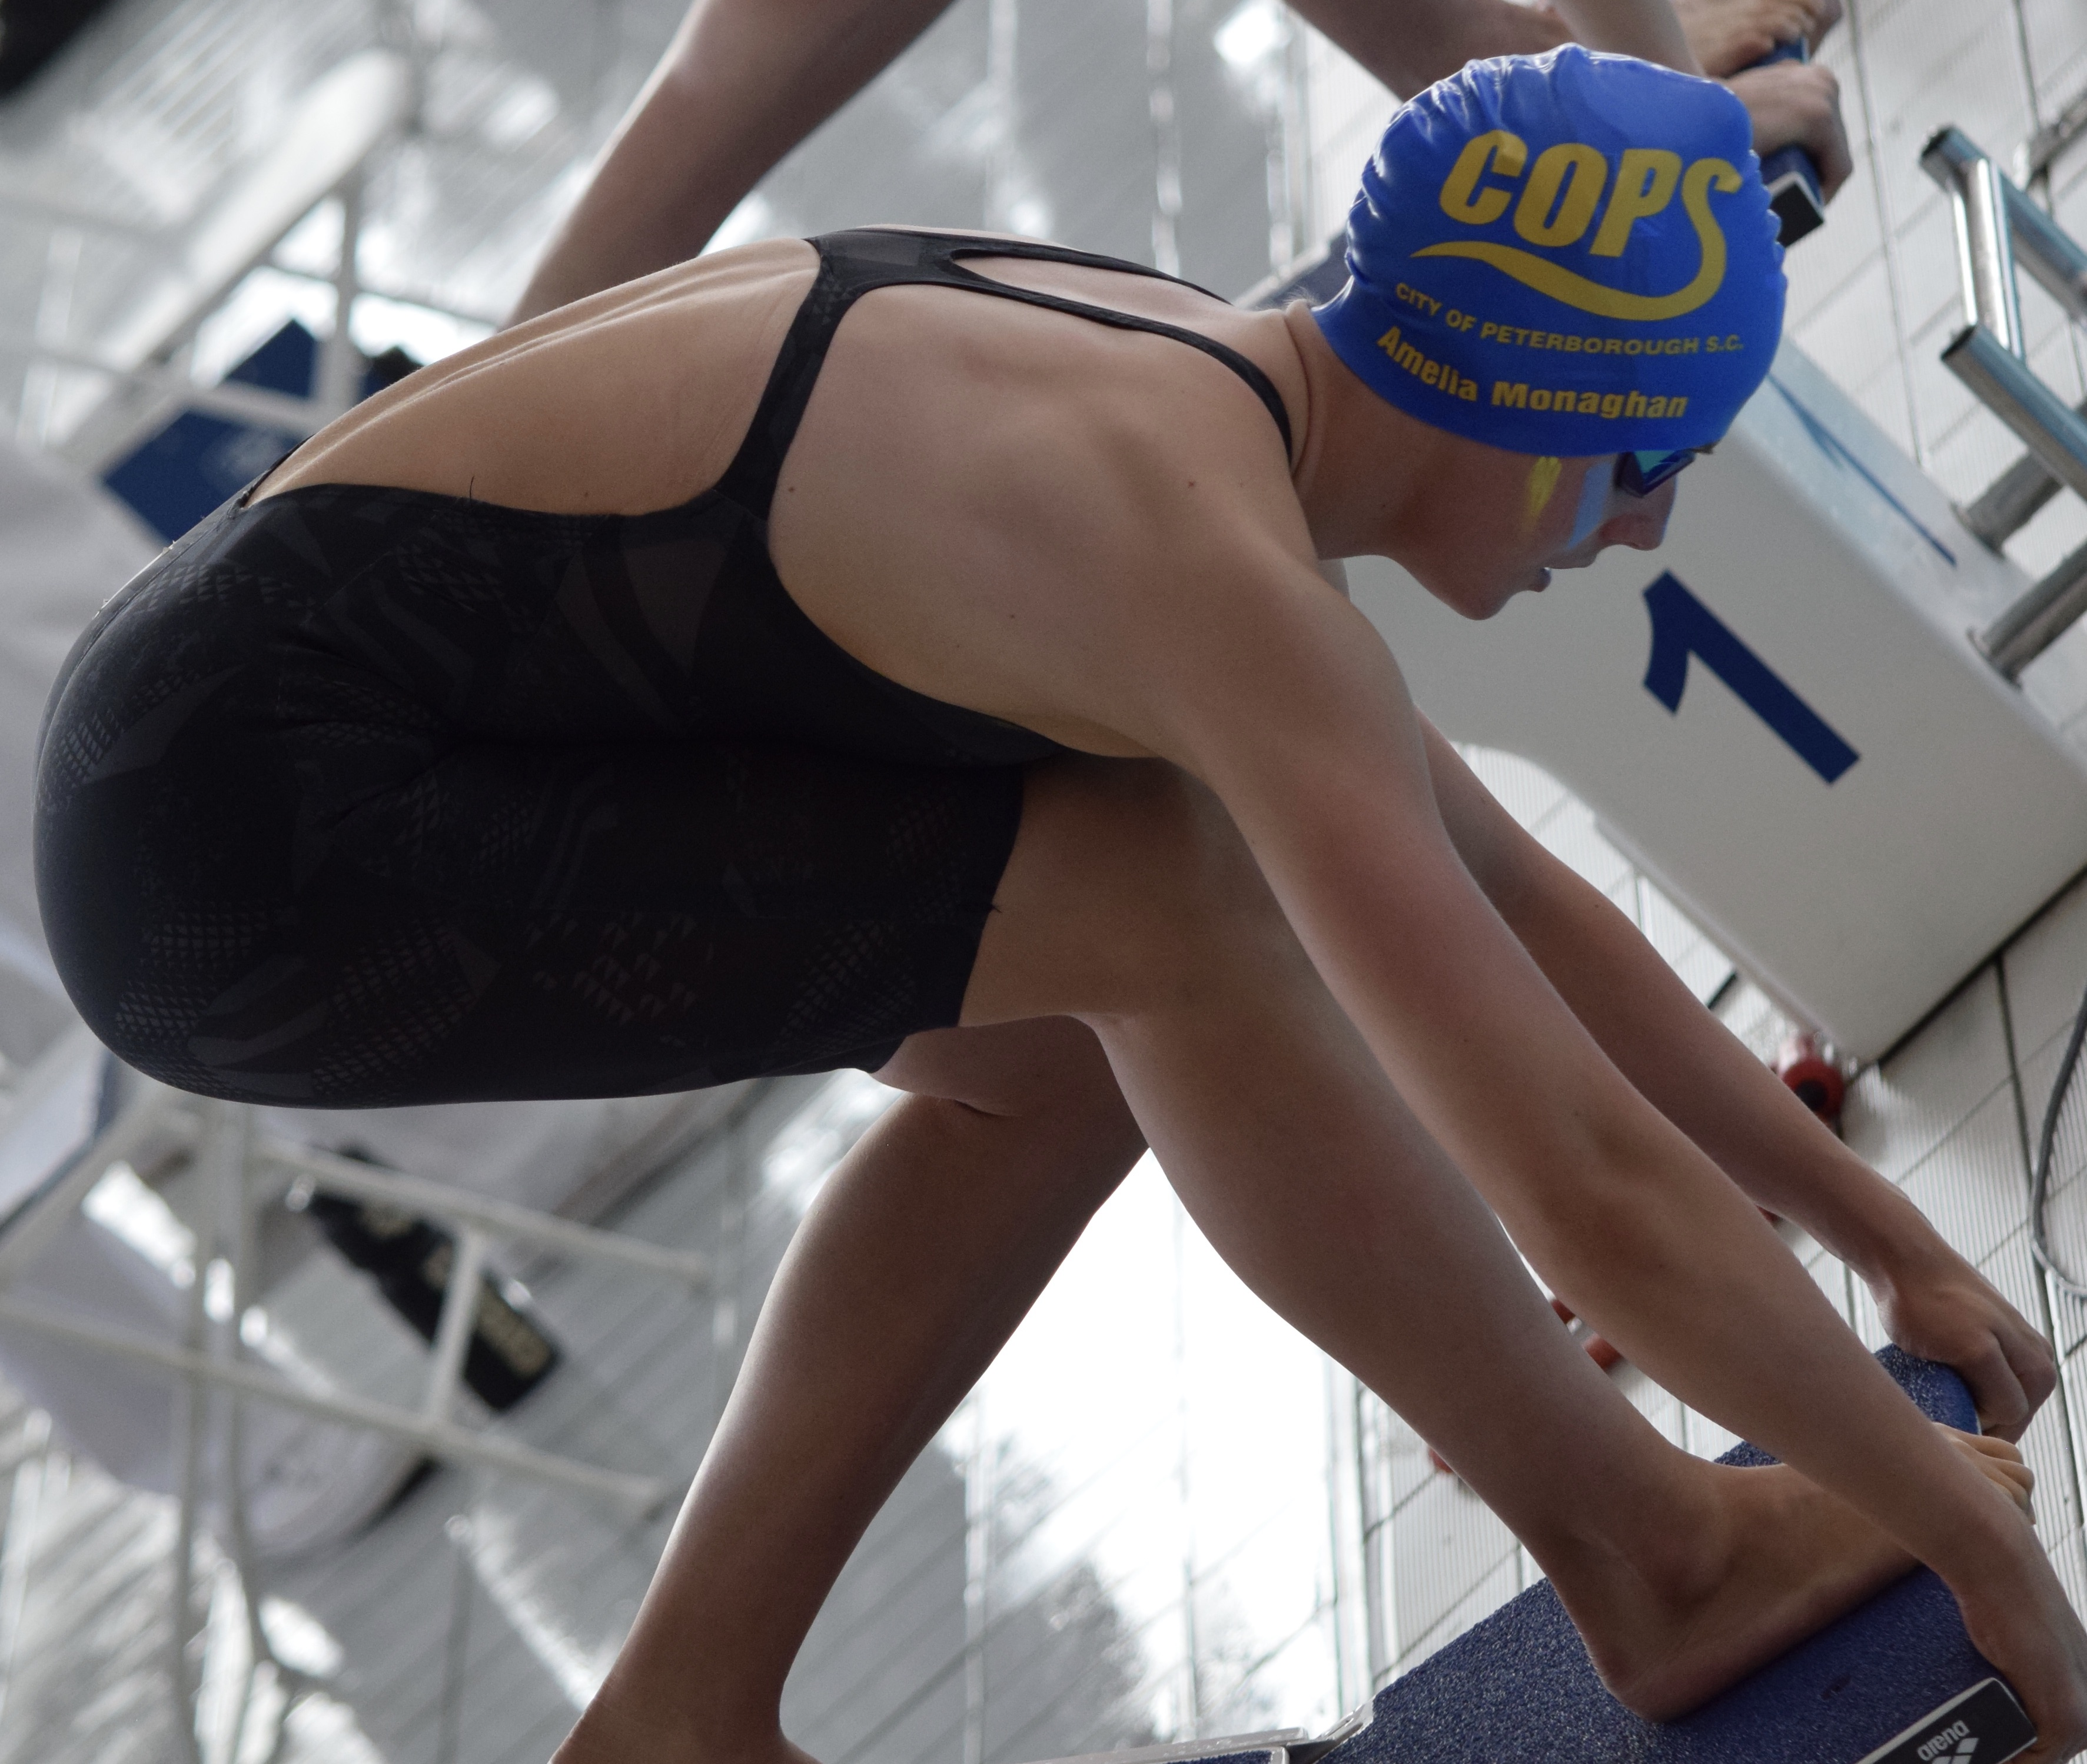

Regional Fitness & Swimming Centre
Bishops Road, Peterborough. PE1 5BW.
Short Course (25m)

COPS SEASON OPENER – INVITATIONAL ONLY MEET

FOR FURTHER DETAILS VISIT: www.copsclub.co.uk

MEET PROMOTOR: Anna Bertou (on behalf of City of Peterborough Swimming Club)

CONTACT DETAILS: Galas@copsclub.co.uk
POSTAL ADDRESS: COPS, Regional Fitness & Swimming Centre, Bishops Road, Peterborough. PE1 5BW.

Venue: Regional Fitness and Swimming Centre, Bishops Road, Peterborough. PE1 5BW.

Affiliation: City of Peterborough Swimming Club is affiliated to Swim England East Region. The meet will be held under Swim England laws and Regulations and Swim England Technical Rules of racing. The meet is licensed at Level 3 under licence no. TBC

Age-groups: 10yrs & under, 11-12yrs, 13-14yrs & 15yrs & over

Events: 50m, 100m and 200m of all four strokes, 100m and 200m Individual medley.

The events will be heat declared winner.

Events will be seeded into heats from submitted times with slowest heats swum first. Heats will be swum in a spearhead formation.

It is the responsibility of swimmers to report to the stewarding area in sufficient time for each event. City of Peterborough SC cannot be held responsible for any swimmer missing the start of their particular heat.

Awards: Medals will be awarded for the 1st, 2nd and 3rd place finishes in each event/age-band. There will also be spot prizes for the winners of each heat.

Entries: Entry Times must be swum at a Licensed (level 1 – 4) meet and published on British Swimming Rankings. Level X times recorded on ASA rankings will also be accepted. Entries must meet the published minimum qualifying standards and all such entries will be considered. Times need have been achieved from 1st September 2019

Following the entry deadline, the event promoters will review all entries in accordance with the capacity of the meet permitted at the time, this may result in some swimmers being ejected from the meet despite being inside the qualifying times.

Entries will be accepted from: 8am 26th July 2021
The closing date for entries: 12am 12th September 2021

City of Peterborough SC reserves the right to close the meet or individual events within the meet earlier than the specified closing date. Details of accepted and rejected entries will be posted on our website at 8am 16th September 2021.

Rejected entries will be refunded. There will be no refunds for withdrawals after the closing date other than withdrawals for medical reasons that are accompanied by the appropriate certification.

In the event that the meet is oversubscribed, a reserve list will be operated at the meet in order to insulate against the effect of late withdrawals and to maximize opportunities for swimmers to participate. Swimmers whose entries are initially rejected will be invited to apply for inclusion on the reserve list. Anyone on the reserve list must be within the qualifying times. Reserve list will close (no more withdrawals) 8am 20th September 2021. The reserve list will be seeded based on a first come first served basis. If swims become available, they will be offered to those highest on the reserve list. Swims for those accepted reserve applicants cannot be guaranteed. Entries from reserves that do not swim at the Meet will be refunded after the Meet.

The Promoter reserves the right to allow additional entries that are slower than the qualification times if the meet is not full by the closing date for entries.

The submission of entries, either electronically or by entry form indicates acceptance of the Meet Conditions. Entries with long course times (short course conversions will be accepted) should be submitted using the Hy-tek electronic entry file available to download via www.copsclub.co.uk.

Individual entries may also be accepted using the Individual Entry Form also available on our website.

A Start list will be available for printing at 8am on 30th September 2021

ENTRY FEES: £6.50 per event

Payment to be in accordance with the instructions on our website. The entry fee includes a levy of 20p per event payable to Swim England South East Region. It also includes spectator entry (see below).
Individual entries will be charged at £7.00 per event to take in to account administration costs.

Results: Results will be posted on the COPS website and live on the following link: TouchPad Live

Safeguarding the running of the meet: All clubs submitting entries are requested to assist in the running of the meet by supplying details of any Licensed officials who are willing to assist at this Gala.

Poolside passes: Poolside passes for Coaches are available at a cost of £10 per coach/team manager for the 2 days. Poolside passes include admittance to all sessions, programmes, food/refreshments and results. A free poolside pass will be provided to any club entering 30 swimmers or more or providing licensed officials for all 4 sessions.

Officials: Names and contact details for officials should be provided by the person responsible for submitting the entries and forwarded to Galas@copsclub.co.uk

Parking: There is ample parking space at the facility. Address: 19 Bishops Road, Peterborough. PE1 5AP. Parking charge is £6.50 for up to 10 hours. Other parking options will be opened once agreement with the council has been agreed.

Spectators: There is ample spectator seating at the Regional Fitness and Swimming Centre. Admission for Spectators will cost £4 per session or £10 for the weekend.

Administration: For all information regarding this meet, please see www.copsclub.co.uk For queries and submission of electronic entries, individual Entry Forms, cheque payments and application for poolside passes should be sent to: Anna Bertou at Galas@copsclub.co.uk

Health & Safety: No outdoor shoes to be worn poolside. Swimmers must not leave poolside without wearing clothes and suitable footwear.

Security: Persons are requested not to leave belongings unattended. There is plenty of space poolside for bags and kit, however, if you wish to use the facility lockers belongings can be placed in the lockers in the changing area (£1 charge which is refunded on leaving).

Data Protection: Entries and results will be managed via computer and available via the internet. By submitting entries, consent is thereby given, as required by the Data Protection Act, to the holding of personal information on a computer. Personal data, including submitted and recorded times, will be available during the meet. Any matter not covered by these conditions or by Swim England laws or technical rules will be at the Promoter’s discretion

Schedule of events

Saturday 2nd October 2021

Session One 1.00-1.45pm warm up (Est finish 4.30pm)

M 50m Butterfly
F 50m Butterfly
M 100m Backstroke
F 100m Backstroke
M 200m Breaststroke
F 200m Breaststroke
M 100m Individual Medley

Session Two 4.45-5.30pm warm up (Est finish 8.30pm)

F 50m Backstroke
M 50m Backstroke
F 100m Breaststroke
M 100m Breaststroke
F 200m Freestyle
M 200m Freestyle
F 100m Individual Medley

Sunday 3rd October 2021

Session Three - 8.00-9.00am warm up (Est. finish 12.00pm)

M 50m Breaststroke
F 50m Breaststroke
M 100m Freestyle
F 100m Freestyle
M 200m Butterfly
F 200m Butterfly
M 200m Individual Medley

Session Four – 12.30-1.30pm warm up (Est. finish 4.30pm)

F 50m Freestyle
M 50m Freestyle
F 100m Butterfly
M 100m Butterfly
F 200m Backstroke
M 200m Backstroke
F 200m Individual Medley

Qualification Times

- All swimmers must be register cat 2 members of SwimEngland
- Category ages are based on age as at Sunday 3rd October 2021
- Entry times can be from short course or long course converted times.
- All events will be seeded by submitted times
- A swimmers entry time must be recorded in the British ranking system, including level X and may be verified. Entries with incorrect times will be rejected.

FEMALE QUALIFYING TIMES (Entry times must be slower than)

Event |  | 10 & U | 11/12yrs | 13/14yrs | 15+
50m Freestyle | Slower | 28.38 | 28,38 | 26.48 | 25.81
100m Freestyle | Slower | 1.03.60 | 1.02.60 | 58.1 | 56.88
200m Freestyle | Slower | 2.20.20 | 2.18.20 | 2.08.96 | 2.01.55
50m Breaststroke | Slower | 37.23 | 37,23 | 32.94 | 31.52
100m Breaststroke | Slower | 1.23.48 | 1.19.48 | 1.14.96 | 1.08.55
200m Breaststroke | Slower | 3.01.41 | 2.59.41 | 2.38.99 | 2.26.58
50m Fly | Slower | 31.99 | 30.99 | 28.21 | 27.03
100m Fly | Slower | 1.15.35 | 1.11.35 | 1.04.53 | 59.89
200m Fly | Slower | 2.57.59 | 2.45.59 | 2.26.14 | 2.10.15
50m Backstroke | Slower | 32.49 | 32.49 | 29.56 | 28.07
100m Backstroke | Slower | 1.11.67 | 1.10.67 | 1.04.75 | 1.00.87
200m Backstroke | Slower | 2.35.01 | 2.30.01 | 2.20.66 | 2.09.43
100m Individual Medley | Slower | 1.16.01 | 1.10.02 | 1.05.03 | 1.00.04
200m Individual Medley | Slower | 2.38.10 | 2.33.10 | 2.20.68 | 2.13.59

MALE QUALIFYING TIMES (Entry times must be slower than)

Event |  | 10 & U | 11/12yrs | 13/14yrs | 15+
50m Freestyle | Slower | 28.38 | 27.38 | 24.98 | 23.01
100m Freestyle | Slower | 1.03.60 | 1.02.60 | 57.1 | 50.23
200m Freestyle | Slower | 2.20.20 | 2.16.00 | 2.04.96 | 1.50.00
50m Breaststroke | Slower | 37.23 | 36.23 | 32.52 | 28.02
100m Breaststroke | Slower | 1.23.48 | 1.18.48 | 1.10.96 | 1.02.69
200m Breaststroke | Slower | 3.01.41 | 2.54.41 | 2.37.99 | 2.16.58
50m Fly | Slower | 31.99 | 30.99 | 27.71 | 23.98
100m Fly | Slower | 1.15.35 | 1.11.35 | 1.01.50 | 54.52
200m Fly | Slower | 2.57.59 | 2.48.59 | 2.12.14 | 2.00.15
50m Backstroke | Slower | 32.49 | 31.49 | 28.5 | 25.5
100m Backstroke | Slower | 1.11.67 | 1.08.67 | 1.02.75 | 55.87
200m Backstroke | Slower | 2.35.01 | 2.28.01 | 2.12.66 | 1.58.75
100m Individual Medley | Slower | 1.16.01 | 1.10.02 | 1.03.03 | 58.06
200m Individual Medley | Slower | 2.38.10 | 2.32.10 | 2.18.68 | 2.03.59

MANUAL ENTRY FORM

Entries should be submitted by clubs electronically. This form should be used for individual entries, which will incur a £0.50 administration fee

Swimmers Name |  | Date of Birth
Club |  | SwimEngland Number
Email Address |  | Gender | Male / Female

Event | Entry Time | Event | Entry Time
50m Freestyle |  | 50m Breaststroke
100m Freestyle |  | 100m Breaststroke
200m Freestyle |  | 200m Breaststroke
50m Backstroke |  | 50m Butterfly
100m Backstroke |  | 100m Butterfly
200m Backstroke |  | 200m Butterfly
100m Individual Medley |  | 200m Individual Medley
 |  | Total Number of Entries
 |  | Total Entry Fee £6.50 per event + £0.50 Admin Fee

Forms should be sent to:
COPS Regional Qualifier Meet Co-ordinator,
City Of Peterborough Swimming Club.
The Regional Fitness & Swimming Centre,
Bishops Road,
Peterborough.
PE1 5BW.

OFFICIALS

This gala can only run if visiting clubs are able to provide officials. We would request that clubs endeavour to provide officials to allow the competition to run efficiently.

Meals are provided for those officials covering both sessions in the day

Please tick box for all sessions you are available
Session 1 | Saturday 2nd October
Session 2 | Saturday 2nd October
Session 3 | Sunday 3rd October (AM)
Session 4 | Sunday 3rd October (PM)

Name

Address

Qualification

ASA Registration Number

Email Address

PLEASE COMPLETE AND RETURN TO Galas@copsclub.co.uk

Coaches/Team Managers Passes

Coaches’ passes are available to coaches supporting competing swimmers at a cost of £10. It is recommended that clubs maintain a ratio of 1:10 Coaches to Swimmers.

Coaches passes will only be awarded to those that are DBS Checked.

Club Name
 | Pass 1 | Pass 2 | Pass 3
Full Name
Position at Club
Coach/Team Manager
ASA Number
DBS Check Number

