COPS MINI MEET GRAND PRIX SERIES 2016/17

Level 3 No. 3ER******

Saturday 28th October 2017
Saturday 25th November 2017
Saturday 24th March 2018
Saturday 28th April 2018

Peterborough Regional Pool
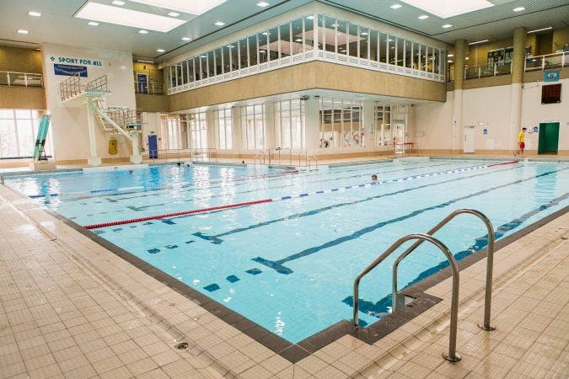

City of Peterborough Swimming Club
COPS MINI MEET GRAND PRIX SERIES 2016-2017
(Licence Number : **************- Level 3 Meet)

Saturday 28th October 2017
Saturday 25th November 2017
Saturday 24th March 2018
Saturday 28th April 2018

Under ASA Laws & Technical Rules: Affiliated to the East Region ASA

Venue: | Peterborough Regional Pool, Bishop Road, Peterborough, PE1 5BW
Pool: | 6 Lane, 25m Pool, Electronic Timing
Age Groups: | 9 – 12 years
Awards: | Top points scoring swimmer – Female & Male (accumulation of FINA points over all 4 rounds)  Top 6 boys and girls in each AGE GROUP for 9, 10, 11 and 12 years
Events: | See Programme Schedule
Qualifying Times | All swimmers must be slower than 2:30.00 for the 200m Individual Medley
Fees: | £36 which covers ALL events for all four rounds  Spectator Entry: TBC
Entries To: | Mini Meet GP, COPS Box, City Of Peterborough Swimming Club. The Regional Fitness & Swimming Centre, Bishops Road, Peterborough. PE1 5BW.
Promoter: | Mrs Nick Pratt  galas@copsclub.co.uk

Closing Date for Entries: Received by 6pm on Saturday 7th October 2017

Meet Rules and Information

Introduction and Aims of Grand Prix
- The Grand Prix series comprises four time-trials for 9-12 year olds with a points based award system.
- The aim of the Grand Prix series is to give young swimmers added incentive to attend training sessions and to provide the ideal environment to gain valuable experience of Open Meet’s on a small scale and to give the coaches an opportunity to assess the progress of their swimmers.

The Rules
- This competition will be held under ASA Laws and ASA Technical Rules of Swimming and the event is LICENCED by the ASA for entry into County and Regional Championships. All swimmers must be Cat 2 members of Swim England.
- Age as at 28th April 2018
- The events are:
50m | All 4 Strokes | All Age Groups
100m | Individual Medley | 9yrs Only
200m | Individual Medley | 10yrs to 12yrs Only
25m | Skins | 9yrs Only
50m | Skins | 10yrs to 12yrs Only

- The age groups are:

50m events | 9yrs, 10yrs, 11yrs & 12yrs
100m Individual Medley | 9yrs
200m Individual Medley | 10yrs, 11yrs & 12yrs

- All events are heat declared winner.
- Awards will be presented at the end of Round 4: Top Scoring Female & Male (accumulation of FINA points over all 4 rounds). Top 6 Boys & Girls in each AGE GROUP. Prize money of £20, £15 and £10 will be awarded to the 1st to 3rd in the 10yrs and over SKINS. Trophies will be awarded to the 1st to 3rd in the 9yrs SKINS.
- Heats will be swum with all age groups combined and swimmers seeded by entry times. All heats will be spearheaded.
- Pool length is 25m (6 lanes) and is equipped with electronic timing and anti-wave lane ropes. All events start and finish at the deep end of the pool
- Swimmers must enter all four rounds regardless of actual attendance and are expected to swim all three races in each round unless otherwise advised by their coach.
- Subsequent rounds will have entry times updated from the Grand Prix series only.
- The entry fee is £36.00, and this covers all events in all 4 rounds. All paper entries must be on the official form (photocopies accepted) and must include the entrant’s ASA Identity Number together with all entry fees. For electronic entries, please follow information which can be found in a downloadable zip file available from https://uk.teamunify.com/Home.jsp?team=ercpsc Cheques payable to City of Peterborough SC please.
- Entries will be on a first come, first served basis with the final date for receipt of entries being Saturday 7th October. Once fully subscribed, any further entries received will be rejected. The confirmation of entry will be posted on the Club’s website (https://uk.teamunify.com/Home.jsp?team=ercpsc). Please check this for accuracy and contact the promoter if any alterations need to be made.
- Competitors that do not intend to compete in an event must notify their withdrawal from the event by the commencement of warm-up for each session.
- Competitors must report to the Competitor’s Stewards when their event or heat is called. Any competitor not reporting on time for their event may be excluded from that event
- The Skins events will be swum at the end of Round 4: 10yrs and over – The fastest 6 males and female swimmers from all rounds of the 200IM (50m IM Skins). 9yrs – The fastest mixed 6 swimmers from all rounds of the 100m IM (25m IM Skins)
- Competitors will only be allowed poolside for the session in which they are competing and will only be allowed in the spectators’ area if wearing appropriate clothing and footwear.
- Free Coaches’ passes are available to coaches supporting competing swimmers. It is recommended that clubs maintain a ratio of 1:10 Coach to Swimmer
- No person will be allowed on poolside without a pass. Only competing swimmers and officials will be allowed in the area behind the starting blocks at the deep end of the pool during the event.
- Results sheets will be posted on poolside and the spectators area on the day and will be available to download from www.copsclub.co.uk after the event
- The City of Peterborough Swimming Club, Peterborough City Council or Vivacity shall not be held responsible for loss or damage to spectators’ or competitors’ property. Competitors are advised to use the lockers in the changing rooms and not to leave belongings unattended.
- For Health and Safety reasons only small rucksack bags will be allowed poolside. Lockers are available
- There will be no glass items allowed on poolside
- The promoters reserve the right to refuse admission to any competitor, participant, coach or spectator
- City of Peterborough Swimming Club uses a computer to manage entries and results. By submitting and accepting entries to the meet consent is hereby given, as required by the Data Protection Act 1998, to the holding of personal information on computer. Personal data handled such as name, club, recorded and entered times may be made public during or after the meet
- All persons wishing to use photographic equipment - including mobile phones with photographic capacity - must register at the reception desk on the balcony in accordance with ASA guidelines No photographs are permitted poolside
- Please help to maintain a high standard of health and safety by not blocking stairways, emergency exits and walkways with bags and report any issues immediately to a member of pool staff or to the Meet Promoter.
- Warm Up protocol: Strictly no diving during any warm-up session, except in the designated sprint lanes. Odd lanes will swim clockwise (1,3,5), even lanes will swim counter clockwise (2,4,6). All swimmers must leave the water by the side of the pool and not over the timing pads.
- Any matter not covered by these conditions will be determined by the Promoter and Referee, subject to ASA Laws, Regulations and the ASA Technical Rules of Racing.

Disability Swimming Conditions
The conditions outlined above shall apply to the Disability Swimming events except where varied by any of the following conditions:
- Swimmers with S1 - S15 classifications will be accepted
- All swimmers must have an internationally authorised classification
- Competitors must be registered members of the ASA
- Personal care attendants will be permitted for swimmers in all disability classes
- Competition to be run under IPC Swimming swim rules

Entries to:
FAO: Anna Rothwell
Regional Fitness and Swimming Centre
Bishops Road
Peterborough
PE1 5BW

Programme of events and running order

All rounds will take place at the Regional Pool, Peterborough using whenever possible Omega electronic timing with scoreboard display.

Registration closes at 5.30pm, late entries will not be accepted. Warm up commences at 5.30pm.
- Please arrive at least 10 minutes before the warm up. The start time is 6.00pm.

Round 1 – 28TH October 2017 |  |  | Round 2 – 25th November 2017
Girls | Boys |  | Boys | Girls
100m IM (9yrs) (Ev1) | 100 IM (9yrs) (Ev2) |  | 100m IM (9yrs) (Ev8) | 200m Free (9-10yrs) (Ev9)
50m Free (9-12) (Ev3) | 50m Fly (9-12) (Ev4) |  | 50m Free (9-12) (Ev10) | 50m Fly (9-12) (Ev11)
50m Breast (9-12) (Ev5) | 50m Back (9-12) (Ev6) |  | 50m Breast (9-12) (Ev12) | 50m Back (9-12) (Ev13)
200 IM (10-12yrs) (Ev7) | 200 IM (10-12yrs) (Ev2a) |  | 200m IM (10-12yrs) (Ev14) | 200 IM (10-12yrs) (Ev9a)
Round 3 – 24th March 2018 |  |  | Round 4 – 28th April 2018
Girls | Boys |  | Boys | Girls
100m IM (9yrs) (Ev1) | 100 IM (9 yrs) (Ev2) |  | 50m Free (9-12) (Ev10) | 50m Fly (9-12) (Ev11)
50m Free (9-12) (Ev3) | 50m Fly (9-12) (Ev4) |  | 50m Breast (9-12) (Ev12) | 50m Back (9-12) (Ev13)
50m Breast (9-12) (Ev5) | 50m Back (9-12) (Ev6) |  | 9yrs Skins event
200 IM (10-12yrs) (Ev7) | 200IM (10-12yrs) (Ev2a) |  | 10 yrs + skins event

Qualifying Times
No swimmer must be faster than 2:30.00 for 200 Individual Medley

