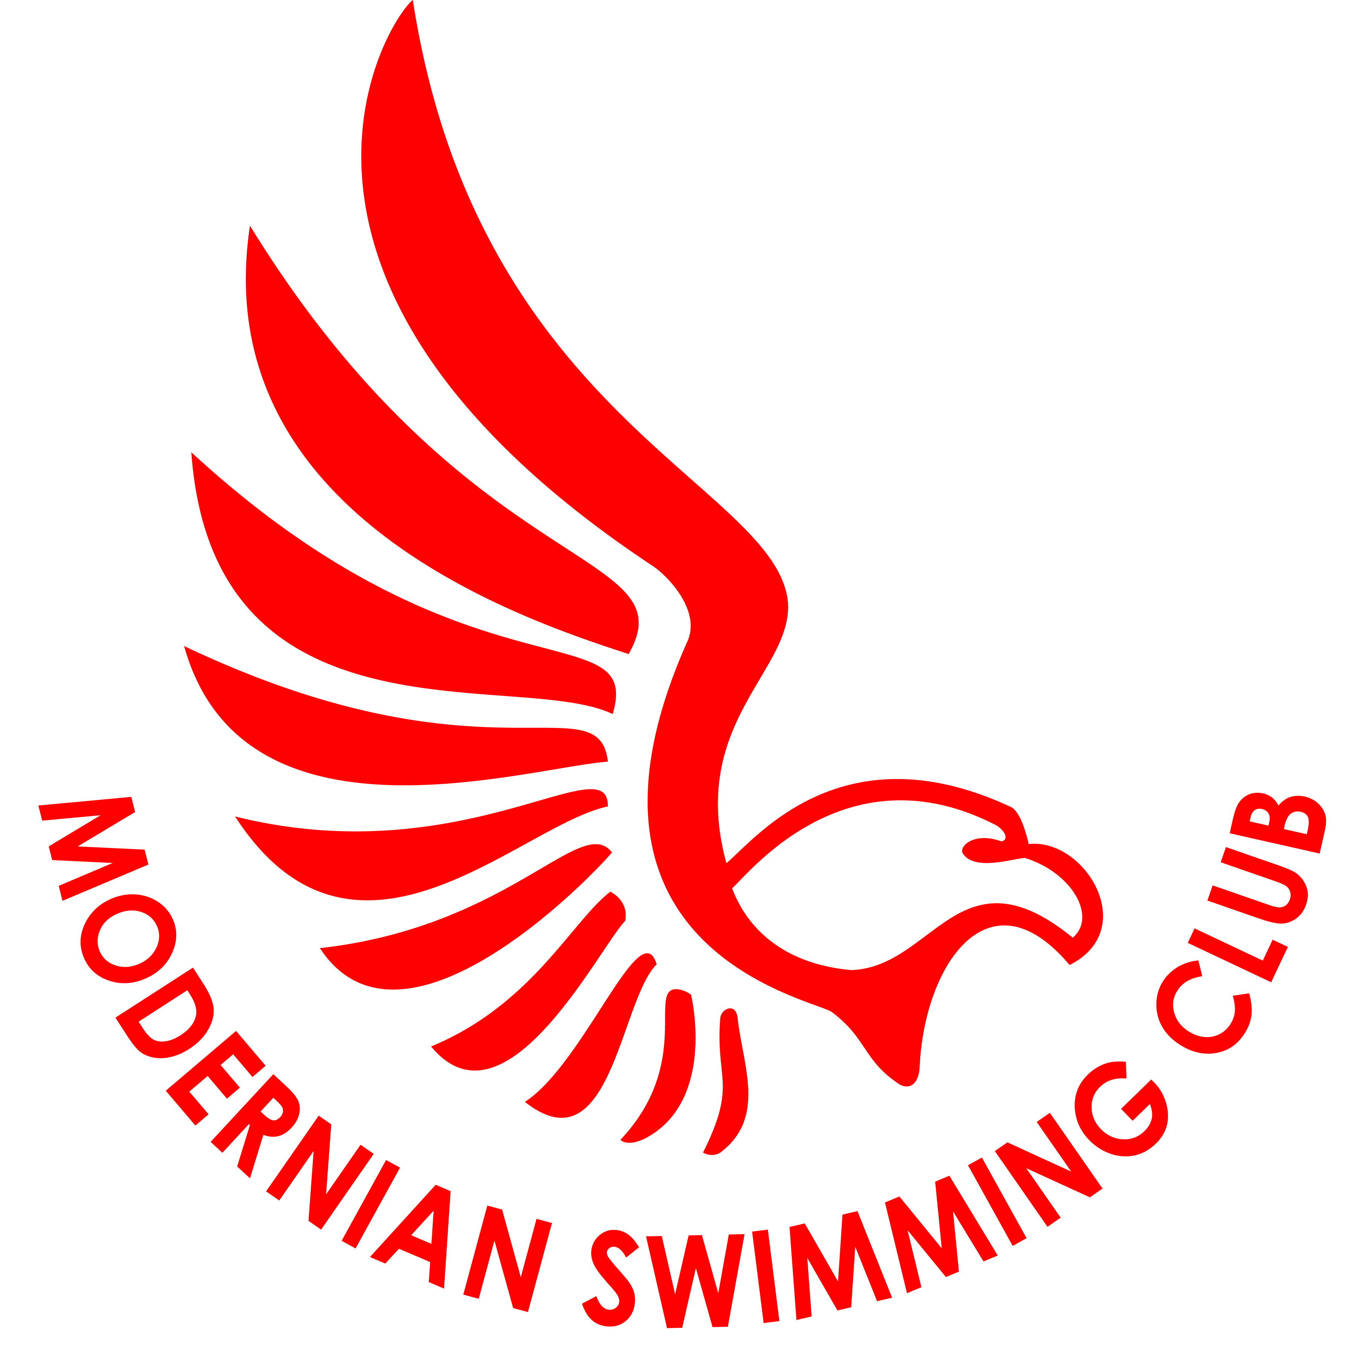 CLUB KIT ORDER FORM

Item | Description | Size | Personalisation | Quantity | Cost | Total
Hat |  | One size |  |  | £5
Round Neck Shirt | Embroidered with Club logo | Youth L, Youth XL,  Adult S, M, L, XL, XXL |  |  | £18
Polo Shirt | Embroidered with Club logo | Adult S, M, L, XL, XXL |  |  | £18
Hoodie | Embroidered with Club logo and personalised | XS, S, M, L, XL |  |  | £30
Zoodie | Embroidered with Club logo and personalised | S, M, L, XL |  |  | £34
Drawstring Bag | Embroidered with Club logo and personalised |  |  |  | £7.50
 |  |  | Special offer, discount £3, if purchasing a hoodie and t-shirt/polo shirt at the same time
 |  |  | Grand Total

Please note: Round Neck Shirts guide for sizes Youth Large is age 9/11, Youth XL is age 12/13

Please complete this order form and make payment online to:

HSBC, Sort Code 40-10-02
Account Number 20600555
Account name Modernian Swimming Club
(referenced with your swimmer’s name)

Then email the form to: kit@modernians.org.uk
Jackie Weston, Kit Coordinator

Any questions please do feel free to ask Jackie

Name of swimmer ………………………………………………… Squad …………………....

Email address ……………………………………………………. Mobile……....……………

