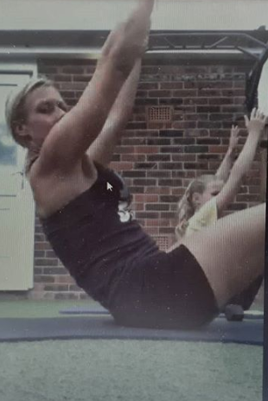

HAILSHAM SWIMMING CLUB
25 DAYS OF CHRISTMAS
SPONSORED FITNESS ACTIVITY
FUNDRAISING INITIATIVE FOR THE CLUB

Individual Sponsored Activity to Raise Funds for the Swimming Club
 | Supplement your normal training plan |  | Tick when each session is completed |  | Enjoy the Activities and Keep Fit
Complete all activities on the date for the specified amount of time indicated in the table below, reducing from 25 mins of activity on 1 December to 1 minute of activity on Christmas Day. Make sure you warm up appropriately before the start of each activity.

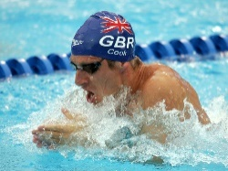
Gain sponsorship from friends, family members and others to complete all
of the activities. The individual who gains the most amount of sponsorship
for the Club will win access to Chris Cook’s on-line programme and an
individual mentoring session in the new year, together worth around £200.
Other potential prizes for sponsorship raised will be announced in due course.

Submit your personal sponsorship money to the Club’s fundraising account: Sort Code: 40-20-06 Account No. 62216116 And send your form to chairman@ailshamswimmingclub.org

Tick* | Date | Duration | Activity
□ | 1 Dec | 25mins | Non-stop run or jog
□ | 2 Dec | 24mins | Star Jumps (30 secs on, 30 secs off)
□ | 3 Dec | 23mins | 23 squats, 22 sit ups, 21 squats, 20 sit ups….all the way down to 1 (slow and controlled)
□ | 4 Dec | 22mins | Fast paced walk (recovery)
□ | 5 Dec | 21mins | 21 step ups and rest (off 60 secs) x 21 times through
□ | 6 Dec | 20mins | (20 squats, 20 lunges, 20secs rest) x 20 times through
□ | 7 Dec | 19mins | 19 squat thrusts, rest 15 secs, 18 squat thrusts, rest 15secs…..all the way down to 1 (slow and controlled)
□ | 8 Dec | 18mins | 18 tricep dips, 18 press ups (wide and controlled), 30 secs rest (repeat until 18mins is up)
□ | 9 Dec | 17 mins | 17 mins of good quality stretching and flexibility (recovery)
□ | 10 Dec | 16 mins | 16 burpees, rest for remainder of 1 min (reduce by one each minute eg. 15,14,13,12 and so on each minute)
□ | 11 Dec | 15 mins | 50m shuttle runs (alternating sprints, fast paced walk and jog)
□ | 12 Dec | 14 mins | Swimmers (on front of body, arms and legs alternating, 40 secs on, 20 secs off)
□ | 13 Dec | 13 mins | Mountain Climbers (30 secs on, 30 secs off)
□ | 14 Dec | 12 mins | 12 bear crawls, rest 10 secs, 11 bear crawls, rest 10 secs…and so on down to 1 (slow and controlled)
□ | 15 Dec | 11 mins | 11 jumping squats, 11 crunches (rest until 60 secs is up) x 11 times through
□ | 16 Dec | 10 mins | 10 walking lunges (alternate legs moving forward), rest 10 secs x 10 times through
□ | 17 Dec | 9 mins | Abdominals work out – 30 secs plank, 30 plank ups elbows to press up position, 30 secs rest (repeat for duration for 9 minutes)
□ | 18 Dec | 8 mins | Meditation and Yoga (Recovery)
□ | 19 Dec | 7 mins | 10 shoulder V Press Ups, rest 30 secs (continue for 7 minutes)
□ | 20 Dec | 6 mins | 6 minute run at fast pace (record distance)
□ | 21 Dec | 5 mins | Burpees (40 secs on, 20 secs off)
□ | 22 Dec | 4 mins | Sit Ups (50 secs on, 10 secs off)
□ | 23 Dec | 3 mins | Press Ups (50 secs on, 10 secs off)
□ | 24 Dec | 2 min | Continuous front plank
□ | 25 Dec | 1 min | Wall Sit (90 degree angle of knees sat against wall with flat back)

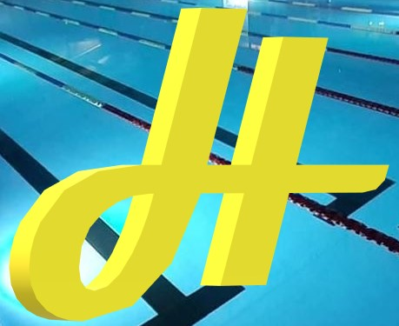

PLEASE SUBMIT THE AMOUNT OF SPONSORSHIP YOU HAVE RAISED TO THE CLUBS FUNDRIAISING ACCOUNT BEFORE SATURDAY 23 JANUARY 2021 WITH A COPY OF YOUR SPONSORSHIP FORM TO chairman@hailshamswimmingclub.org

MY PERSONAL SPONSORSHIP FORM HAILSHAM SWIMMING CLUB: 25 DAYS OF CHRISTMAS

Name |  | Total Amount of Sponsorship (£)
Group

 | Name of Sponsor | Amount Sponsored | Received: Yes/No
 | Add more rows as necessary

Once completed, collect your sponsorship and submit it to the Swimming Club’s Fundraising account (details above) before Saturday 23 January, and forward the sponsorship form to chairman@hailshamswimmignclub.org

