RETURN TO TRAINING ACTION PLAN
HAILSHAM SWIMMING CLUB
HAILSHAM SWIMMING CLUB COMMITTEE IN PARTNERSHIP WITH BEDES SENIOR SCHOOL |  | V7 07 Sep 2020

To all of our Members,
The COVID-19 pandemic has been a very challenging time for us all. We have had to deal with changing the way that we lead our lives and the inability to undertake exercise and sport that we love has been incredibly difficult. Whilst the health and safety of everyone is always paramount, I am glad that we now have the potential opportunity to return to swimming training, albeit in a completely different way for the foreseeable future.
The Club Committee has been proactive in its future planning, foreseeing changes and reacting quickly to Government and Swim England guidance to ensure that we are best placed to return to training when it is safe to do so. I would like to thank the support of the Committee and Bedes School in preparing the Return to Swim Action Plan along with its supporting documentation to ensure we can provide an effective and safe service to our Members.
CRAIG STEENHOFF
Chairman
Please read the Action Plan carefully and familiarise yourself with the new procedures and rules that are in place to protect the health and safety of all of our Members along with other members of the community who may be in close proximity to the facilities that we are using. Please understand the seriousness of the measures and that non-compliance with the rules and procedures will be seen as a breach of the Club’s Code of Conduct and will be dealt with accordingly.
I am looking forward to the Club getting back to operation. We are focused on making sure that our existing members can get back to training, but understand that this may not be the right time for you all. As such, please reply to the supporting questionnaires in relation to your capacity to come back to training, and secondly the health questionnaire. Club membership will be maintained for any swimmer that does not currently wish to return. We will not be accepting any new members to the Club initially, other than those that had already planned to join, unless there is space to do so after the initial period of review. This document forms the first phase of our Action Plan and we will not yet seek to restart our Learn to Swim Programme as there are too many risks associated with delivering that service initially, along with limitations on pool space and time. We will review this situation over time.
The type of training will be very different to begin with as the focus will be on aerobic and technique training at low intensities. Over time as the situation is monitored and Government guidance changes then we may be able to offer a different style of training environment. The Club Committee will monitor the situation in liaison with the COVID-19 Lead Officer and the Liaison officers for each training squad.
Thank you for your understanding and I look forward to seeing swimmers back at training soon.

Context
- When the government and Swimming England indicate that it is safe to return to training at indoor swimming pool facilities, the Club need to be prepared. As such the Club was proactive in commencing a plan for a potential return to training using best practice examples. The Club has now validated its approach, utilising the national governing body best practice guidance from Swim England which was published on 15 June 2020.

- The Club will need to satisfy our indoor training facility at Bedes Senior School, along with any other facility that we use, that it is safe to train. A detailed action plan on how the club can return to training in a social-distanced manner and minimise any potential interaction with Bedes students and other uses of the sports facilities and school is therefore urgently required. In considering our plans, the Club has looked at other potential training opportunities at different venues to contingency plan for the future. The same principles for all venues would apply, albeit the set up of the pool and entrance/egress of the facility will differ.
- The Action Plan has been prepared by the Hailsham Swimming Club Committee and has been subject to engagement and review with officers at Bedes Senior School. The Action Plan does not state a proposed new training timetable as there are still unknowns with regards to the timeframes for a full return to Bedes School and use of other facilities. A trial week period from Monday 3 August to Friday 7 August for morning training has been secured and will be used to implement the measures in this Action Plan. A training timetable for August 2020 using two facilities: Bedes School and Freedom Leisure Centre, Hailsham has been published, and it is hoped that we can add to this in the coming weeks, along with confirming our timetable for September 2020. The HSC Committee will authorise all decisions that are made to the training programme as part of our phased transition, seeking to add to and amend its training and session programmes over time.

[Freedom Leisure Uckfield pool added to temporary training timetable in August 2020, plus Battle Abbey Prep pool in Bexhill pool added temporary training timetable in September.]

- The following sections of the Action Plan look at different aspects of the training environment, providing rules and guidelines for accessing Bedes Senior School (and any other facility, as advised) to undertaking the training session and going home. We require the full support of our Members and their families to ensure that we can deliver our protocols and procedures effectively. The Action Plan is supported by detailed Risk Assessments for training at the Bedes Senior School facility, including other external training facilities and remote land training in a home environment. These will be able to accessed from the Club’s website.

- This document will now take you through the rules and protocols that apply to all members, including staff from arriving to leaving the training session at Bedes Senior School. The protocol for the use of other alternative training facilities will be published by the club in advance of any potential use. The alternative facilities that the Club may use in the future have been listed later in this Action Plan.

Entering Bedes Senior School Car Park and Dropping off Swimmers
- Cars will still be able to enter the Visitors Parking by the barriers for morning training, and if the barriers are up will be able to drive into the lower car park to drop swimmers off for their sessions. This will also apply to all other training sessions. Cars should drop off and park in the lowest part of the car park as indicated on the hatched area below.

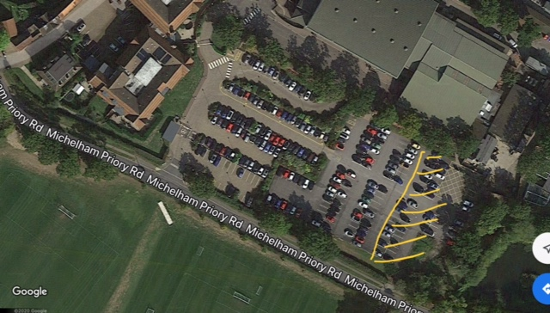

- Parents must stay in their cars and are not permitted to enter the sports complex as they are at higher risk. Parents must only drop off the swimmers and then leave the car park, only returning to pick the swimmers up after training.

- Swimmers must arrive between 10 - 15 mins before the start of each session. For all sessions, the pool will be open 30 mins before the session starts by the dedicated lead coach/teacher. Parents should then return to collect their children at least within 5 mins of the end of the session so that the children are not having to wait to be picked up.
- Designated members of the Committee along with the COVID-19 Lead Officer and Squad Liaison Officers will attend sessions on a rota basis so that they can ensure all correct protocols are adhered to. This will ensure that two additional adult members of the Committee are in attendance at all training sessions, in addition to the coaching staff and lifeguard.

Entering Bedes Pool and Getting Ready for Training
- Swimmers will enter Bedes pool via the glass doors along poolside and must not use the main reception area. There will be an entrance door by the shallow end of the pool and an exit door at the deep end of the pool and when practical all the doors will be kept open for ventilation. This procedure is in place to ensure that swimmers are separated from other users of the facility.
- Swimmers will access the pool from the car park by walking over the small bridge that is nearest the deep end of the pool, not the normal bridge that is nearest to reception. Everyone should always stick to the left hand side when travelling over the bridge and moving along the paved area outside of the swimming pool before entering the pool. Swimmers may enter the swimming pool through the shallow end door when it is open and instructed to do so by coaching staff. Gathering outside should be minimised and as such it is essential that swimmers stay in their cars until the doors are open and it is safe to enter the pool.
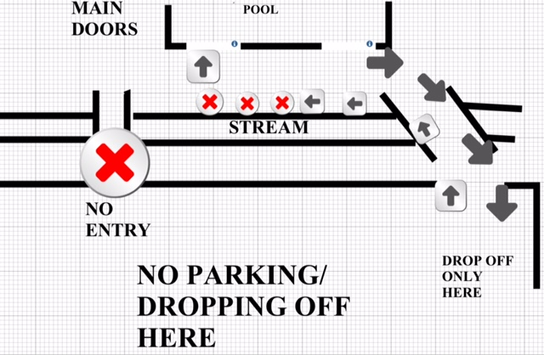
- Swimmers must enter the facility at least 2m apart in distance from others and must ensure that this distance from others is maintained throughout their training session. This does not apply to swimmers who are from the same household group e.g. brothers, sisters and parents (if masters swimmers). All swimmers who enter the complex will have a non-contact thermometer reading before they are allowed to enter the pool area which is used in line with the video demo that can be found here.

- Swimmers must come to training with their swimwear under their clothes so they are ready to swim. They must bring their own equipment in their training bag and if possible ensure hand sanitiser is used before entering the pool area. Swimmers will enter the pool and proceed in a clockwise direction to the spectator area where they will place all their personal items on marked spots already in place. There will be enough of these provided to cover the maximum number of swimmers attending. Swimmers will then take their training equipment with them to the poolside where they will undertake their stretching and mobilising warm up at least 5 mins prior to the start of the session, in their own space at least 2m apart from others.
- The lead coach will call swimmers up by group and name in a staggered way and swimmers should go to their allocated lanes, place their equipment on the side and then immediately enter the water.

- The dedicated lead coach for the session will take a register of all the swimmers and provide this in written form to Bedes Pool so they have a register in place in case there is an emergency and evacuation.
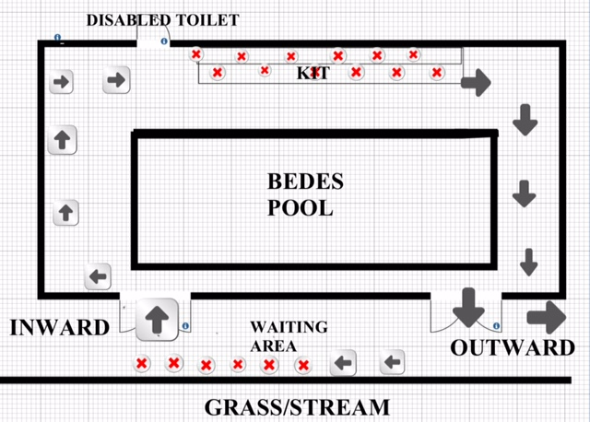

Arrangements for Other Facilities
- Whilst this Action Plan focuses on the facility at Bedes Senior School there will be separate arrangements in order to access other facilities and these will be communicated to Members separately. With effect from Saturday 8th August the Club added Freedom Leisure Uckfield to its available temporary training facilities, in addition to Bedes Senior School and Freedom Leisure Hailsham. Following commencement of evening training sessions at both Freedom Leisure Uckfield and Freedom Leisure Hailsham, it was agreed by the Club Committee following the recommendations of the Covid Lead Officer, that egress arrangements at both Freedom Leisure Uckfield and Freedom Leisure Hailsham should be revised to ensure the continued safety of the swimmers. With effect from Thursday 13 August (all members were advised on Wednesday 12 August) all swimmers will continue to egress via the appropriate fire exit under the supervision of a Covid Liaison Officer. Parents/Guardians should then collect their swimmer from outside the fire exit and return to their vehicle within the car park. All Parents/Guardians are reminded that they should maintain social distancing whilst on site, as this is a key requirement of our use of the facilities.

- With effect from Sunday 6 September, the Club added Battle Abbey Prep School pool in Bexhill to its available temporary training facilities. The detailed procedures and protocols for using the pool are set out in a separate document on the Club website.

- Access arrangements for both Freedom Leisure Hailsham and Freedom Leisure Uckfield remain unchanged, ie parents/guardians drop off swimmers in the car park and remain in their cars. Swimmers then queue outside (whilst socially distancing) the appropriate fire exit to the pool area, whilst supervised by a Covid Liaison Officer, before having their temperatures checked using a non-contact thermometer. If their temperature is normal then they will be asked to sanitise their hands before entering the pool area. A second Covid Liaison Officer will be inside the pool area to ensure they safely make their way to the changing area, before they are then called to their lane by a coach.

- All staff and Covid Liaison Officers will continue to have their temperatures checked using a non-contact thermometer and will sanitise their hands before entering the pool area. Only staff and Covid Liaison Officers will enter the facilities in the normal way via reception. This is to ensure that they sign in and can provide their full details for the facility’s track and trace procedures.

The Proposed Swimming Groups and Sessions
- It is not possible for training to resume in the same way as before. The Swimming Club are following Swim England guidance by planning to deliver sessions using a single lane layout (amended after Swim England provided new guidance on 20 July 2020), with six training lanes (at Bedes Senior School Pool) all swimming in a clockwise direction, with a maximum of 5 swimmers in each lane (30 swimmers in total). For other facilities we will be able to operate with up to 6 swimmers in each single lane. It will normally be the case that based on current group sizes that between 4-6 swimmers will be in each lane (subject to attendance levels). Swimmers in alternate lanes will start from the opposite sides of the pool. The layout of the training lanes is shown in the following diagram.
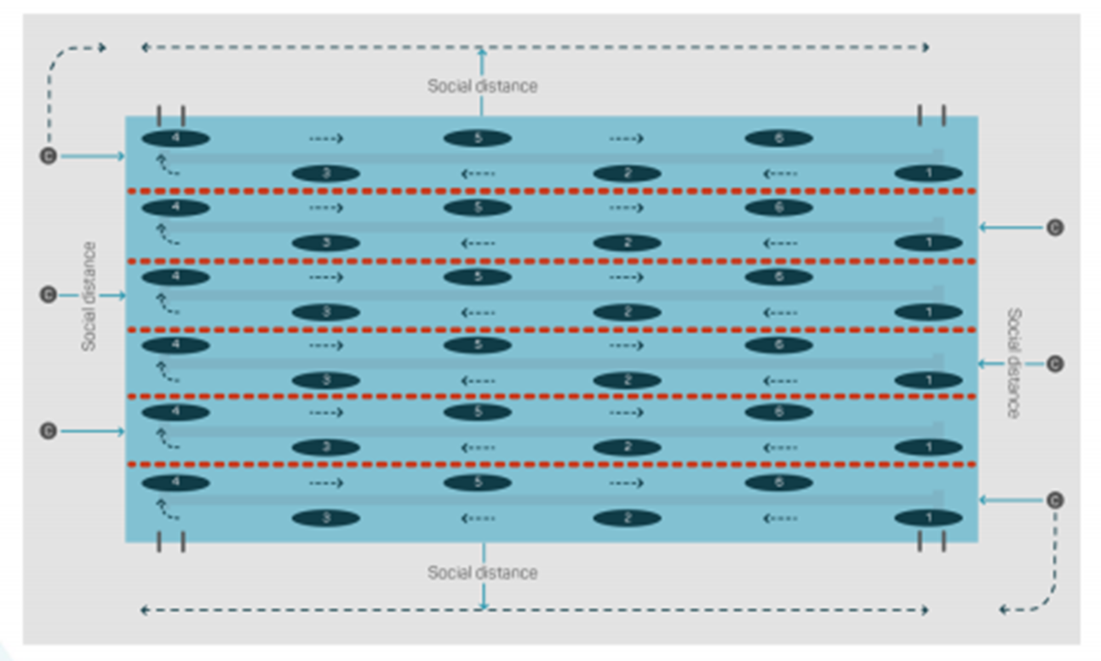
- Training sessions will be devised by the coaching teams that minimise the risk of breathing in close proximity to other swimmers, and initially sets will be at low intensity as advised by Swim England. Coaches will operate moving in a clockwise direction around the pool, always at least 2m away from swimmers.

- The swimming Club intend to deliver a phased increase and change to its programme, reviewed on a monthly basis as the national position and guidance changes. Restrictions to the number of swimmers in each lane will apply in line with Swim England guidance, a considerable reduction from previous bathing loads), and a maximum of 6 staff (including COVID officers).

- A maximum of 2 COVID-Liaison Officers will be in attendance at all sessions and they will be responsible for monitoring the procedures put in place through this Action Plan and Risk Assessments. They will wear a face mask and will be responsible for taking the temperature of swimmers and ensuring hands are sanitised on entry.

- It will be important for our members to indicate their intention to return to training based on the Club’s Return to Training Plans. If the position changes over time then members should alert our Membership secretary as soon as possible so we can plan our training sessions accordingly.
- The Club will use the responses of the members intentions to return to training to allocate swimmers to the swimming sessions for this week, whilst at the same time supplement this with additional training sessions elsewhere. These will be announced as soon as possible once they are agreed by the HSC Committee.

- In the use of Bedes Senior School it is important to minimise times when students and other users will be around the facility and as such helps to minimise risk.

The Training Sessions

- There will a minimum of two teaching/coaching staff in attendance for each session. When at the Bedes facility one of these coaches must be a Bedes member of staff in order that they are aware of the Bedes operational procedures in case of an emergency. The Club has three members of staff that are also employed directly by Bedes Senior School.

- Any proposed timetable will seek to minimise the instances of cross over between groups at Bedes School Pool, but on some days this will be inevitable because of the length of sessions. As such, any proposed timetable will allow for a 15 minute break between sessions. No swimmer will be allowed into the facility until all swimmers from the previous group have left and during this cross over period there will be opportunity for the coaching staff and lifeguard to rinse down the poolside with pool water as well as rinsing the disabled toilet. When it is clear and safe for swimmers to come into the next session then a member of coaching staff will identify this with a sign at through the poolside door. At other external facilities such as Freedom Leisure Centre in Hailsham, cross over between groups will be managed effectively by staff and as such sessions can run consecutively.
- All people at the facility should always move in a clockwise direction to avoid any unnecessary cross over of swimmers. Swimmers should use vacant space in the raised spectator area for their bags and should start warming up poolside before the start of the session. Any mobilising or warming up that can be done at home, if travelling short distances is preferable to minimse the time needed poolside. There should be no need for crossover as swimmers will always travel in a clockwise direction around poolside, including going to the toilet, picking up bags and drying themselves off. This may not always be possible at every venue that the club uses because of the position of lifeguards, and in these instances social distancing measures will be maintained.
- As stated previously, the maximum number of swimmers in any one single lane at Bedes Pool will be 5, and as such a maximum of 30 users will be able to use the pool at any time. At other pools a maximum of 6 swimmers will be in one single lane (of a 25m pool) will be allowed. For longer pools, such as 50m pools, the capacity in a lane can be increased.
- At Bedes Pool swimmers will only be able to use the disabled toilet which can be accessed poolside from the shallow end of the pool. The toilet facilities will contain hand sanitising gel, handwash and anti-bacterial wipes. After each use, hands should be washed and the toilet seat should be cleaned with anti-bacterial wipes. Any other parts of the toilet that are touched (including the door handle and lock), should be cleaned with anti-bacterial wipes after each use. The toilet floor will be rinsed down by HSC staff after each session and between sessions. At other external facilities, the toilets will be available, with social distancing being maintained at all times.
- Swimmers will not be able to use the changing rooms to get changed as they will be locked. The changing rooms pose a risk to general safety as they are too small for social distancing measures to be maintained. Swimmers should towel themselves off after the training session and then put on clothes on top of swimwear and then get properly showered and changed at home. At all times in communal space social distancing should be maintained. To allow this to happen, the completion of the training session will be slightly staggered, ensuring smaller groups of people are drying themselves off at a time.
- Swimmers should leave the premises in the same manner as they entered following a clockwise direction through the marked exit via the glass doors at the deep end of the pool. They must maintain social distancing at all times and must go straight to their parents or their car for travelling home and not congregate in groups within the car park.
Land Training and Alternative Facilities
- Land training programmes and other outdoor sporting/leisure activities should be undertaken by all swimmers as advised for each group. Natalie Weston and Craig Steenhoff will continue to provide this service in the short term for to the Club on a voluntary basis and will update the programme monthly. Other qualified staff can take on this responsibility we return to training. The timetable indicates the advisable amount of time that each group should undertake land training and other fitness activities each month. A monthly fitness plan will be provided in order to supplement the swimming training that is appropriate for each group.
- The Club has requested additional training opportunities from other facilities in order to contingency plan for the future and extend our training offer during social distancing measures. This will help the club plan for its phased return to training. Some additional sessions therefore may be planned, or may become regular parts of the training programme at the following facilities:
- Freedom Leisure Swimming Pool, Hailsham
- Freedom Leisure Swimming Pool, Uckfield
- Battle Abbey Prep School Pool, Bexhill
- Previously used swimming pools in Eastbourne
Swimmers Conduct During Sessions and the Training Environment
- Swimmers will take their instruction from their coach from the water, with the coach on poolside at a greater distance than 2m away from the swimmers. Sets will continue to be written on the main white boards.
- When waiting for a set to be explained whilst they are in the water, they should maintain an appropriate spacing in the deep end of the pool.

- All swimming coaches and HSC staff (apart from lifeguards) coach will never get nearer than 2m from any swimmer. A lifeguard will be provided for evening training sessions, whereas for the morning sessions, the coaching staff will be lifeguard trained.

- Coaching staff will continue to take the registers on Team Unify along with completing a paper register for Bedes School Purposes.

- All swimmers must follow these updated rules and procedures in line with their Code of Conduct. Any inadvertent breaches, whilst swimmers are coming to terms with the new rules, will be brought to their attention and reminders given. However repeated and deliberate breaches will be taken extremely seriously, initially resulting in any such swimmer being asked to cease training immediately and leaving the pool immediately to await collection by their parent or, if the breach/es are considered severe enough action may be taken in line with Section 6 of the HSC Constitution which may result in expulsion from the Club.

- Swimmers and parents must accept that the training environment will be very different and that equipment, including water bottles cannot be shared between swimmers. Swimmers must therefore have their own equipment. If any swimmer does not have or is not able to purchase their own equipment then it can be agreed with swimming coaches for a set of equipment to be temporarily borrowed from the Club, taken away by swimmers and looked after in the same way as if the equipment was their own. All such equipment must be logged on a sheet by the issuing coach and signed for by the swimmer/or their parent if deemed too young to take responsibility for the items. At the end of the loan period, items should be checked back in and any losses/damage should be reported and if necessary the cost of replacement recouped from the swimmer’s parent/s. It is recommended that all equipment is submerged in the pool water after each session in order to sanitise the equipment in chlorinated water.

- By no means can swimming hats, goggles or noseclips be shared or borrowed by any swimmer. You must ensure that swimmers turn up with their own goggles and a spare pair in case their goggles break as under no circumstances can these be borrowed and the swimmer would then have to swim without.

- Swimmers must maintain good spacing in the lanes and make every effort not to touch other swimmers. This will mean that swimmers must be more alert than normal as to the position of other swimmers in the lane and stop within an appropriate distance from the end of a length to let swimmers past who may need to overtake.

- Swimmers will not be allowed to get out of the pool during the training session except under the following circumstances:
- If an emergency occurs and they are instructed to clear the pool, in which case they should follow the procedure as outlined in the HSC document “In case of Emergency/Evacuation” issued to all new members and their parents;
- If they are in desperate need for the toilet;
- If they are instructed to do so for dive starts or dive practice sets (e.g walkbacks) at which time they should follow the direction of movement already outlined (previous section) and maintain a 2m distance between themselves and other swimmers; or
- If they have been instructed to do so following a repeated breach of the rules despite reminders being given.
- If a swimmer has to finish the set early for any reason eg. because of illness or being picked up early (with previous agreement by the coach) or as a result of a breach of rules then a swimmer must leave the pool, get dried poolside and put clothes on over their swimwear and wait poolside for parents to arrive in the car park before they can leave.
The responsibilities of Swimmers, their Parents and Coaches
- It is the responsibility of swimmers and their parents to ensure that the health survey on Team Unify is filled in correctly and updated on a daily basis if there is any change in circumstances. Bedes School also require a specific COVID -screening assessment which must be filled in and returned on-line via Team Unify prior to every training session at Bedes School. This screening assessment can be found at Appendix A.
- It is the responsibility of swimmers and their parents to clean and disinfectant all of their equipment after each session ensuring it is clean and hygienic for the next session.
- It is the responsibility of coaches, teaching staff and any attending Committee member(s) to ensure that equipment is not shared.
- It is the responsibility of swimmers to be aware of the position of other swimmers in the pool and maintain social distancing as much as possible, even within the training lane. Please be aware of coaching and teaching staff signalling if you are in close proximity to another swimmer.
- It is the responsibility of parents to ensure that swimmers arrive at the correct time and are picked up at the right time after training.
- It is the responsibility of swimmers and their parents to ensure that swimmers have adequate water/liquid for the session as they will not be able to fill water bottles.
- Whilst on Bedes Senior School premises (and any other facility that the club uses) swimmers and (in exceptional circumstances) their parents must always adhere to social distancing rules and as such it is advised that parents do not leave their cars to speak to other parents during drop-off and pick-up. This protects themselves and others from the risk of infection. If parents need to speak to a coach regarding their swimmer or have an issue which they feel needs to be dealt with by the committee, then they should send an email to the Membership Secretary who will pass the message on to the correct person who will get in touch with the parent at the first opportunity.
Self Isolation if you have Coronavirus Symptoms
- If any swimmer or member of coaching staff has Coronavirus symptoms then they must not attend swimming training the most important symptoms of coronavirus (COVID-19) are recent onset of a new continuous cough, a high temperature, or a loss of, or change in, normal sense of taste or smell (anosmia) of the coronavirus, then they must following the government and NHS guidance and isolate for a minimum of 10 days (amended as of 30 July 2020) or until the symptoms subside. If a family/household member has symptoms then a swimmer must self isolate for a minimum of 14 days or until any symptoms they may have subside. There will be no exception for any swimmer or member of staff and if it is found out that this guidance has not been followed, there will be relevant sanctions. If a swimmer or member of staff has been diagnosed with COVID-19 then the Club will use a track and trace system to notify all potentially affected individuals.
First Aid Procedures
- A coach will be qualified in First Aid for the morning sessions and a lifeguard will be on duty for the evening sessions. They will maintain their position in the lifeguard chair.
- For a lifeguard to provide first aid effectively whilst mitigating the risk from COVID-19, the following should be followed:
Continue to:
- Use disposable gloves for all first aid treatment
- Ensure first aid equipment is fit for purpose and is in date
- Maintain good hygiene practices and those providing first aid should cover any open wounds.
In addition, during this period:
- Encourage self-treatment where appropriate, to help maintain current distancing guidance.
- PPE should be worn by anyone providing first aid and if possible and appropriate, casualties may also be encouraged to wear a face mask.
- Educate all users to minimise contact with their face at all times.
- Dispose of PPE and soiled dressing etc. safely in a biohazard bin
- Following treatment, swimming teachers should wash their hands and any of their bare skin and clean the area with disinfectant.
- Report to COVID-19 Lead Officer if you develop COVID-19 symptoms after providing direct first aid.
- In summary, the normal First Aid procedures would apply but PPE equipment should be used if there is need to be within 2m of the affected person/swimmer. Face masks should be removed if needing to give mouth to mouth resuscitation. Cardiac arrest in children is more likely to be caused by a respiratory problem (asphyxial arrest), therefore chest compressions alone are unlikely to be effective.
- If a decision is made to perform mouth-to-mouth ventilation in asphyxial arrest, a lifeguard should use a resuscitation face shield where available. Should a lifeguard have given mouth-to-mouth ventilation there are no additional actions to be taken other than to monitor themselves for symptoms of possible COVID-19 over the following 14 days. Should a lifeguard develop such symptoms they should follow the advice on what to do on the NHS website.
- In these instances, ensuring the overall quality of life of the person being treated is paramount, above and beyond social distancing measures and PPE equipment.
- The lifeguard should clean the lifeguard chair once they have finished the session and dispose of any issued and face masks and gloves.
- All HSC staff that are lifeguard trained will attend training sessions prior to the reopening of the swimming pool facility. These will be undertaken in July and will be organised by Bedes Senior School. This will ensure that the latest guidance on COVID-19 in relation to lifeguard principles and protocols is being adhered to.
- HSC will purchase a supply of face masks and disposable gloves in order that PPE can be used when assisting someone in need.

Testing of Chemical Levels of the Water and Maintaining Bedes Swimming Pool
- For the morning sessions, the lead coach is responsible for testing the water and ensuring the chlorine levels are at the required level in line with COVID-19 national guidance. This will be a Bedes Senior School member of staff. For the evening sessions, a HSC and Bedes’ member of staff is responsible for testing the water and ensuring the chlorine levels are at the required level in line with COVID-19 national guidance:
The guidelines are as follows: PH 7.0, and Free Chlorine Level at a minimum of 1.5mg/L and a maximum of 5mg/L.
- If there are any issues with the chemical levels, then these are reported straight away to the Bedes Estate Management team and the Sports Centre Manager.
- The Bedes Senior School Estates and Maintenance staff are responsible for the overall management of the chemical levels within the pool, reporting to the club of any issues and responding quickly to any dropping or elevated levels in the pool chemicals.

- HSC teaching and coaching staff, will be responsible for ensuing the poolside area is thoroughly rinsed and hosed down after each session concludes and between sessions. This includes the disabled toilet. No chemicals will be used.

Risk Assessment
- HSC have updated its Risk Assessments to reflect the measures that are to be implemented and the risks associated with them. This is an incredibly detailed set of documents that is legally required and these will be published on the Club’s website.
- The updated Risk Assessments (RA) include:
- Swimming training at Bedes School Pool
- Swimming training at Freedom Leisure Pool, Hailsham
- Swimming training at Freedom Leisure Centre, Uckfield
- Swimming training at Battle Abbey Prep School, Bexhill
- Swimming training at outdoor training facilities
- Swimming training at other indoor training facility
- First Aid for the Club
- Learn to Swim Swimming Lessons
- Land training (outdoor and indoor facilities)
- Please note that if swimmers take part in any individual or group open water swimming activities, they do so at their own risk. The Club will not organise any such activities as it does not have qualified open water coaches to undertake such sessions, and as such will not be insured, as advised by Swim England. The Club asks our Members to consult the Swim England guidance on open water swimming and the current restrictions by government on the ability to undertake this in small groups of up to 6 people.
Review and Monitoring
- The Club commit to a fortnightly review of the success of the measures outlined in this Action Plan along with responding to the changing national guidelines by Government and the resulting guidance from Swim England. The designated COVID-19 Lead Officer and the Liaison Officers for each of the training squads will review the success of the measures, with the Liaison Officers reporting back more frequently on a weekly base to the COVID-19 Lead Officer, and in turn the Committee to address any issues as they are raised.
- The Club reserve the right to make quick and important changes to its training timetable to respond to any required changes and may have to cancel or amend the training programme at short notice, including the potential for alternative training venues for a short or extended period.
- The Club Committee, although it meets regularly on a monthly basis, may need to meet more frequently and as such multiple remote Committee meetings may need to be held each month. In the lead up to the return to training implementation fortnightly meetings have been held.
- All decisions will be discussed and authorised at the Hailsham Swimming Club Committee and minutes will be recorded as normal.

Appendix A - Hailsham Swimming Club - Required Bede’s COVID-19 Questions
Swimmer Name | PLEASE NOTE THIS FORM WITH  NOW BE FILLED IN IN VIA TEAM UNIFY AS PART  OF THE GENERAL HEALTH SCREENING SURVEY
Age
Swim Group
Emergency Name and Contact No:
Please delete where applicable…
1. Have you visited any countries covered in the FCO COVID-19 guidance to travellers (either Category 1 or Category 2)? |  | Yes | No
2. In the last 15 days, have you had contact with someone who has visited areas affected by the coronavirus and had symptoms such as cough and / or fever? |  | Yes | No
3. Have you had any of the following symptoms in the past 15 days? -
- Temperature rise above 37.2 degrees |  | Yes | No
- Cough |  | Yes | No
- Breathlessness |  | Yes | No
- Worsening of general physical conditions |  | Yes | No
4. Have you or an immediate family member come in close contact with a confirmed case of the coronavirus in the last 14 days? |  | Yes | No
5. I understand there is no onsite, specific first aid cover from a nurse. First aid will be provided by the relevant sports coach. |  | Yes | No
6. I give permission for my child to be physically touched in order for staff to treat a first aid incident |  | Yes | No
7. I understand the precautions put in place by and accept any risk is solely mine as the parent/guardian |  | Yes | No
8. I confirm that I (or anyone coming onsite) am not in the shielded category |  | Yes | No
9. I understand my agreement is directly with Hailsham Swimming Club and Bede’s school accept no liability |  | Yes | No
Signature (can accept being sent by email)
Date
Thank you very much for completing this form and supporting our work to protect our school community

