HAILSHAM SWIMMING CLUB
POOL LAYOUT FOR UCKFIELD LEISURE CENTRE

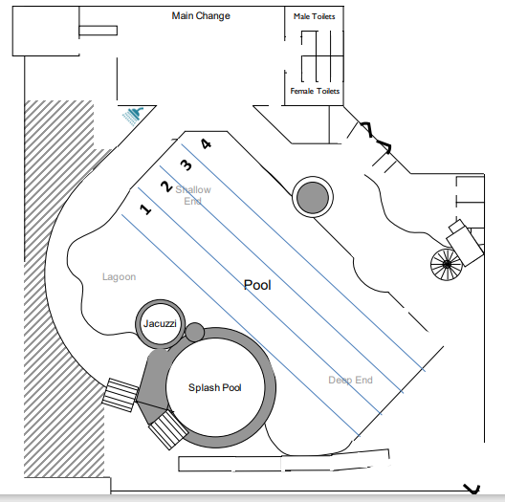
Starting/Finishing End
Benches
Exit
Entrance

