Laois Marlins Covid Return to Water Operating Plan
Information for Members
The aims of our Covid-19 Operational Procedures are:
- to reduce the risk of transmission of Covid-19
- to protect the health and well-being of all athletes and coaches in our club

COVID 19 Officers
In advance of returning to training our club has appointed Bridget Moore as Lead COVID-19 Officer.
- A COVID-19 Officers has to be on deck for every training session.
- The club has merged the Pool Side Duty role and the Covid Officer roles.
- All parents/guardians will need to complete the Swim Ireland elearning module before their swimmer can return. It can be found here https://covid.swimireland.ie/#/
- It is a condition of membership that every swimmer has a parent/guardian available to be rostered to cover their poolside responsibilities. Rosters will be available in advance of each month.
- If you cannot cover the allocated session, it is your responsibility to arrange alternative cover and to inform the Lead COVID officer of any change. It there isn’t a parent on duty the coach will have to cancel the session.
- Bridget, the Lead COVID Officer is contactable on 086 8048662.
Education
All Laois Marlins Parents/guardians have to complete the Swim Ireland COVID-19 training and meet the requirements as set down by Swim Ireland. Coaches, committee, and COVID-19 officers have completed a risk assessment and walk through of the facility prior to returning to training.
Coaches are required to complete a Self-Declaration form in advance of returning to training and self-report screening forms in advance of each session to ensure that they are feeling well before coming to training.
Return to Training Declaration
All Athletes are required to complete and submit their Return to Training Declaration. This was included in the membership form.
Self-Screening Form for Athletes
- In advance of each training session athletes must complete and submit their self-screening form to confirm you are fit and well for training.
- We are using Jotform to record this information. You can save this link https://form.jotform.com/202624690173352 or a button to this form is now on the front page of our website www.laoismarlins.ie.

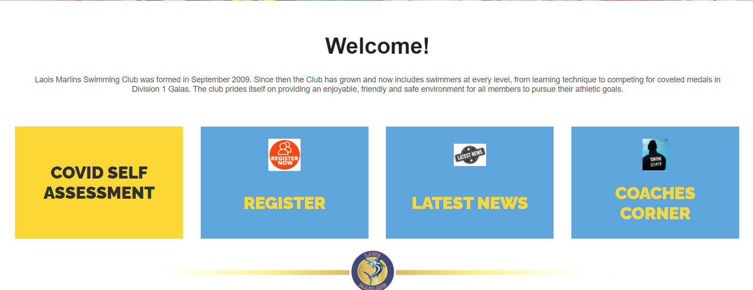

- This form can only be filled in the day before for each session. It must be completed by 8pm the evening before the training session.
- If you answer YES to any question on the form you should not attend training and should notify Bridget Moore.
- If you become unwell after submitting the form you should not attend training and should notify Bridget Moore.

Entry and exit to/ from the Facility
- Athletes should only come to training if they are feeling well
- Arrive no earlier than 10mins before the agreed time. There is no waiting area in either location.
- Please note that latecomers will not be permitted
- Athletes should be dropped to the facility and parents/ carers should remain in the car park.
- In the interest of social distancing & minimisation of person to person contact, no parents/ carers are permitted into the facility.
- Athletes should wear masks when arriving and departing from the pool.
- Athletes should use hand sanitizer upon entry to the building.
- Athletes should go straight to the deck of the pool using the one way system implemented by the centre.
- Athletes should check in with the COVID officer on duty who will verify that self-screening form has been returned.
- If a self-screening form hasn’t been completed the athlete will not be able to attend the session.
- Athletes then make their way to their assigned changing spot on deck. This will be allocated to each swimmer at their first training session and should be followed for every session.
- Athletes to arrive ready for training. Swimwear should be put out before leaving home.
- Athletes will be assigned a lane and this becomes their pod. Swimmers will stay in that pod for every training session regardless of location.
- Athletes must bring their own water bottle(s), which should be filled in advance.
- Athletes must bring their own equipment; no sharing of equipment is permitted.
- Use of changing rooms is permitted for changing only. Showers are only permitted for rinse down. No shampoo or shower gel is allowed.
- In Portarlington LC a one way system is in place in the changing village.
- Athletes should be collected promptly from the facility at the end of the training session. There is no facility for athletes to wait in the centre.
- Changing room protocol for Portarlington Leisure Centre
  - Athletes enter the changing village where they will be instructed to place their bag in a locker provided in front of the showering area and have a quick rinse down (no shampoo, conditioner, body shower gel allowed) before following the one way system to their numbered cubicle.
  - Once the first five swimmers have exited the shower area, then the next five swimmers can get their bags and have a quick rinse down and move to the next available block of changing rooms.
  - Once dressed athletes are to leave the changing village promptly. They are not allow to congregate in reception and need to leave the centre immediately.
- Changing protocol in Midlands Park Hotel.
  - There are no shower facilities available in the Midlands Park. Athletes will leave the pool lane by lane and go the relevant male/female changing room.
  - The changing rooms are communal and athletes are requested to maintain social distancing at all time.
  - Once dressed athletes leave through the changing room door and leave the building immediately. Athletes cannot congregate in the reception area and need to leave the centre immediately.
- Parents/guardians need to collect athletes promptly from all swimming sessions.

Hand Hygiene
- Hand sanitiser available on entry and exist of both centres
- Athletes to sanitise their hands:
- on entry/exit from the facility,
- after using the toilet.
- after coughing or sneezing

Respiratory Hygiene and Cough Etiquette
Respiratory hygiene is vital to prevent the spread of respiratory infections such as influenza, colds etc. The following measures to contain respiratory secretions will be promoted in the club:
- Covering nose/mouth using disposable tissues when coughing, or sneezing
- Disposing of tissue in the nearest bin after use.
- Performing hand hygiene after coughing or sneezing.
- Keeping hands away from the mouth & mucous membranes of the eyes and nose.
This is one of the most important measures that can be followed as Covid-19 is transmitted through the mucosa - mouth, nose, and eyes. Viral droplets do not pass through the skin so keeping hands away from the face is vital in preventing transmission.

Social Distancing and Club Operation
Social distancing is recommended to reduce the potential spread of infection. We have considered the layout of our pool/ lanes for training sessions.
In line with the guidance of Swim Ireland, we have put the following measures in place:
- There will be 5 athletes per lane/ in pool at any one time
- Each athlete will be designated a home point, from which they will start and finish. We will rotate the home point frequently to ensure fairness to all.
- Athletes will need to follow the coach’s instructions for entry to and exit from pool
- Each athlete will be given a designated space to place their water bottle and equipment
- Toilet facilities – only one athlete permitted to use toilet at any one time
- See Swim Ireland Pool Layout diagrams
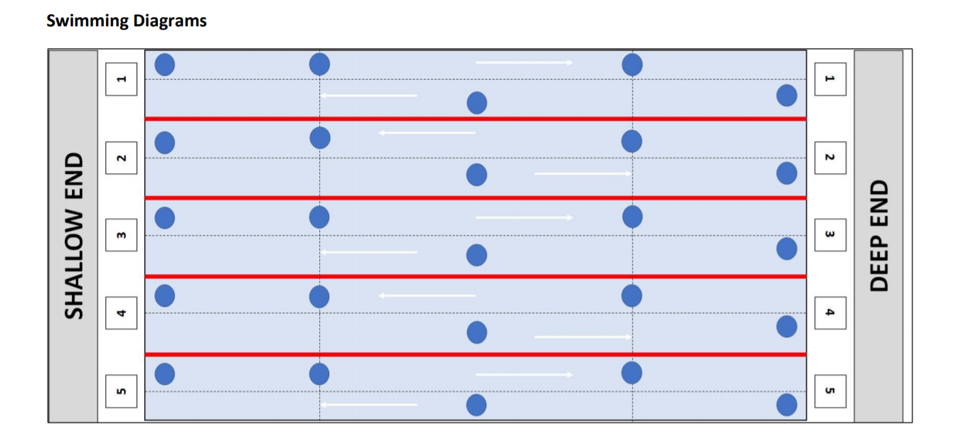

Contact Tracing
Attendance register will be taken & contact details established to ensure adequate details available for contact tracing if required.
Contact details will include:
Athletes – for each session they attend & times they are in the facility.
Coaches – for each session they coach & times they are in the facility.
Suspected case of COVID-19 and designated isolation area
In the event of a suspected case of Covid-19, the club is required to provide a designated isolation area and have a Suspected Covid-19 procedure in place. The designated area is The room next to the viewing gallery in Portarlington Leisure Centre and the disabled toilet in The Midlands Park Hotel.
The designated isolation area is equipped with the following:
- Face masks
- Hand sanitiser
- Tissues
- Disposal gloves & aprons
- Waste disposal facilities

Suspected Covid-19 Procedure
The COVID-19 Officer on duty will:
- Direct the individual to the Isolation area.
- Supplies individual with a face mask.
- Contact the next of parent/ carer to advise and arrange collection from the facility.
- Complete Swim Ireland Covid-19 Suspected Case Form.
Cleaning
(outline the steps taken by the facility and club to maintain and clean and sanitised training space)

