Laois Marlins Swimming Club

Club Handbook 2018/19
www.laoismarlins.ie

WELCOME
As another swim season kicks off we’d like to welcome back all our swimmers and parents. A very special welcome goes out to our new swimmers and also to our junior swimmers that are moving up to the senior squad.
Now in its 9th year the club has grown steadily and we now have members at all levels of swimming; from beginner to national competitor.
The club prides itself on providing an enjoyable, friendly and safe environment for all members to pursue their athletic goals.
The club provides an opportunity for anyone interested in competitive swimming to receive professional coaching and instruction. Our highly qualified, motivated and motivating coaching team work with the swimmers to encourage and enable them to reach their individual potential in this very demanding but rewarding sport.
The club is affiliated to Swim Ireland, the national governing body of all aquatic disciplines in Ireland and comply with all standards that lead to the safe and harmonious participation in our sport.
The club depends largely on volunteerism in the day to day running of the club. This takes many forms from the organising committee to poolside rotas, gala management and fundraising. We are always looking for volunteers and new ideas to develop the club and enhance our swimmers.
Wishing all our swimmers and their families a successful swimming season.
Rose Bergin
Chair

2018/19 CLUB COMMITTEE
We are delighted to have a full and dedicated committee for the 18/19 season. The committee can be contacted in person, on email or by calling 085 1833616.
CHAIR - Rose Bergin, E: chair@laoismarlins.ie
SECRETARY - Anna Hayes E: secretary@laoismarlins.ie
TREASURER - Judith O’Connor E: treasurer@laoismarlins.ie
CPO- Rufina Colley, E: childprotection@laoismarlins.ie
PUBLIC RELATIONS OFFICER - Roma Burke E: pro@laoismarlins.ie
MEMBERSHIP SECRETARY: Bridget Moore
TRAINING & VOLUNTEER COORDINATOR: Brenda Murphy
EDUCATION OFFICER: Rafal Kalich
GALA SECRETARY - Ross Moore E: galas@laoismarlins.ie

WHAT DOES IT MEAN TO BE A LAOIS MARLIN?
The aim of the club is for our members to enjoy training hard and become competitive swimmers within a positive and encouraging environment. We understand that sport can be hard work and requires discipline to achieve your goals. Your commitment and attendance levels will determine what you will achieve from swimming.

Regardless of what level you swim at you have the opportunity to train properly during every session.

Swimmers are divided into training lanes based on speed, stamina and ability. This ensures that every swimmer gets the opportunity to train and develop according to his or her individual level. Our coaching team work very closely with all swimmers and are experts in motiving and nurturing each swimmer. Swimmers need to learn to trust their coach, listen to all advice given and learn to be noble in victory and gracious if you do not always achieve your goals.
It is important that swimmers attend all their sessions each week. Swimming is a sport that requires regular attendance to ensure that fitness is maintained and individual swimming standards are improved.

What is expected from swimmers?

- All swimmers are expected to train at all times to their full potential.
- It is important to arrive on deck on time (10 minutes before training session begins).
- Have all their required equipment, including water bottle.
- Swimmers are expected to listen to and carry out the instructions of the coach at all times.
- Respect other athletes and your opponents.
- Be part of the team and respect and support other team members at all times.

Health & Safety

We endeavour to keep rules and regulations to a minimum but the Club is obliged to provide an environment in which committed, conscientious swimmers have an opportunity to realise their full potential.

- If a swimmer is unable to attend this should be communicated to their coach as soon as possible.
- If a swimmer is unwell or excessively tired during a session this should be communicated to the coach who will make the appropriate arrangements
- All swimmers are expected to be courteous to each other, the coaching team, parents and committee members, the leisure centre staff and other users of the leisure centre. Bad language or any form of horseplay either in the pool area, in the showers or dressing rooms cannot be tolerated.
- will not be accepted and swimmers will be displicined i
- Proper respect must be shown for all equipment and fixtures – sitting or standing on lane ropes can result in damage to the ropes but also can result in serious injury.
- Water bottles, floats or pull buoys should not be kicked or thrown.
- Coaches have been instructed to report any or all breaches of discipline without delay. In addition, coaches may at their own discretion request any swimmer who fails to comply with their instructions to leave the water.
- Cameras in any form are not allowed in the changing area at any time.

WHAT IS EXPECTED FROM PARENTS?
Parents play a large role in the support of swimmers and the club. Your role within this club is vital. Be supportive and enthusiastic, Let the Coach.... Coach! If you would like to become involved in various club duties please talk to committee members
Training
There are a number of things we must Insist upon at training.
- Do not leave a swimmer at the door of the complex and presume coaching staff are present or that somebody else is supervising the session.
- There must be at least One Parent/Guardian on Supervision duty for all Pool training session.
- Make sure that the swimming or Dry Land session is taking place.
- Ensure that you are back to collect the swimmer in a timely manner at the end of the session.
- Read the notice board, there is always something going on galas, pool duty & new timetables will also be posted there.
- Never presume that "somebody" is minding your child. Always be sure you know who is in charge. Check the pool duty rota has been signed when you sign in. If not there is no parent currently on duty you should not leave.
- The Person on duty must remain until all swimmers are collected; if the person on duty cannot remain until the end of a session they must organize with another parent / guardian to fulfil this role and to sign on their behalf.
Galas
Where you have entered your swimmer into a Regional (Leinster) or National Gala you must be aware that the club will be given “Officials Slots” based on your swimmers entry. You will therefore be required to assist on the day of the gala by filling a slot. Slots are typically assigned for Timekeeping, Turn Judges or Line Up duties. A rota will issue where possible prior to the gala informing you of your slot.

Pool Side Duty
Pool Side Duty or Duty of Care is here for the protection and safety of the Coach's and the Swimmers. This is a Swim Ireland Rule, while the coaches are coaching a session a parent/guardian is on the pool bank observing the swim.
If an accident/incident occurred in the pool or on the pool bank, you would assist the coach with the situation. We ask the following of you while you are on pool side duty. Bank duty is for Pool Time. A parent must be present at these trainings If there is not a parent/guardian there will be no training.
1) Sign in with Coach at the beginning of the session; that way the coach knows which parent is on Bank duty.
2) Watch the session. If you see a swimmer get out of the pool and go into changing area, make sure they return. If a swimmer is unwell, you may be asked to contact the parent of that swimmer. Also sometimes, if a swimmer gets out early for whatever reason, once they are changed, they should wait in the pool area until they are collected.
3) You may have something to read or review which is grand, we just ask that you do keep an eye on the water.
4) You are not allowed to be with a swimmer on his or her own. i.e.: be in the changing room with them and no other parent.

Complaints and Disciplinary Procedure
Swim Ireland requires that we have procedures in place should you have a problem. We have adopted the Swim Ireland Complaints & Disciplinary Rules and Procedures, as amended from time to time.
If you have a concern or complaint you can go to a Committee member, Coach or Child Protection Officer and they can help you with what is the best way for you to be assisted. If they are unable to assist you, you can write a letter to the Complaints Committee of Laois Marlins c/o Club Secretary. All complaints must be in writing.
All Members should be assured that all complaints will be dealt with in a private & confidential manner and as expeditiously as possible. All Members should be assured that should they not be satisfied with the outcome of their complaint then an appeal can be made to Swim Ireland.

UNDERSTANDING SQUADS
As a swimmer progresses through the competitive levels they will gain new skills as well as a greater confidence in themselves to compete.
It is important to figure out what type of swimmer you are and work with your coach to set goals that will offer personal development, enjoyment and satisfaction.
Junior Squad
Training Times
Monday: 4.30-5.30pm
Friday: 6-7pm
Saturday: 8-9am

There is a strong emphasis on technique and learning about competing. Swimmers learn to swim with disciplined technique and begin to learn about training for competitions. The swimmers spend three hours per week in the water under the guidance of their coaches. The focus is primarily on technique and on learning to swim continuously in sets. Many junior swimmers will attend their first galas and will enter races in all strokes and individual medley normally at 50m level. They will also swim in relay races. A novice swimmer in the junior squad will be aiming to achieve a number of firsts in swimming and each is very important to their development. These can be:
- Completing all training sessions to the best of their ability.
- Attending their first gala. Ideally they should aim for 4-6 galas over the swim year and only in galas suitable for beginners.
- Only pick 2-3 races per gala and in the 25-50m distance.
- Getting a first Personal Best (PB) in all 4 main strokes
- Using starting blocks for the first time.

Senior Squad
Training Times
Monday: 5.30 -7.30pm
Tuesday & Thursday: 5.30-7.30am
Friday: 7-8.30pm
Saturday: 10-11.30am

In the senior squad our swimmers learn to increase the intensity of their training and continue to hone and improve their technique. Swimmers will be mastering all the swimming strokes and techniques required for competitive swimming. They will swim 9 hours a week and have one hour of dry land training. As well as becoming very accomplished swimmers and competitors the swimmers will also be targeting the achievement of Leinster times and national Division 1 or Division 2 times.
Expectations from a senior swimmer
- Swimmers are responsible for their own training equipment and self-monitoring recovery and adaptation
- Goal setting is formalised with the coaching team and swimmer.
- A positive approach and attitude in training sessions must be shown.
- Ensure all skills are performed to your best through all sets, including streamlining, racing turns, finishes etc. These are the difference between good and great.
- Be disciplined under all conditions, in training, in competition and outside of the pool.
- Attend all target Galas and enter target events as set out by Head Coach and coaching staff.
- Show respect to all members of LMSC and other clubs, including swimmers, parents, coaches and officials. Remember you are Role Models for the younger swimmers.

SWIMMER CRITERIA
Season 2018/19
General Criteria for All Groups
Inclusion in all of Laois Marlins swimming training squads is based on the availability of places, coach agreement, signed registration and parent consent forms, Swim Ireland Affiliation, payment of fees and the agreement of representatives of Laois Marlins Swim Club committee.
Criteria for Trials/Training
Building Fundamentals in Order to join Laois Marlins Swimming Club as a novice member, children are required to meet the following criteria:
1. Swimmer can complete 2 lengths front crawl (basic, regular breathing);
2. Swimmer can complete 2 lengths back crawl, with reasonable body position;
3. Swimmer can complete 1 length basic breast stroke with reasonable body position;
4. Swimmer can complete 1 length basic butterfly kick, with a float;
5. Swimmer can somersault or tumble anywhere in the pool;
6. Swimmer can dive off the pool edge head first in either a sitting, kneeling or standing position;
7. Swimmer has water confidence in all depths of the pool;
8. Swimmer is mature enough to take instruction;
9. Swimmer will affiliate to Swim Ireland.
N.B. Your child will be assessed by the Head Coach who will decide whether or not your child is a competent enough swimmer to join the club.
Depending on availability of places in the squads there may be a waiting time before your child can actually start.
Ranking the Swimmer
Laois Marlins Swim Club has used a ranking process for the swimmers based on Freestyle. It has now been recognised that this does not provide enough data about the swimmers’ development. Hence, the club is now ranking the swimmers according to their Individual Medley (IM) times, allowing assessment over Butterfly, Backstroke, Breaststroke and Freestyle. IM times will be refreshed through both competition and club time trials and increasingly, the 200m/400m IM will be used for Senior squad as this provides more information on the swimmers stamina and competitive abilities.
Lane Criteria
Swimmers’ position in the lane will be based on IM times of the swimmer. We will be using the Personal Best time from all four 100m swims to calculate the overall time and lane position for the Senior Squad.
Junior Squad times will be based on four 25m times for each stroke.

Work and Expectations
The Criteria for retaining a lane place with LMSC is based on 2 key areas:
-Training and competition application
-Training/Gala attendance
The Head Coach reserves the right to move swimmers outside the guidelines where it is felt it will benefit the club and/or the individual.
Head Coach
Padraic Dolan
Coach@laoismarlins.ie

CLUB FEES
The club is self-financing and can only function when all members’ fees are paid on time. This allows for pool rental and other overheads to be paid and to deliver the highest coaching standards possible. If at any time there is an issue with fees please contact our treasurer who will be happy to help.
It must be noted that non-payment of fees may result in refusal of a swimmer to partake in training and galas until fees have been paid.
Cost Per Term
Fees are broken down into 3 terms per year. Fees cover 3 hours of coaching per week for the junior squad and 9 hours for the senior squad and offers great value for money, especially when broken down on a per session basis.
 | Junior | Senior
Term 1 (includes Swim Ireland Insurance) | €225 (competing)  €210 (non competing) | €330
Term 2 | €175 | €285
Term 3 | €175 | €285

Payment of Fees
Since 2016 we have moved to online payment only. This allows for fees to be paid 24/7, 7 days a week at time that is convenient to you and removes the security risk of the club handling large volumes of cash. To pay online go to https://www.itsplainsailing.com/club/lmsc.
Fees can be paid over 3 instalments per term. There is an additional €5 charged with this option. For people who pay in full before a certain date a prompt payment discount of €10 will apply.

Paying Fees Online
The online payment portal It’s Plain Sailing has made payment of fees as easy as possible, is secure and you can be assured that payment has taken place and not sitting in the bottom of a swimmers bag!
To access go to https://www.itsplainsailing.com/club/lmsc
- You will get the following screen. Payment of fees will always be at the top of this page.

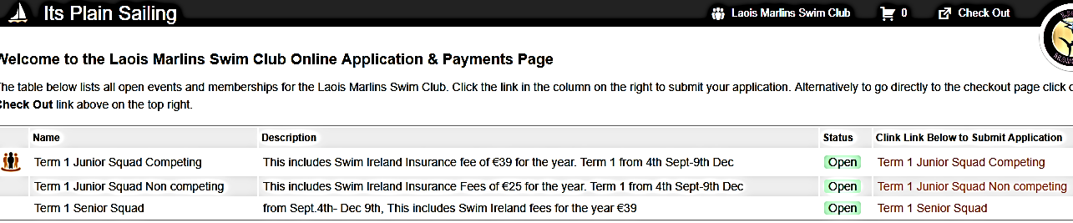

- Choose the squad that applies, junior or senior.
- You will then be taken to the following screen. Fill in all details on the swimmer.

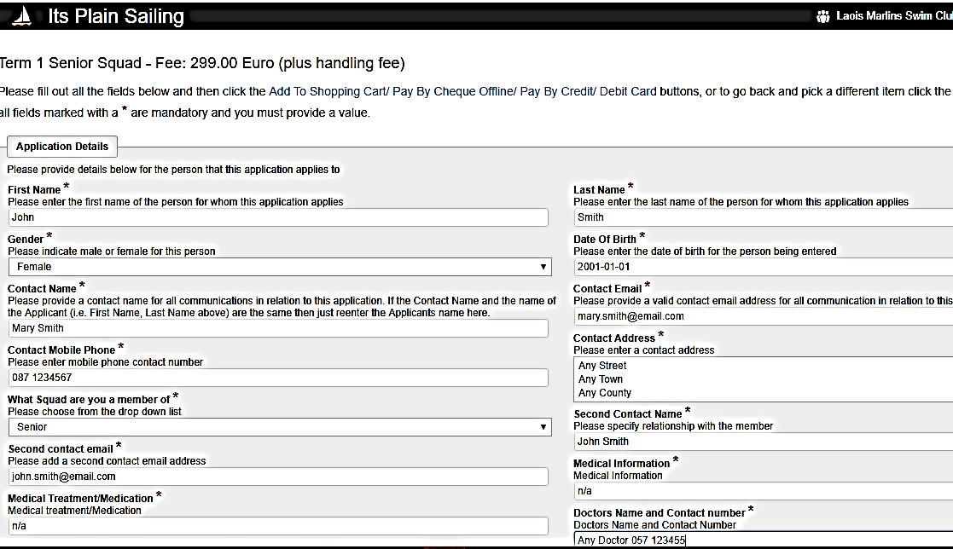

- Scroll down and read and accept the terms and conditions and then click add to shopping cart .
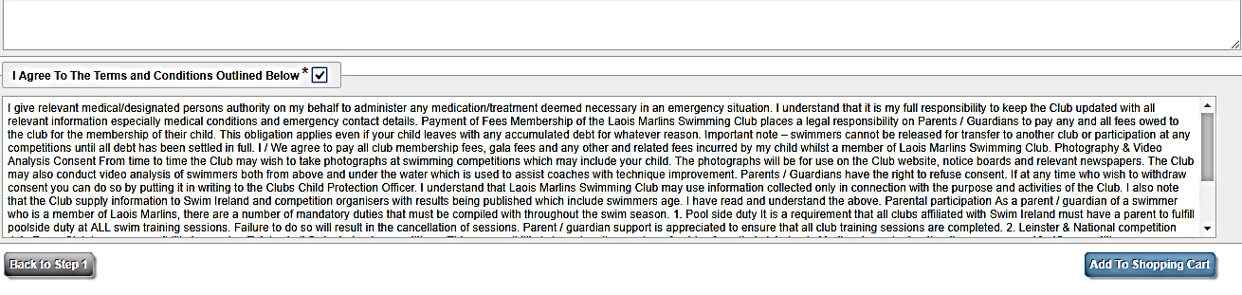
You are now in your shopping cart and ready to check out. Please review and ensure that all information is correct. If happy click the secure order and pay button.
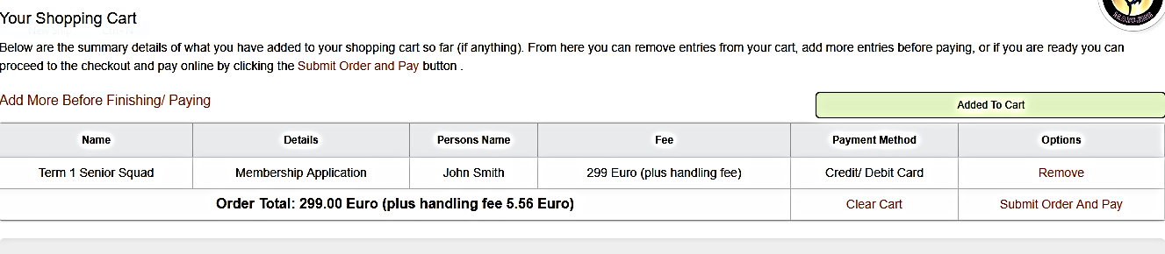

- You will then be asked to fill in your credit or debit card details. All payments are handled securely online.
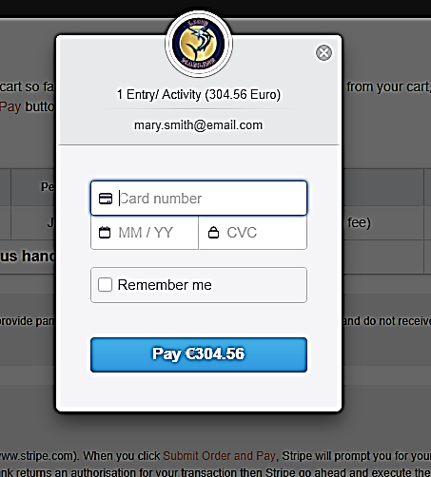
- Once your payment has been completed successfully. You will get an order number as your reference. An email with your order details will also be sent to the email address that was on the order.
GALAS EXPLAINED

Welcome to the 2018/19 Laois Marlins swimming season
As a swimmer, parent or guardian one of the most difficult things to get your head around is which galas should you attend and how do you do that. With that in mind we have pulled together the following summary of the swimming season, what galas we will be attending, whether the gala is in a short or long course pool, any age or time restrictions and whether the gala is fun/competitive in nature.
These golden nuggets of information will ensure you and your swimmer are fully prepared for the season ahead:
Golden Nugget 1: The swim season is divided into two parts.
From Sept 1st to Dec 31st all competitions are run in short course pools (i.e. 25 metre)
From Jan 1st to July 31st a lot of competitions are run in long course pools (i.e. 50 metre)
Note: when checking the swim schedule see if there is an S or an L next to it – (S) is for short course (25m) and (L) is for long course (50m). A swimmer should have competed in a number of short course galas before taking on a long course gala. If in doubt ask your coach.

Golden Nugget 2: There are 5 different types of galas (note number on swim schedule)

• Level 1: (Fun Gala) – example – our own Laois Marlins gala
• Level 2: (Development or Local Gala) – example Leinster Development, St Fiaccs, Kilkenny
• Level 3: (Qualifying gala or Advanced Local gala) – example Leinster Qualifying gala, Schools or Wexford
• Level 4: (Regional Championship gala) example Leinster Short course Championships
• Level 5: (National Championship gala) example National Short course Championships

Golden Nugget 3: Which galas should I attend?

- Level 1: These are fun galas aimed at younger swimmers from our own club as well as our surrounding clubs – this is a great entry into competitive swimming and it is highly recommended for all swimmers regardless of age.
- Level 2: Development and local galas have a dual purpose:
>If a swimmer wants to achieve a time for a level 3 gala then they can use times achieved in a level 2 gala for that purpose - note they cannot use times achieved in a level 1 gala for a level 3
> If a swimmer wants to compete and better his/her times but isn’t interested in competing at regional or national level then level 2 local galas (i.e. Carlow, Kilkenny, Nenagh) are a great place to do this.
- Level 3: Qualifying Galas and Advanced Local galas are the most important step for swimmers who want to compete at regional championships. To compete at a level 4 (Regional Championship gala) you must have achieved a qualification time in a level 3 gala within the qualification time period (typically that calendar year)
- Level 4: Regional Championship galas are only for swimmers who have met the qualification standard for that event and achieved the standard in either a qualifying or advanced local gala (i.e. Level 3)
- Level 5: National Championships galas are only for swimmers who have met the qualification standard for that event and achieved the standard in their relevant level 4 regional championships.

Golden Nugget 4: What age should I be?
All ages for swimming are based on your age as at the 31st of December of the year you are in.
So if you are 12 today but 13 on Dec 22nd 2018, then when you compete in 2018 you compete as a 13 year old, similarly as soon as Jan 1st 2019 comes then you compete as a 14 year old (as you will be 14 on the 31/12/19)
- For level 1 galas you must be 9 as at 31st December of the year of gala
- For level 2 galas you must be 10 as at 31st December of the year of the gala.
- For level 3 galas you must be 10 as at 31st December of the year of the gala

Golden Nugget 5: My son/daughter would like to attend the schools gala – how do I organise this?
The Leinster Minor and Senior schools gala is one we encourage all our swimmers to attend, however, please note that its organised through your childs school and not through the club. That being said we as a club will help in any way possible to ensure your child is entered correctly.
As such we will notify all parents when entries for the schools swimming is open. Your next step is to download an application form from the relevant site (to be advised), bring this to your local Principal (to be signed and stamped), specify what swims your son/daughter wishes to do and then send all of the above off, along with payment to the address specified. All other swim entries are done via the club. If in doubt please contact the club gala secretary: Ross Moore (086-8360767)

Golden Nugget 7: How do I enter a gala for the first time?
- Step 1: Make sure you are on the Laois Marlins Whatsapp group.
- Step 2: An announcement of an upcoming gala will be broadcast to the group along with cost, venue, dates and what level the gala is for.
- Step 3: Consult with your coach – ask them what swims your son/daughter should do.
- Step 4: Consult with a fellow parent – ask them what happens at a gala, what do you bring, times etc – we have all been through it and knowing what to expect is half the battle.
- Step 5: Go onto ItsPlainSailing.com/clubs/lmsc (our payment system) and select the gala, and the events you wish to enter your child in and then pay via the Strype payment system – this is the same way you pay your membership.
- Step 6: The Club Gala Secretary takes all the orders and enters them via the Hytek System (this is the system of record of every swimmer in every race and is the swimmers bible ☺). The Gala Secretary will then send a message out to all parents and guardians confirming the swims they have chosen – make sure to check to avoid an error – and if its wrong please contact the gala secretary as soon as:
- Step 7: Make sure to find out what coach is going to the gala, what time you need to arrive at, what time warm up is, what other parents are going, where to sit etc. (this may seem a little daunting but it’s not and when we go to galas we cheer each and every swimmer who dons the Laois Marlins colours).
- Step 8: Make it a special day out for your swimmer and your family, leave the swimming advice to the coach, and just make sure your child is dressed appropriately, knows where to go and is fed!

