When |  | Instructions
On arrival | 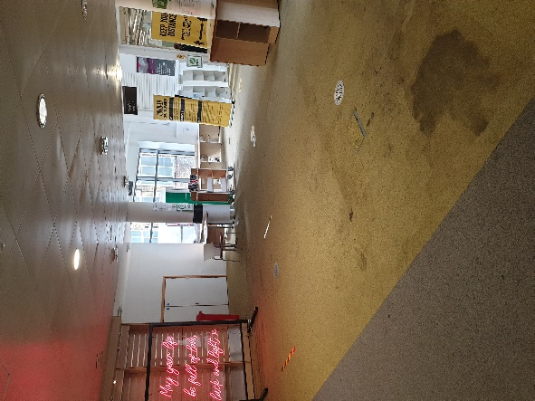 | When arriving at Eltham Leisure Center, parents should not enter the building.  Swimmers need to go through the main entrance wearing a mask and wait in front of the Library (far end, right hand side) where the COVID-Liaisons to direct them when the time comes
 | 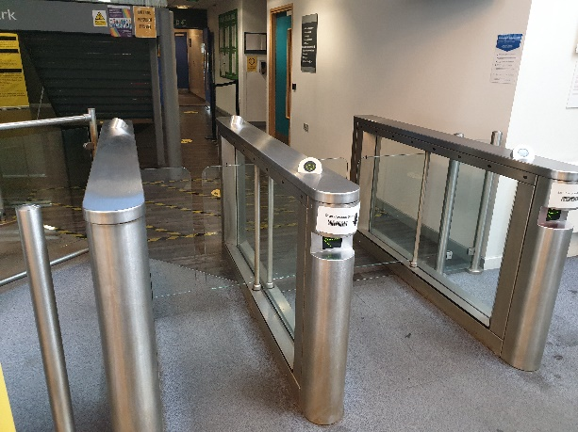 | 5mn before the start of the session, a COVID-Liaison should make sure swimmers have used their hand sanitizer, then let them the swimmers through the gates (left hand side of the main hall), clearly separated by 1m minimum
Before entering poolside | 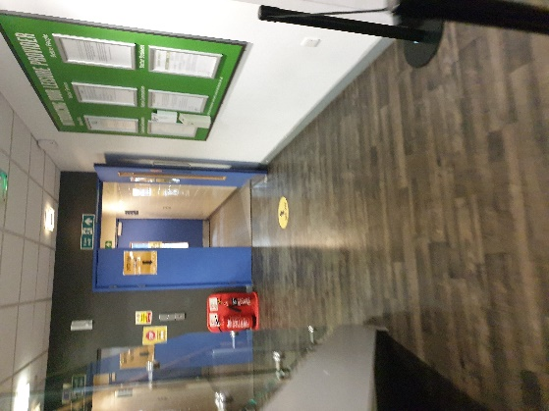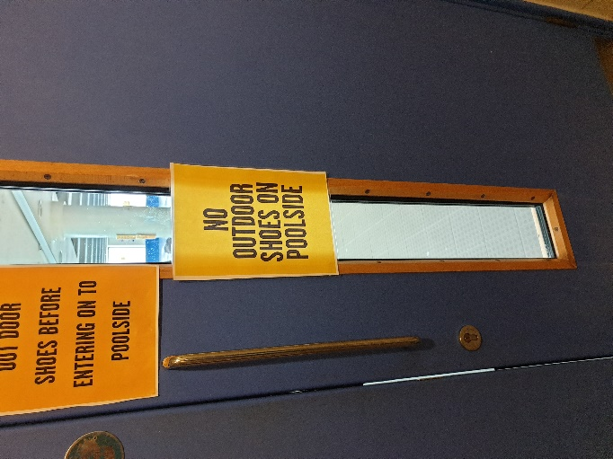 | COVID-Liaisons will ensure that from the gates, swimmers will not go through the changing rooms, but directly on poolside, taking their outdoor shoes off first.
On poolside | 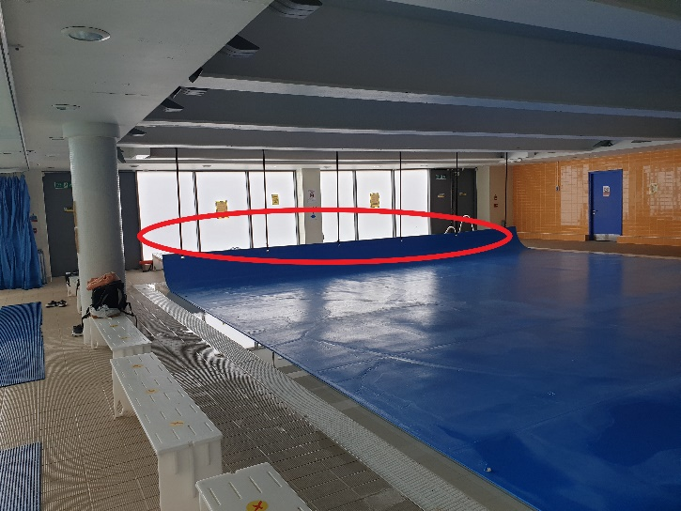  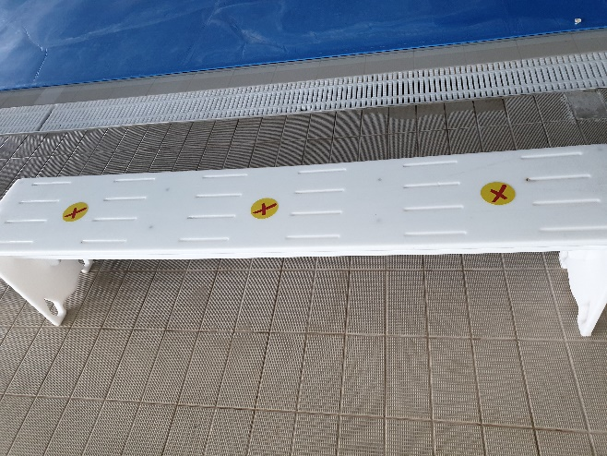 | COVID-Liaisons will allocate benches to each swimmer. Benches are located around the pool. Benches have been clearly marked with Crosses on them, there should be 1 cross between 2 swimmers. There is room behind the teaching pool to put bags should the benches not be enough. Once changed, Swimmers need to be “beach ready”.  Once changed, swimmers should follow coaches instructions as to which end of the pool they should go to end which lane to swim in. All this should be done with at least 1m between each swimmers. COVID-Liaisons must ensure the distance is respected from arrival at the facility until swimmers leave the premises
In the pool |  | Swimmers are under the coaches responsibility but must respect the 1m distance at all times when not actively swimming.
When the session ends |  | Swimmers need to dry themselves and put their clothing over their swimsuits (for now. A new procedure will be given in October). Changing rooms are NOT TO BE USED)
Exiting |  | Once ready to go, swimmers should put their mask on and leave via the changing rooms, at least 1m apart at all times. The exit is through the back door, via the car park
Toilets |  | Please make sure you use the bathroom BEFORE leaving for training. But should you desperately need the toilet, there are 2 toilets between the teaching pool and the changing rooms, or inside the changing rooms. Only 1 swimmer is allowed to go at a time. If using the changing room toilets, I suggest a COVID-Laison accompanies the swimmer, even though BSC will be the only ones using the pool

