

***Star 2019***

March 14th – 17th

[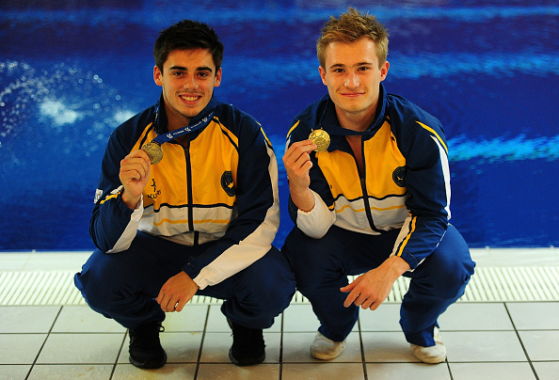](http://www.google.co.uk/url?sa=i&rct=j&q=&esrc=s&source=images&cd=&cad=rja&uact=8&ved=0ahUKEwj4zr_qpv3OAhXlA8AKHS-0Bq8QjRwIBw&url=http://www.gettyimages.fr/photos/chris-mears-plongeur&bvm=bv.131783435,d.d2s&psig=AFQjCNHGHRLBZRi538F4tbQm8o0GespBuw&ust=1473339317935555)**Welcome to  
City of Leeds Diving Club’s  
Annual G Star Diving Competition**

**The Event:**  The event will be run under Swim England Conditions.

[***www.diveleeds.com***](http://www.diveleeds.com)

Events will be in the following categories:

**SYNCHRO – for the first time we will be hosting Synchro events – pairings are NOT required to be from the same club**

**Synchro events will be open to pairings of any age / combination of ages**

**INDIVIDUAL EVENTS**

* **9 – 11yrs Group E2/D**
* **12 – 13yrs Group C**
* **14 – 15yrs Group B**
* **16yrs + Group A/Senior**
* Competing in a higher age group: Group B (those aged 14 or 15 this year) divers can compete up an age group if they choose but must compete all events as that higher age group.

There are 3 possible individual events in each category 1m, 3m and a Platform Event. There will be 1 overall team trophy and the points will be awarded as follows:

**1st 20 pts 2nd 17pts 3rd 14pts 4th 12pts**

**5th 10pts 6th 8pts 7th 6pts 8th 5pts**

**9th 4pts 10th 3pts 11th 2pts 12th 1pt**

Only the top 2 divers in each event, from each club will count towards team points.

**Awards:**  The Northern Cross Trophy (Top Club)

Gavin Brown Memorial Trophy (Diver of the meet)

Medals for Overall top 6 finishers

Top Coach (This year voted for by the coaches)

**Technical** **Meeting:** **Thursday 14th March @2:30pm in the Dennison Suite – ALL clubs must have a representative at this meeting**

**Entry Forms:** Please complete the full entry form and make sure we receive it by;

**Saturday 2nd February 2019**

**after this date there will be a £10 late entry fee per entry per event in addition to standard event fee**

**NO entries will be accepted after Sunday 24th Feb 2019**

**Entries:** City of Leeds Diving Club,

Ann Barker, 24 Lyndale Road, Eldwick, Bingley, BD16 3HE

[AnnBarker@aol.com](mailto:AnnBarker@aol.com) ***(All entries will be taken on a first in first served basis)***

***There will be a restricted entry per event of 35 divers.***

***As soon as we hit this entry number that event will CLOSE!***

***We will also be restricting each individual event   
to a maximum of 6 divers per club.***

**Entry Fees and Payments:**

Synchro Events £20 per pair

Individual Events £14.00 per event

*(UK clubs must pay by the closing date and foreign clubs must pay by the technical meeting)*

*If you wish to pay online:*

**HSBC Leeds city branch Sort code – 40-27-15**

**Account number – 74427653 Ref – club name/G star**

Please make cheques payable to:

**“The City of Leeds Diving Club”**

**Dive Sheets**: **Electronic submissions must be made by no later than Midnight on Tuesday 12th March.**

Divers/Coaches are requested to submit dive sheets electronically

Coaches may make bulk submission of dive sheets on behalf of their divers by using the

program DiveSheets. Alternatively, individual divers may submit their own dive sheets

online. Please agree with your coach which method you should use.

To submit your dive sheets on-line there are two options:

* Either visit: [www.diverecorder.co.uk/onlinesheets](http://www.diverecorder.co.uk/onlinesheets) and follow the instructions, or

if you have an Android phone or tablet, you can get the **ADiveSheets app** from this page on the DiveRecorder website: [www.diverecorder.co.uk/dive/android](http://www.diverecorder.co.uk/dive/android)

As soon as you complete either on-line submission method you will see a success/failure message. If successful you will be sent an automatic email confirming receipt of your details and dives.

**Electronic submissions must be made by no later than Midnight on Wednesday 13th March.** You will be asked to sign hard copies of these sheets at the venue, available from the Recorders. If neither you nor your Coach are able to use the above electronic methods, you can submit a hard copy of your lists of dives to the Recorders.   
**The deadline for manual dive sheets is at the Technical Meeting**

You can check your submitted dive sheets a few days before the event online at [**www.diverecorder.co.uk/live**](http://www.diverecorder.co.uk/live)**.** If you experience problems and need assistance please contact Ann Barker ([AnnBarker@aol.com](mailto:AnnBarker@aol.com) ).

Judging

All diving Club’s attending will be required to supply at least one judge, preferably two. This is to help us man the simultaneous preliminary events. Coaches can judge but please be discrete.

**Diving Event Procedures**

**1**. Preliminary events will be run simultaneously.

**2.** In Age Groups D, C and B divers will perform all their dives in the preliminary event and there will be a cut to the top 6 for the final.

In the final all divers will perform 3 dives without limit.

All Dives in the final must be from a different group.

All finals will start from Zero points – no carry over score!

**3.** In Age Group A+ divers will perform all their dives in the preliminary event and there will be a cut to the top 6 to the final.

In the final all divers will perform 3 dives without limit,

Dive one from forward or inward

Dive two from back or reverse &

Dive three from twist.

In the platform event Dive three will be from twist or armstand.

All finals will start from Zero points – no carry over score!

**Diving List Requirements**

**SYNCHRO EVENTS**

|  |  |  |  |
| --- | --- | --- | --- |
| Open Male 3m | 6 dives | 2 dives with an allocated dd of 2.0 + 4 x optional dives.  5 groups to be covered | In each round the two divers must perform the same dive (same dive number and same position). All forward facing dives on springboard shall be done with a running approach. |
| Open Male Platform  Synchro events can be performed at 5m, 7.5, & 10m | 6 dives | 2 dives with an allocated dd of 2.0 + 4 x optional dives.  5 groups to be covered | In each round the two divers must perform the same dive (same dive number and same position). |
| Open Female 3m | 5 dives | 2 dives with an allocated dd of 2.0 + 3 x optional dives.  5 groups to be covered | In each round the two divers must perform the same dive (same dive number and same position). All forward facing dives on springboard shall be done with a running approach. |
| Open Female Platform  Synchro events can be performed at 5m, 7.5, & 10m | 5 dives | 2 dives with an allocated dd of 2.0 + 3 x optional dives.  5 groups to be covered | In each round the two divers must perform the same dive (same dive number and same position). |

|  |  |  |  |  |  |  |
| --- | --- | --- | --- | --- | --- | --- |
| **Age Group** | **Gender** | **Event** | **Dives with**  **Limit** | **Maximum DD** | **Dives without Limit** | **Total** |
| ***Group D divers must cover 3 groups on all boards*** | | | | | | |
| 9/11yrs  D | Girls & Boys | 1m | 3 from 3 | 5.4 | 3 from 3 | 6 |
| 9/11yrs  D | Girls & Boys | 3m | 3 from 3 | 5.7 | 3 from 3 | 6 |
| 9/11yrs  D | Girls & Boys | 5m | 2 from 2 | 3.6 | 3 from 3 | 5 |
| ***Group C Divers must cover 4 groups on all boards*** | | | | | | |
| 12/13yrs  C | Girls & Boys | 1m | 3 from 3 | 5.4 | 3 from 3 | 6 |
| 12/13yrs  C | Girls & Boys | 3m | 3 from 3 | 5.7 | 3 from 3 | 6 |
| 12/13yrs  C | Girls & Boys | Platform  *5/7m* | 3 from 3 | 5.7 | 3 from 3 | 6 |
| ***Group B Divers must cover 4 groups on all boards*** | | | | | | |
| 14/15yrs  B | Girls & Boys | 1m | 3 from 3 | 5.6 | 3 from 3 | 6 |
| 14/15yrs  B | Girls & Boys | 3m | 3 from 3 | 6.1 | 3 from 3 | 6 |
| 14/15yrs  B | Girls & Boys | Platform  *5/7/10m* | 3 from 3 | 6.1 | 3 from 3 | 6 |
| ***Group A+ Divers must cover 5 groups on all boards*** | | | | | | |
| 16+yrs  A+ | Girls & Boys | 1m | 3 from 3 | 5.8 | 3 from 3 | 6 |
| 16+yrs  A+ | Girls & Boys | 3m | 3 from 3 | 6.1 | 3 from 3 | 6 |
| 16+yrs  A+ | Girls & Boys | Platform  *5/7/10m* | 3 from 3 | 6.1 | 3 from 3 | 6 |

**Venue:** John Charles Centre for Sport

Leeds Aquatic Centre, Middleton Grove, Leeds, LS11 5DJ

TEL: 0113 3788235

**Facilities:**

Dryland training area including tumble track, s/s blocks & two dry boards

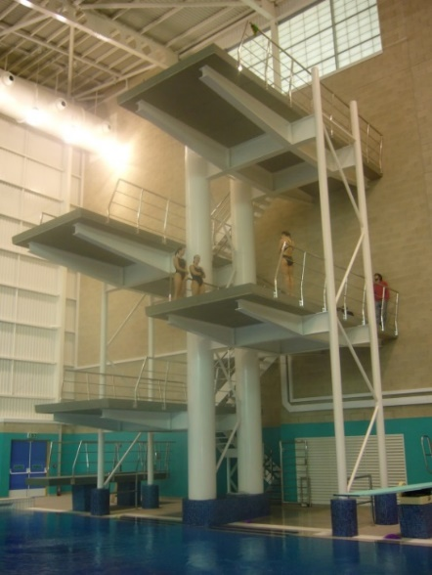

1 x 1m Platform

1 x 3m Platform

1 x 5m Platform

1 x 7m Platform

1 x 10m Platform

4 x 1m Springboards

2 x 3m Springboards

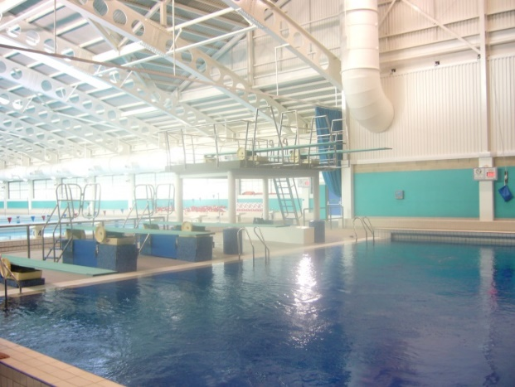

**Meet Director:** Harriet Jones

Meet Directors: Joe Meszaros & Harriet Jones

Contact: [joe.meszaros@leeds.gov.uk](mailto:joe.meszaros@leeds.gov.uk) / [harriet.jones@leeds.gov.uk](mailto:harriet.jones@leeds.gov.uk)

**Info Pack:** All teams will receive an information pack on arrival. It will contain programmes, start orders, dive orders, dive sheets, pool safety rules and other general information regarding the weekend.

**Training Times:** Training will be available on Thursday 13th March. Please contact Harriet Jones / Joe Meszaros to book a training slot.

Available training slots in the pool on Thursday will be as follows: 9-10am, 10-11am, 11-12pm, 2-3pm

**Nearby Accommodation:**

Premier Inn Leeds City Centre, Tel: 0871 527 8584,

Postcode for sat nav: LS12 6LX

Travelodge Leeds Central, Tel: 0871 984 6155

Postcode for sat nav: LS1 4AD

Hotel Ibis Budget Leeds Centre, Tel: 0113 245 0725

Postcode for sat nav: LS9 8B2

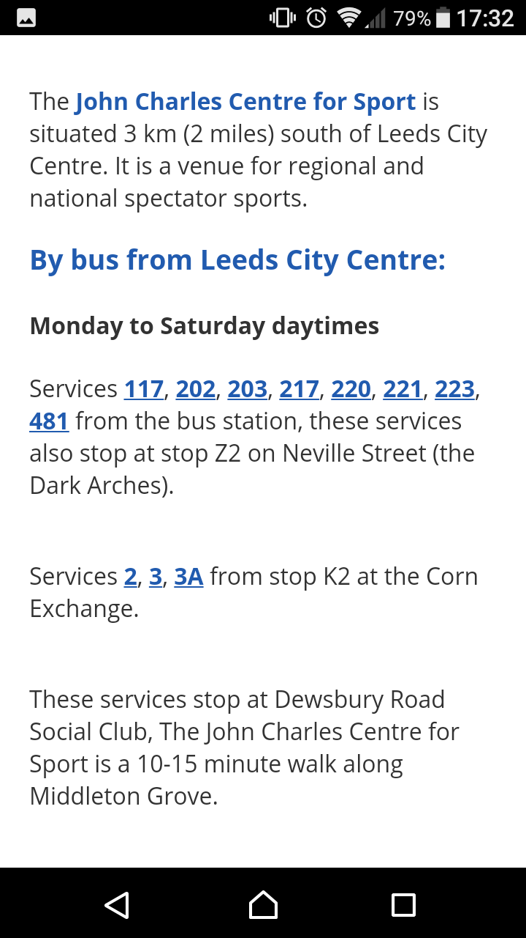**Transport Links to John Chares Centre for Sport:**

**G Star Diving 2019**

**Provisional Programme – *all days and times subject to change depending on entries***

**Thursday 13th March**

|  |  |
| --- | --- |
| ***3:00 - 4:00pm*** | Restricted Training for synchro events |
| 4:00pm Synchro Finals | Women’s Open 3m Synchro |
|  | Men’s Open 3m Synchro |
|  | Women’s Open Platform Synchro |
|  | Men’s Open Platform Synchro |

**Friday 16th March**

|  |  |  |
| --- | --- | --- |
|  | **Restricted Training for Session 1 Divers** | |
|  | Session 1 | |
|  | Girls 9/11yrs 5m Prelim | Boys 9/11yrs 1m Prelim |
|  | Girls 14/15yrs 3m Prelim | Boys 12/13yrs Platform Prelim |
|  | **Restricted Training for session 2 Divers** | |
|  | Session 2 | |
|  | Girls 16+yrs 1m Prelim | Boys 14/15yrs Platform Prelim |
|  | Girls 12/13yrs 3m Prelim | Boys 16+yrs 1m Prelim |
|  | **Restricted Training for Session 3 Divers** | |
| *5.00pm* | Session 3 | |
|  | **FINALS**: Events 1-8 | |

**Saturday 17th March**

|  |  |  |
| --- | --- | --- |
|  | **Restricted Training for Session 4 Divers** | |
|  | Session 4 | |
|  | Boys 9/11yrs 5m Prelim | Girls 9/11yrs 3m Prelim |
|  | Girls 12/13yrs 1m Prelim | Boys 14/15yrs 3m Prelim |
|  | **Restricted Training for session 5 Divers** | |
|  | Session 5 | |
|  | Girls 14/15yrs 1m Prelim | Boys 12/13yrs 3m Prelim |
|  | Girls 16+yrs 3m Prelim | Boys 16+yrs Platform Prelim |
|  | **Restricted Training for Session 6 Divers** | |
| *5.00pm* | Session 6 | |
|  | ***Opening Ceremony & Parade of Teams*** | |
|  | **FINALS**: Events 9-16 | |

**Sunday 18th March**

|  |  |  |
| --- | --- | --- |
|  | **Restricted Training for Session 7 Divers** | |
|  | Session 7 | |
|  | Girls 9/11yrs 1m Prelim | Boys 9/11yrs 3m Prelim |
|  | Girls 12/13yrs Platform Prelim | Boys 12/13yrs 1m Prelim |
|  | **Restricted Training for session 8 Divers** | |
|  | Session 8 | |
|  | Girls 14/15yrs Platform Prelim | Boys 14/15yrs 1m Prelim |
|  | Girls 16+yrs Platform Prelim | Boys 16+yrs 3m Prelim |
|  | **Restricted Training for Session 9 Divers** | |
| *4.30pm* | Session 9 | |
|  | **FINALS**: Events 17-24 | |
|  |  | |

Order of Events

We reserve the right to amend the order of events at the meet to ensure the best use of competition/training time.

WE LOOK FORWARD TO WELCOMING YOU IN

2019



[https://uk.teamunify.com/css/pro/facebook.jpg](https://www.facebook.com/groups/147590665256581/)[https://uk.teamunify.com/css/pro/instagram.jpg](https://www.instagram.com/leeds_diving/)[https://uk.teamunify.com/css/pro/twitter.jpg](https://twitter.com/LeedsDiving)