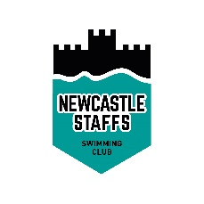
Yule in the Pool 2022
Officials Form

Kindly complete the form below and return to galas.nssc@gmail.com. Thank you!
Your Name (required):

Your Club:

Your Email (required):

Your Contact Phone (required):

I'm Available for (required): Session 1 Yes/No
Session 2 Yes/No

I can act as (required): Referee Yes/No
Starter Yes/No
Judge 1 Yes/No
Judge 2 Yes/No
Timekeeper Yes/No

Other state below:

Any additional information/message (e.g. mentoring required?). Please state below:

All information will be stored safely and securely. It will be treated confidentially and used solely for the purpose of gala liaison. All data will be permanently deleted after a 3-month period. You may request removal of any personal data via the membership officer to: membershipsecretary.nssc@gmail.com

