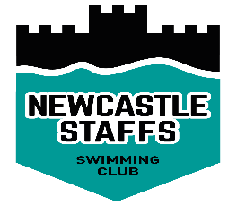
Newcastle Staffs Swimming Club
Role Description – Workforce Co-ordinator
Role:

A non-committee member appointed to co-ordinate the recruitment and organisation of volunteers within the club.

Skills

- Well organised and able to delegate
- Enthusiastic and a good motivator
- Approachable
- Confident and effective communicator

Main Duties

- Main contact for all volunteers
- Get to know all club volunteers and potential volunteers by name
- Ensure all jobs have job descriptions
- Supervise and oversee all volunteers
- Liaise with the Chairperson to ensure all tasks required to run the club are carried out
- Co-ordinate the implementation of the volunteer’s requirements
- Liaise with the Development Officer and Competition Secretary as to their volunteer requirements
- Liaise closely with the Child Welfare Officer to ensure that each volunteer is aware of the Child Protection Policy and Procedures
- Awareness of the Sport England – Volunteers Investment Programme (VIP)
- Ensure volunteers are directed to the ASA website for useful information on volunteering
- Organise social and recruitment events for volunteers

Commitment

Determined by the clubplus Committee Meetings

Further Development/Support Volunteer Management Workshop

Training opportunities are available through the ASA Regional Training Network, for your nearest training centre visit the ASA website www.britishswimming.org or telephone the ASA on 01509 618700. If you have any queries regarding volunteering within the sport contact your County Volunteer Coordinator, details available on the ASA website www.britishswimming.org > Volunteers and Officials

Useful Websites

ASA website www.britishswimming.org
Sport England www.sportengland.org.uk
Volunteering England www.volunteering.org.uk
Millennium Volunteers www.millenniumvolunteers.gov.uk
DO-IT www.do-it.org.uk
CSV www.csv.org.uk
Sports Coach UK www.sportscoachuk.org

