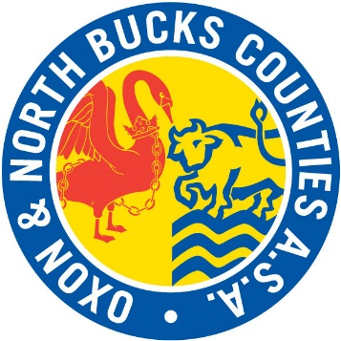

County Pathway Coaching Programme

Expression of interest form – Assistant Team Manager
Personal Details:
Name:
Email:
Telephone:
Current Role and Club:

Team Manager Qualifications:
Team Manager 1 course date:
Team Manager 2 course date:
(if applicable)
Safeguarding course date:
DBS number and date:

Team Manager Experience

Please provide a brief summary of your key Team Management experience; Team Manager Roles or similar roles.
Outline any other key qualifications and continual professional development.

Please provide a personal statement of no more than 200 words
Answer the following questions in your statement:
1. Why do you want to be an assistant Team Manager?
2. What would you hope to gain from this experience?
3. How will this opportunity assist you in your future development?

Please return completed forms to Jo Ulyett via email jo_ulyett@hotmail.com by Monday 24th February 2020.

