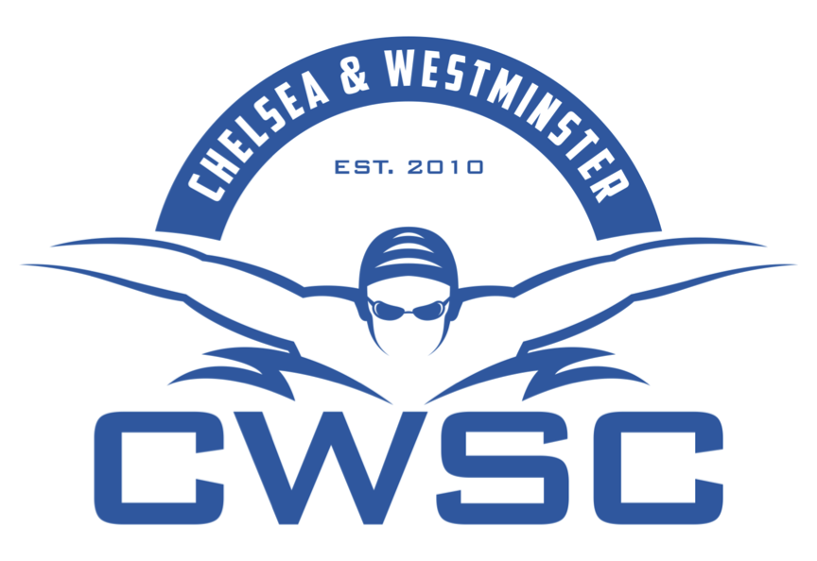

CWSC 2018 Long Course Season Fixtures

January 2018
20th to 21st | 10-13 | Middlesex County Age Group Championships  Southbury Rd, Enfield | Qualifiers
27th to 28th | 14-Open | Middlesex County Youth Championships  London Aquatic Centre | Qualifiers
February 2018
3th to 4th | 10-13 | Middlesex County Age Group Championships  Southbury Rd, Enfield | Qualifiers
24th to 25th | 9-Open | Ealing February Regional Qualifier  Northolt | All
March 2018
9th to 11th | 10-Open | WDSC Long Course Premier Meet  Wycombe Leisure Centre | Qualifiers
10th, 11th and 17th | 10-Open | Middlesex Development Meet  Southbury Rd, Enfield | All
30th, 31st | 10-Open | Beckenham Open  London Aquatic Centre | Qualifiers
April 2018
1st | 10-Open | Beckenham Open  London Aquatic Centre | Qualifiers
May 2018
5th to 7th | 15-Open | London Regional Youth Championships  London Aquatic Centre | Qualifiers
12th to 13th | 11-14 | London Regional Age Group Championships  London Aquatic Centre | Qualifiers
19th to 20th | 11-14 | London Regional Age Group Championships  Crystal Palace | Qualifiers
26th to 27th | 12-Open | 2018 May Open Meet  London Aquatic Centre | Qualifiers
June 2018
July 2018

(*) Please note:
- Competitions will be added and removed throughout the year.
- Please keep fixture dates free. If you are not sure whether you will be needed for a gala or suitable for a particular meet, please check with your Squad Coach.

