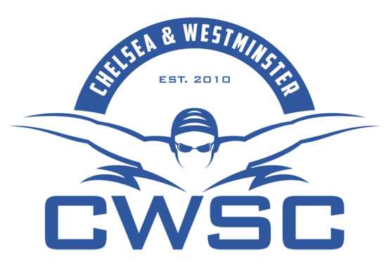

CWSC Squad Moves and Squad Trials 2018-2019

Please see below a scheduled timetable which represents ‘in house’ moves and club trial dates.

The first column gives the dates for when club members will be notified by the Director of Swimming if they are to move squads. Discussion with coaches prior to written notification is unrelated and doesn’t signify an agreed move.

The second column is for swimmers wishing to join the club and our new member trial dates.

CWSC IMPORTANT SQUAD DATES 2018-2019
INTERNAL MOVE NOTIFCATION | EXTERNAL TRIAL DATES
BY 15TH DECEMBER 2018 | SEPTEMBER 15TH 2018
BY 16TH MARCH 2019 | DECEMBER 1ST 2018
BY 6TH JULY 2019 | TBC
 | TBC

