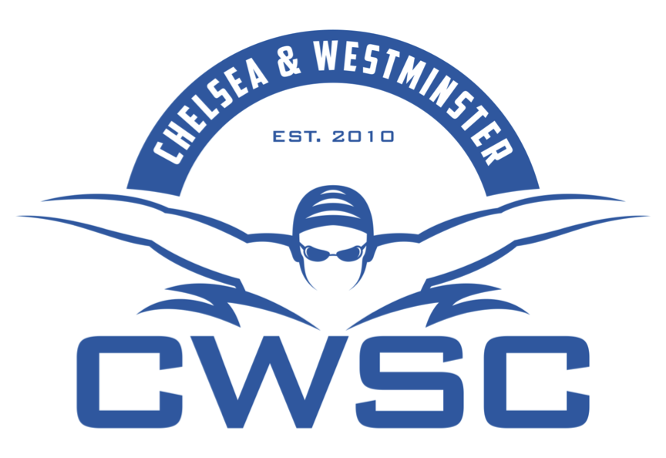

Chelsea and Westminster Competition Schedule 2018-2019

October

Date | Competition | Squads | Club Closing Date
13th | Arena League Round 1 | Selected Swimmers | N/A
20th/21st | Middlesex Autumn Dev | Blue, Black, JD, Gold, AD, Silver | 14th Sept
27th | Middlesex Autumn Dev | Blue, Black, JD, Gold, AD, Silver | 14th Sept
20/21st | Nova Centurion Open Meet | RP, NP | 26th Sept

November

Date | Competition | Squads | Club Closing Date
3rd/4th | London Region Winter Champs | Those qualified 12yrs+ | Tbc
3rd | CWSC Coloured Hats Gala | Red, Orange, Yellow, Blue | Tbc
10th | Arena League Round 2 | Selected Swimmers | N/A
17th/18th | Guildford Level 2 Open Meet | NP (selected swimmers) | 28th September
18th | Hitchin Open Meet | AD, JD, Black, Gold, Silver | 28th September
23/24/25th | WDSC County and Regional Qualifier | RP, NP*  *Swimmers not going to Guildford | 30th August

December

Date | Competition | Squads | Club Closing Date
8th | Arena League Round 3 | Selected Swimmers | N/A
15th/16th | Hillingdon | AD, RP, NP | Tbc
14th-16th | Swim England Winter Champs | Selected Swimmers | Tbc

