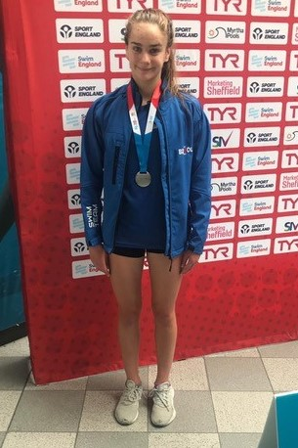
ATHLETE: Jess Lawton
AGE: 13
EVENTS QUALIFIED: 50m Butterfly, 100m Butterfly
Jess' Response:
When did you first join a Club?
When I was 5.
Why did you want to Swim?
Because my brothers were swimming and it was better than just waiting around for them.
Who were your first Club?
Keynsham
Who are/were the Coaches along your pathway who have had a big influence on you?
Marc Williams has had a big influence on my swimming as I joined his squad when I was 9 and he has seen me through my pathway from county to regional to nationals. He has always been kind, patient and encouraging and I don’t think I would be where I am today without his coaching.
Why do you still Swim?
I still swim because I love it. I have always loved the water, the excitement of racing and the best friends I’ve made have been through swimming.
What's the best thing about being a part of CoB?
I think the best thing about being part of CoB is the feeling of being part of a community where we all share a common interest.
Any other motivational info for our club members?
You might miss swimming, another sport or just your school friends - but remember this quarantine is only temporary.

