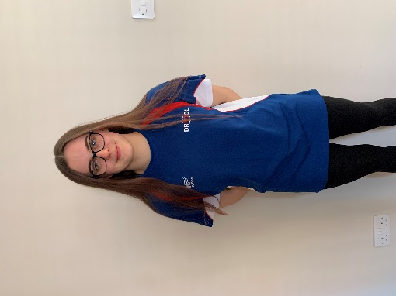
ATHLETE: Kiera Noon
AGE: 19
EVENTS QUALIFIED: 200m Butterfly
Questions Kiera was asked to answer:
When did you first join a Club? Why did you want to Swim? Who were your first Club?
Who are/were the Coaches along your pathway who have had a big influence on you?
Why do you still Swim? What's the best thing about being a part of CoB?
Any other motivational info for our club members?
Kiera's Response:
I first joined Bristol Central swimming club in October 2004. From what my mum has told me, she took me along to Paddy’s session at Redcliffe and they were looking for non-swimmers for coaches who were training for their qualifications. After that swimming just stuck.
I proceeded to join City of Bristol when I was 9 after Bob Lisle told my mum to bring me along to a session after seeing me race at a Weston-Super Mare meet. I achieved my first English national times in 2017 (getting into the 200 fly final) and then again in 2018 whilst being coached by Matt Puddy and Marc Williams. Matt had a large influence on not only competing but my mindset and work ethic in training. Lisa in the 2018/19/20 seasons had a massive influence on me; after moving to Eli’s squad then moving back into the Youth Performance. She coached me to summer British Champs as well as winter nationals and April British Champs in 200 fly.
The best thing about being in CoB for me is the friendships and memories I have made, along with the various pools I have been able to swim at.
My advice to younger members is that you may not achieve when you are young but if you stick with it and push yourself you can achieve when you’re older.

