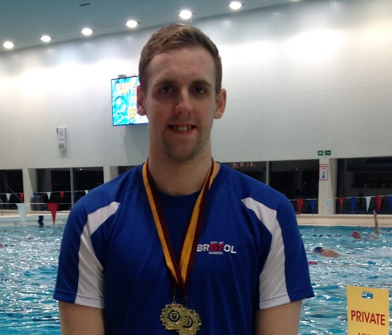
ATHLETE: Marcus Gardiner
AGE: 23
EVENTS QUALIFIED: 50m Breaststroke, 100m Breaststroke
Questions Marcus was asked to answer:
When did you first join a Club? Why did you want to Swim? Who were your first Club?
Who are/were the Coaches along your pathway who have had a big influence on you?
Why do you still Swim? What's the best thing about being a part of CoB?
Any other motivational info for our club members?
Marcus' Response:
I first started swimming at Backwell S.C aged 11 and was quickly moved to Bristol Henleaze and CoB under guidance of Bob Lisle and Jez Bird.
I moved to Weston Super Mare aged 15 under coach Rachel Aldington and made Nationals finals and British Champs finals every year from then on since aged 16.
I then moved to Plymouth Leander when I started university; I studied Psychology at Plymouth University where I later a gained Psychology BSc degree. I trained under Jon Rudd and Robin Armayan, whilst training with Olympic medallist Ruta Meilutyte, Ben Proud, Laura Stephens and Anthony James to name but a few.
My Highlight was winning Silver at English Champs in LC 100m Brs and placing 4th in the Winter Short Course 50m Brs. I also competed against some of the World’s most famous breaststrokers in Luxembourg and across the UK including: Marco Koch, Adam Peaty, Daniel Gyurta, Laszlo Cseh and James Wilby.
I returned to the City of Bristol in September 2018 and have continued to perform under the guidance of Lisa, although I’m unable to train regularly now due to work commitments. I am very aware that this year may have been my last opportunity to swim at a high level of achievement, as having a full time job with long hours means I can’t train as much as I would like.
All of the coaches I have trained with have helped me become the athlete and person that I am today.
The sense of achievement at competitions, and always trying to improve is what keeps me motivated to train. My motivational quote is “THE PRICE OF EXCELLENCE IS DISCIPLINE, THE COST OF MEDIOCRITY IS DISAPPOINTMENT”.
I am very proud to be a member of CoB and be part of the big swim family, I hope to be an active member for many years to come, in the friendly yet competitive environment at CoB.

