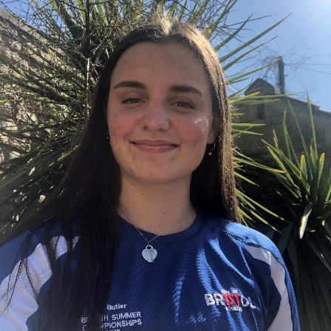
ATHLETE: Liv Butler
AGE: 17
EVENTS QUALIFIED: 200m Individual Medley, 400m Individual Medley, 200m Backstroke, 200m Butterfly
Liv's Response:
When did you first join a Club?
I first joined a swimming club at the age of 7/8 years old.

Why did you want to Swim?
I wanted to swim because I ( my parents ) believed it was a fundamental life skill, because my siblings both did it and because it was fun!

Who were your first Club?
My first swimming club was Severnside Tritons SC, who were based between Thornbury and Stroud.

Who are/were the Coaches along your pathway who have had a big influence on you?
Coaches that had a big influence when I was younger were John Scanlan and David Mcoubrie, Rachel Aldington when I briefly decided to maybe join Weston super mere and had worked with her on many camps, Matt Puddy when I first joined Cob and definitely Lisa, my coach, as I think we have successfully worked well together so far through many different experiences.

Why do you still Swim?
I still swim because I feel it has been something that has come naturally since I was younger, because I still enjoy it and because I still think I have a long way of improvement and potential yet to come.

What's the best thing about being a part of CoB?
The best aspect of being apart of Cob is the experiences and people I have met. The facilities were significantly better from what I had ever been able to use prior to joining and maximising the facilities alongside the people around me has enabled me to go on many trips and I have made some really good friends.

Any other motivational info for our club members?
I think that my motivational info for club members would be to enjoy any moment in the present because anything can happen and to maximise anything as it can really push you to better experiences. I think that especially during this time, everyone should progress random skills and enjoy other activities/sports whilst mainly being caring to yourself because that can be hard in isolation!

