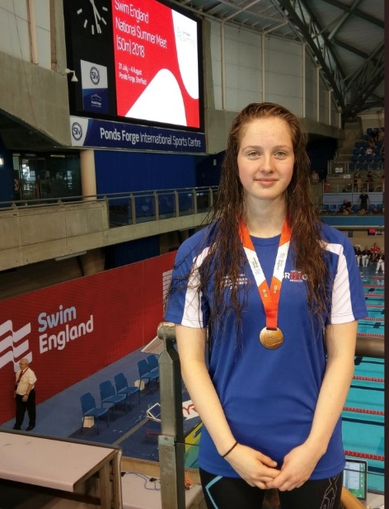
ATHLETE: Oriana Munden
AGE: 18
EVENTS QUALIFIED: 50m Backstroke, 100m Backstroke, 200m Backstroke
Oriana's Response:
When did you first join a Club?
I first started swimming when I was 8.
Why did you want to Swim?
Initially I wanted to swim because it was fun, the people were amazing and I really enjoyed competing at primary school.
Who were your first Club?
Bristol Henleaze
Who are/were the Coaches along your pathway who have had a big influence on you?
One of the coaches that had a big influence on me was Jon Falco, as he helped me really love swimming and he massively developed my swimming technique. Another coach that has had a big influence on me is Lisa Atkinson, because she has helped me as I have got older and started university to keep competing at a good standard and really enjoy training, even though I can only do a limited amount, I didn't think it was possible to study medicine and train, but Lisa has adapted training sessions for me so that it is possible.
Why do you still Swim?
I still swim because I enjoy both training and competing and I believe that swimming helps to develop me as a person.
What's the best thing about being a part of CoB?
The best part about CoB is the atmosphere and the people. They always motivate and support each other with everything, especially during grueling training sets.
Any other motivational info for our members?
During lockdown it's really important to keep talking to each other and remember that lockdown won't last forever, the pool will be open again soon.

