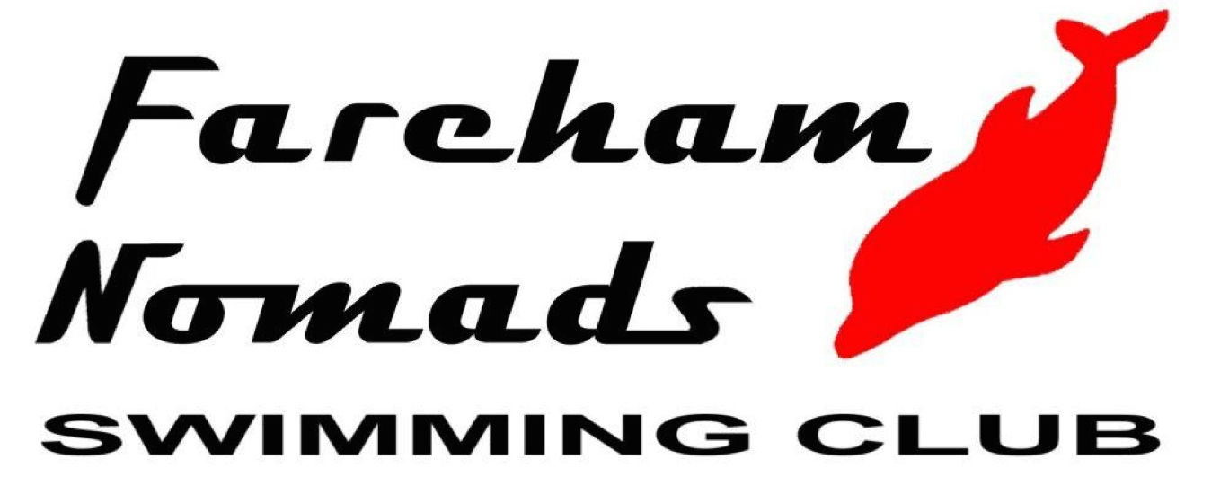 | Fareham Nomads  SUMMER MEET 2023 L3 Meet  Licence No. 3SE230987
Affiliated to ASA SE Region | (Under ASA Laws and Technical Rules)  At the Waterlooville Leisure Centre  22nd July 2023

Entries Summary Form
This form must accompany club entries or individual entry forms
Clubs should also submit entries electronically. Entry files are available from
By email from: openmeets@farehamnomads.co.uk

CLUB:
CONTACT NAME:
ADDRESS:
POST CODE:
TELEPHONE:
EMAIL:
NUMBER OF ENTRIES AT £7 = x £7 = £

NUMBER OF COACH PASSES @£15 =  (to include lunch each day) |  | = | £
TOTAL REMITTANCE = |  |  | £

No. of Swimmers =
Please pay by one cheque per Club payable to ‘Fareham Nomads Swimming Club’ or online to Sort Code: 20-11-43, Account Number: 43538265.

CLOSING DATE FOR ENTRIES IS 17th June 2023

All Entries Summary Forms with their Individual Entry Forms or Hytek entries reports, accompanied by the full entry fees should be sent to:

FNSC Open Meets, 2 Heather Gardens, Fareham, Hants, PO15 6JB

