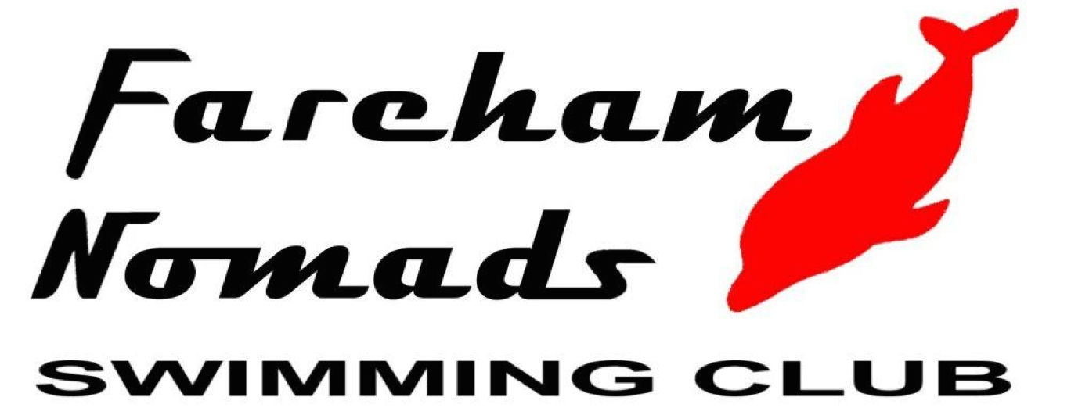 | Fareham Nomads  Level 3 Summer Meet 2023  Licence No. 3SE230987
Affiliated to Swim England SE Region | (Under Swim England Laws and Technical Rules)  At the Waterlooville Leisure Centre  22nd July 2023

FORENAME …………………………… SURNAME ………………………….…...
CLUB …………..………………….…………………… MALE / FEMALE
FULL ADDRESS …………………………………………………………………………………...
…………………………………………………………………… POST CODE …………..…………
TEL NO……..…………………….… EMAIL ………………………………………………………..
ASA REGISTRATION NO.

Events | ENTRY TIME  (SHORT COURSE) | Date of Birth:  _______/_______/______  Age as at  22nd July 2023  _______________ years  Please mark time trial entries with a ‘T’
- 200M INDIVIDUAL MEDLEY
- 50M FREESTYLE
- 100M FREESTYLE
- 200M FREESTYLE
- 50M BACKSTROKE
- 100M BACKSTROKE
- 200M BACKSTROKE
- 50M BREASTSTROKE
- 100M BREASTSTROKE
- 200M BREASTSTROKE
- 50M BUTTERFLY
- 100M BUTTERFLY
- 200M BUTTERFLY
Individual entry fees are £7 per event plus £10 individual Levy fee per event up to a maximum of 5 events after which we will drop the levy and there after events will be at £7. (e.g 5 events are 5@£17 = £85, 6 events would be 5@£17 + 1@£7 = £92)  Total Entry Fees | £
External Clubs please return this form with an ENTRIES SUMMARY FORM
Please pay by one cheque per Club payable to ‘Fareham Nomads Swimming Club’ or online to Sort Code: 20-11-43, Account Number: 43538265.

I hereby declare that the above particulars are correct and that I am an eligible competitor in accordance with the laws of the Swim England and will abide by the conditions laid down by the promoter for this competition.

Signature of Competitor ……………………………………… Date ………….………………

CLOSING DATE FOR ENTRIES IS 17th June 2023

