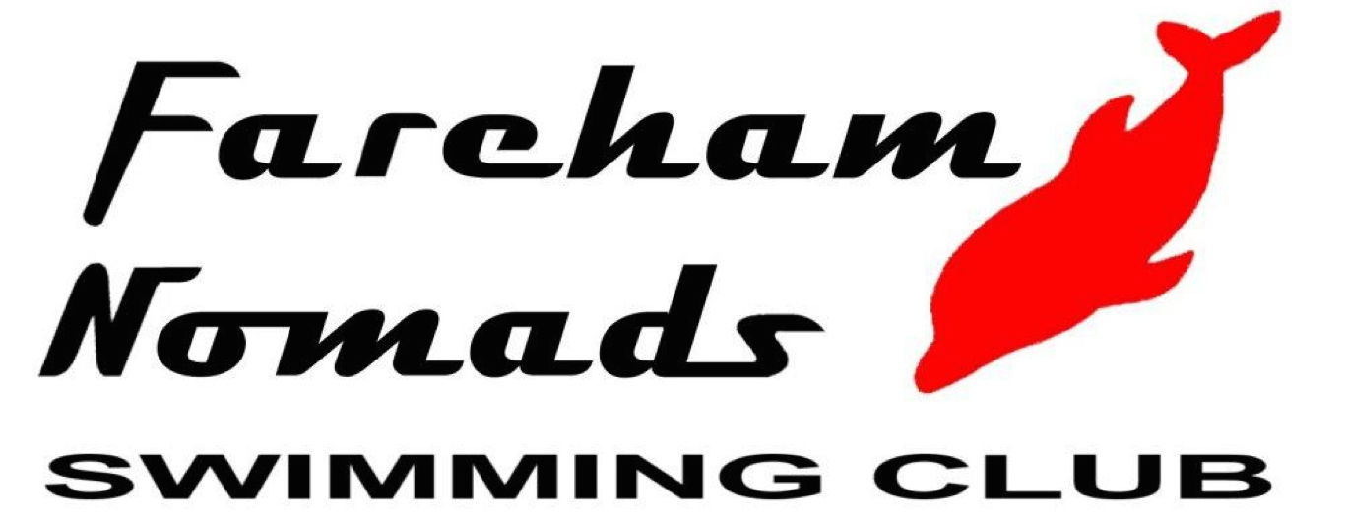 | Fareham Nomads  Back In The Pool L3 Meet  Licence No. 3SE210201
Affiliated to ASA SE Region | (Under ASA Laws and Technical Rules)  At the Waterlooville Leisure Centre  24th / 25th July 2021

Entries Summary Form
This form must accompany club entries or individual entry forms
Clubs should also submit entries electronically. Entry files are available from
www.farehamnomads.co.uk or by email from: openmeets@farehamnomads.co.uk

CLUB:
CONTACT NAME:
ADDRESS:
POST CODE:
TELEPHONE:
EMAIL:
NUMBER OF ENTRIES AT £7 = x £7 = £

NUMBER OF COACH PASSES @£10 =  (per weekend, £5 per day) |  | = | £
TOTAL REMITTANCE = |  |  | £

No. of Swimmers =
Please pay by bank transfer to Fareham Nomads Swimming Club S/C: 201143 A/C: 13424561

CLOSING DATE FOR ENTRIES IS Friday 10th July 2021

All Entries Summary Forms with their Individual Entry Forms or Hytek entries reports should be sent to:

FNSC Open Meets, 1 Mays Lane, Stubbington, Fareham, Hampshire, PO14 2ER

