MIDDLESEX COUNTY AMATEUR SWIMMING ASSOCIATION
President: Pam Crofts (Haringey Aquatics SC)

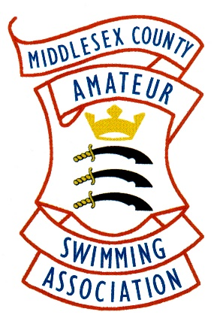

Club ……………………………………………………………..

Delegate………………………………………………………….

I certify that the above-named person is authorised to attend the Middlesex County Annual Council Meeting on Thursday, 24 November 2022 at 7 p.m. held at Perivale Resident’s Association as a delegate for the above named Club

Signed…………………………………………………Hon Secretary

…………………………………………………………Swimming Club

Please Note

The delegate must email this Authority to the Verification Officer

And

Have the Agenda stamped before attending the Meeting

e-mail: secretary@middlesexswimming.com

