Northampton Swimming Club was founded in 1970 with the amalgamation of three existing local clubs. The prime objective to improve coaching and provide the best programme possible for the abundance of talented swimmers in Northamptonshire.  Since then the Club has gone from strength to strength and is now one of the most respected clubs in the country having placed swimmers on Olympic, World, Commonwealth and European Squads and Teams at both Junior and Senior International Level.  Northampton Swimming Club’s coaches have been selected onto International, National and Home Nation teams as Head and Group coaches which not only recognises the excellence of our coaching staff but the success of our coaching programme in placing athletes onto Teams as well as British Swimming’s World Class Programmes and England Talent Levels 1,2 and 3 every year for the past 18 years.  Collectively, the Club boasts a Swimming Development and Competitive Programme. The Development section offers tuition to 400 plus swimmers. Northampton Swimming Club's Development Programme (NSCDP) boasts a dedicated team of qualified A.S.A. teachers. From the Development Programme swimmers progress into the Performance and Competitive section of the Club which caters for around 280 members.  NSC employs 5 full time staff:  Director of Swimming – Jacquie Marshall  Head Coach – Andy Sharp  Head of Junior Swimming – Michael Haines  These coaches are supported by a staff of highly qualified, teachers, coaches and assistant coaches, squad and team managers, and volunteers who help run and manage the Club  Northampton Swimming Club offers extensive opportunities for both the competitive and non competitive swimmer, catering for all ages. Competitions range from Development gala's for the youngest swimmers through to a range of Junior competitions, County and Regional Championships, progressing through to National Championships. The Club takes part in the Nuneaton and District Junior League; National Arena League East Midlands and Inter Club County Competitions.  The Club aims to create an environment in which swimmers thrive and are able to reach their full potential. By actively encouraging people to swim, promoting it's social and physiological benefits, Northampton Swimming Club makes a positive contribution to the local community. | Caitlin McClatchey, Athens Olympics 2004  Holly Avil, Beijing Olympics 2008  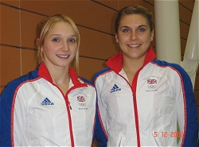  Myles Crouch-Anderson  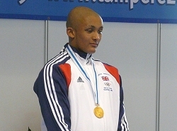  European Youth Olympics 2009

