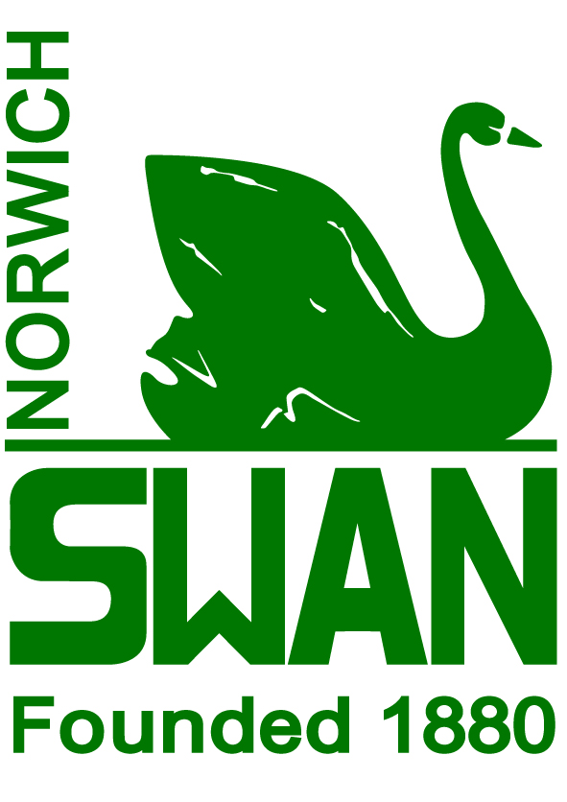
Norwich Swan Swimming Club
Privacy Notice for our Members
We are committed to respecting your privacy. This notice is to explain how we may use personal information we collect before, during and after your membership with us. This notice applies to you if you have registered to become or are a member of our club. This notice explains how we comply with the law on data protection, what your rights are and for the purposes of data protection we will be the controller of any of your personal information.
References to we, our or us in this privacy notice are to Norwich Swan Swimming Club.
We have not appointed a Data Protection Officer to oversee our compliance with data protection laws as we not required to do so, but our Committee has overall responsibility for data protection compliance in our organisation.
- Personal Information we may collect from you
When completing our membership form, we collect and hold the following personal information relating to the member:
- personal contact details that allows us to contact you directly such as name, title, address, email addresses and telephone numbers;
- date of birth;
- gender;
- any credit/debit card and other payment details you provide so that we can receive payments from you and details of the financial transactions with you;
- records of attendance at any events/training hosted by us;
- images in video and/or photographic form with your consent;
- details of Swim England membership number;
- details of emergency contacts;
- records of competition/swim gala & meets including results & attendance;
- comments, notes or information about an Athlete submitted by any end user;
- any disciplinary and grievance information

- Special Categories of Personal Information
We may also collect with your consent, store and use the following “special categories” of more sensitive personal information regarding you:
- information about your health, including any medical information, disabilities, doctor’s information, allergies and dietary requirements, social requirements.
We may not collect all of the above types of special category personal information about you.
In relation to the special category personal data that we do process we do so on the basis that:
- It enables us to provide the best care for our members in training, competition and social events;
- It is necessary for the establishment, exercise or defence of legal claims.

- Where we collect your information
We typically collect personal information about our members, when you apply to become a member of the club and complete a paper membership form and are registered with an account with us at norwichswansc.co.uk via the TeamUnify secure access portal, when you make a query and/or complaint or when you correspond with us by e-mail or in some other way.
If you are providing us with details of, family members and emergency contacts they have a right to know and to be aware of how what personal information we hold about them, how we collect it and how we use and may share that information. Please share this privacy notice with those of them whom you feel are sufficiently mature to understand it. They also have the same rights as set out in the “Your rights in relation to personal information” section below.

- Uses made of this Information
The main purposes for which we process your personal information is to:
- administer the membership you have with us and manage our relationship with you, including dealing with payments and any support;
- send you information including details about competitions, events, training, social events newsletters, club news & updates;
- answer your queries or complaints;
- for the purposes of promoting the club including publishing race and competition results;
- administer attendance at training and competitions;
- comply with our safeguarding requirements;
- ensure your health and safety and for the safe running of club events, competitions, meets and training including sharing medical information with Team Managers at these events.
For some of your personal information you will have a legal, contractual or other requirement or obligation for you to provide us with your personal information. If you do not provide us with the requested personal information we may not be able to admit you as a member or we may not be able to properly perform our contract with you or comply with legal obligations and we may have to terminate your membership. For other personal information you may not be under an obligation to provide it to us, but if you do not provide it then we may not be able to properly perform our contract with you.
Where you have given us your consent to use your personal information in a particular manner, you have the right to withdraw this consent at any time, which you may do by contacting us as described in the "Contacting us" section below.
Please note however that the withdrawal of your consent will not affect any use of the data made before you withdrew your consent and we may still be entitled to hold and process the relevant personal information to the extent that we are entitled to do so on bases other than your consent. Withdrawing consent may also have the same effects as not providing the information in the first place, for example we may no longer be able to provide certain member benefits to you.

- Disclosure of your Personal Information
We share personal information with the following parties:
- Any party approved by you.
- To any governing bodies or regional bodies for the sports covered by our club: to allow them to: properly administer the sports on a local, regional and national level.
- Other swim clubs: to enable competing at competitions, meets, galas.
- The Government or our regulators: where we are required to do so by law or to assist with their investigations or initiatives.
- Police, law enforcement and security services: to assist with the investigation and prevention of crime and the protection of national security.

- Transferring your personal Information Internationally
European privacy law restricts the transfer of personal information outside of Europe without an appropriate data transfer mechanism (e.g., Standard Contractual Clauses, Privacy Shield for US companies, consent, Binding Corporate Rules). As TeamUnify’s parent, SportsEngine, Inc, is based in the United States, to help us comply with European cross-border data transfer rules, TeamUnify have incorporated the European Commission’s Standard Contractual Clauses for processors into their updated subscription agreement. TeamUnify may also at times engage non-European vendors to help deliver services requested from them (e.g., to relay emails). Where this is the case, they shall adopt an appropriate data transfer mechanism to ensure that the personal data with which our club customers entrust us remains protected irrespective of location. To further demonstrate their commitment to privacy, they have transitioned all European Clubs from their data storage facility in the United States to Amazon’s Amazon Web Services data centre in Ireland.

- How long do we keep Personal Information for?
The duration for which we retain your personal information will differ depending on the type of information and the reason why we collected it from you. However, in some cases personal information may be retained on a long-term basis: for example, personal information that we need to retain for legal purposes will normally be retained in accordance with usual commercial practice and regulatory requirements. Generally, where there is no legal requirment we retain all physical and electronic records for a period of 1 year after your last contact with us or the end of your membership. Exceptions to this rule are:
- Information that may be relevant to personal injury or discrimination claims may be retained until the limitation period for those types of claims has expired. For personal injury or discrimination claims this can be an extended period as the limitation period might not start to run until a long time after the event.
It is important to ensure that the personal information we hold about you is accurate and up-to-date, and you should let us know if anything changes, for example if you change your phone number or email address. You may be able to update some of the personal information we hold about you through our membership portal vial www.norwichswansc.co.uk Alternatively, you can contact us by using the details set out in the "Contacting us" section below.
- Our Website
Our website is set up to provide members and the public with the relevant information about Norwich Swan Swimming Club.
It includes details of recent achievements of our members and results and times of individual members from recent events. It does not contain any further personal data about the members. The website is not set up to allow transactions to be carried out through the website. It is available generally on the world wide web. Access to our swim team manager portal is via the website but is secure to members only.
Our site may, from time to time, contain links to and from the websites of our partner networks, sponsors advertisers and affiliates. If you follow a link to any of these websites, please note that these websites have their own privacy policies and that we do not accept any responsibility or liability for these policies. Please check these policies before you submit any personal data to these websites
The club has the following social media pages: Facebook/Instagram page and Twitter. All members are free to join these pages. If you join one of the Social Media pages, please note that the provider of the social media platform(s) have their own privacy policies and that the club do not accept any responsibility or liability for these policies. Please check these policies before you submit any personal data on the club social media pages.

- Your Rights in Relation to Personal Information
You have the following rights in relation to your personal information:
- the right to be informed about how your personal information is being used;
- the right to access the personal information we hold about you;
- the right to request the correction of inaccurate personal information we hold about you;
- the right to request the erasure of your personal information in certain limited circumstances;
- the right to restrict processing of your personal information where certain requirements are met;
- the right to object to the processing of your personal information;
- the right to request that we transfer elements of your data either to you or another service provider; and
- the right to object to certain automated decision-making processes using your personal information.
You should note that some of these rights, for example the right to require us to transfer your data to another service provider or the right to object to automated decision making, may not apply as they have specific requirements and exemptions which apply to them and they may not apply to personal information recorded and stored by us. For example, we do not use automated decision making in relation to your personal data. However, some have no conditions attached, so your right to withdraw consent or object to processing for direct marketing are absolute rights.
Whilst this privacy notice sets out a general summary of your legal rights in respect of personal information, this is a very complex area of law. More information about your legal rights can be found on the Information Commissioner’s website at www.ico.org.uk
To exercise any of the above rights, or if you have any questions relating to your rights, please contact us by using the details set out in the "Contacting us" section below.
If you are unhappy with the way we are using your personal information you can also complain to the UK Information Commissioner’s Office or your local data protection regulator. We are here to help and encourage you to contact us to resolve your complaint first.
- Changes to This Notice
We may update this privacy notice from time to time. When we change this notice in a material way, we will update the version date at the bottom of this page. For significant changes to this notice we will try to give you reasonable notice unless we are prevented from doing so. Where required by law we will seek your consent to changes in the way we use your personal information.
- Contacting Us
In the event of any query or complaint in connection with the information we hold about you, please get in contact with the Norwich Swan Committee via this email membership@norwichswansc.co.uk

