*Taunton Deane Water Polo Player Pathway*

*Introduction*

The Purpose of our Water Polo Pathway is to provide a framework for the development of young people into water polo players.

Water polo is one of the most demanding of all team games. It is a contact sport typically played in a deep pool and players need stamina, strength and endurance to play the game. The early stages of our Water Polo Pathway, which is consistent with the principles of long-term athlete development, is designed to meet the needs of children. The adult game in deep, full-size pools does not meet the needs of young children. Children need a modified game that fits their needs; children should not be modified to meet the demands of the game. In our Water Polo Pathway we modify the game while at the same time giving them a real water polo experience.

Culture of fun and learning

We want to develop a culture which is about players having fun with their friends and learning to play water polo. The focus in mini polo and junior water polo is not on winning, but on enjoyment and development. We do not put pressure on young players and coaches to win, the emphasis is on growth and development. Having said that, it is clear that most young players prefer winning to losing, so if they can be encouraged in a positive way to develop their skills, it will follow that their teams are more likely to be successful.

It is a fine balance that needs to be struck, but it is nevertheless clear that the most successful and effective coaches are those that encourage and nurture rather than those who voice their upset at losing and criticise young players. Coaches, parents and players therefore need to understand that there is no pressure to win and that we want to create an environment in which we can win, without a win-at-all-costs mentality.

*Mini Polo- Stage 1*

In Stage 1, children play mini polo. This is a game children can actually play rather than struggling to understand and cope with the physical demands of a game created for and played by adults. We want young players to enjoy playing water polo, and for this they need to:

feel success take an active part in the game learn to play as a team understand the rules develop polo skills be able to take part whatever their ability develop their fitness

We will achieve this by playing mini polo in field and goal sizes that meet the needs of children, and with a reduced number (preferably 5 aside). These games offer a water polo experience in an environment that allows every player in the water to be involved and the development of ‘game understanding’.

Mini polo is a smaller, more basic version of water polo and has been introduced to teach young players the fundamentals of the full game. In fact, the fewer rules there are, the easier it is for young players to learn and, more importantly, the more fun it is. For example, if players cannot swim yet, let them stand up. If they cannot catch with one hand yet, let them catch with two.

The polo skills we teach at this level are primarily catching, passing, shooting, dribbling and game understanding. Players develop hand-eye coordination, basic team play and decision-making skills.

*Junior Water polo – Stage 2-3*

In Stage 2 (typically U13), sessions take place in deep water and introduce young players to the physical demands of water polo. In Stage 2 we concentrate on the development of:

body movement skills such as eggbeater, sculling, jumping, jump half turns and turning swim skills such as water polo front crawl and water polo backstroke ball-control skills such as how to pick up and hold a ball, catching, passing and shooting

At this age players do not have specialist positions, but learn how to play in a range of positions. Players also continue to develop their game understanding with the introduction and development of basic tactical skills. As with mini polo, this is achieved by playing in field and goal sizes that meet the needs of the children. Games typically take place in a reduced area with junior floating goals that are two thirds the size of normal goals. In this stage players are introduced to competition in local leagues and competitions.

In Stage 3 (typically U15) we continue to concentrate on the development of core techniques and expose the players more to matches in full-size pitches with full-size goals. We introduce the players to other key skills such as blocking, releasing, driving and protecting the ball. Players develop basic tactical skills and an understanding of all positions (general ability to play in all). In this stage players compete in local leagues and competitions.

*Junior Water polo – Stage 4*

In Stage 4 (typically U17) players develop more advanced tactical skills, for example they learn about setting up the arc, man-up and man-down. They also start to focus on one or two positions. At this stage of their development players are fluent in the core techniques they have learned and developed in Stages 1-3. They specialise in one or two positions and develop the skills required to play in these positions (centre forward, centre back, wings, drivers and goalkeeper).

In Stage 4 players can also train with the senior teams and develop tactical game play. Boys start to integrate into the senior teams in development matches, while girls, who typically mature physically at a younger age, often play senior water polo. In this stage players compete in local leagues and competitions.

*Senior Water polo – Stage 5*

In Stage 5 (adult water polo) we still continue to develop techniques and practise drills that are relevant to both individual and tactical play, as well as those skills learned in Stages 1-4.

At this stage we

play to win

specialise in one or two positions

compete in local leagues and competitions

Although we play to win, it is just as important in Stage 5 as in Stages 1-4 to find the right balance between winning and development. Younger adults who are not yet strong enough for the senior teams will continue to have the opportunity to represent the club in development friendlies and tournaments. Numbers permitting, we will also enter U19 competitions.

*Other Key Information*

External development

In Stages 2-4 our more capable players have the opportunity to take part in Regional and National Academies (invitation only).

Cooperation with other clubs

We also cooperate with other clubs so that our players can take part in competitions such as the National Age Group competitions, the Bristol & West Water Polo League, Devon Water polo league and major invitational events. Our players are encouraged to play for other clubs if we do not enter these events ourselves.

We also invite other clubs into our sessions in all stages to train and play development matches with us. This allows us to learn from each other, and it also allows players to gain match experience in development games.

Swimming sessions

Players with aspirations to play at a high level should also attend the club’s swimming sessions. It is no coincidence that our stronger players are those who attend two or three swimming sessions a week on top of their water polo training.

Flexible approach We adopt a flexible approach to the application of this Water Polo Pathway, and no skill is exclusive to any stage. We will occasionally teach skills in Stage 2 that are a focus in Stage 3. And in Stage 5 we will practise skills developed in all of the previous stages.

We also recognise that players develop physically and technically at different rates/ages. We allow players to train in the groups that we feel are right for their development and will not assign them to training groups purely on account of their age.

Stage 1 - Mini Polo FUNdamentals

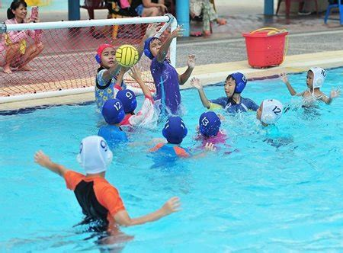

* Half-hour swim session and half hour game in standing depth
* Focus on basic skills: catching, passing, shooting, dribbling
* Smaller goals, smaller pitch size, smaller balls.
* Develop basic team play and decision-making skills in small sided games
* Introduction to competition in local tournaments

Mini Polo 1

Basic skills: Learn to swim, Hand-eye coordination, Basic team play, Mini polo games, Decision-making skills

Mini Polo 2

Movement skills: Learning and development of core body movement skills, Eggbeater, Sculling, Jumping and scissor, Upper body movement

Swim skills: Head-up frontcrawl, Head-up backcrawl, Spider

Ball control skills: Picking up ball, Catching, Passing, Shooting

Tactical: Decision-making skills

***Players typically of primary school age***

***Training Sunday’s 5pm***

Stage 2 - Junior Polo - Learning to play

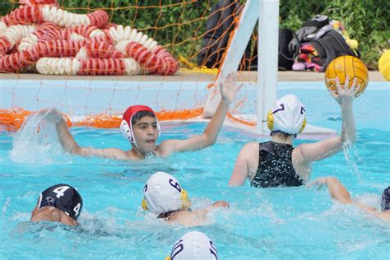

* Deep water sessions – introduction to the physical demands of water polo
* Focus on body movement skills, swim skills and ball-control skills
* Players learn to play in a range of positions
* Develop basic team play and decision-making skills in small sided games with midi goals
* Introduction to competition in local tournaments and leagues

Continue to develop all skills learned in previous levels

Swim skills: Development of aerobic base Maintenance and improvement of core skills

Body movement skills: Eggbeater Sculling Jumping Jump half turns Turning

Ball-control skills: How to pick and hold a ball Catching Passing Shooting - range of shots (back shots, push, tip, etc.)

External: Regional Academy National Academy

Cooperation with other clubs: Players are encouraged to play for other clubs in major events that we do not enter ourselves.

Joint training sessions and development matches with other clubs

Swimming sessions: Our stronger players attend two or three swimming sessions a week on top of their water polo training

***Players typically U13***

***Training Thursday and Sunday***

Stage 3 - Junior Polo - Training to train

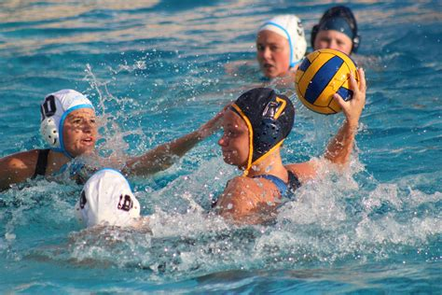

* Continue to concentrate on the development of core techniques
* Expose players more to matches in full-size pitches with full-size goals
* Players start to focus on one or two positions
* Develop more advanced tactical skills
* Compete in local leagues and competitions

Continue to develop all skills learned in previous levels

Other key skills: Blocking Releasing Driving Shooting Protecting the ball

Tactical: Introduction and development of basic tactical skills Understanding of all positions (general ability to play in all)

External: Regional Academy National Academy

Cooperation with other clubs: Players are encouraged to play for other clubs in the National Age Group competitions, the BWPL and major events that we do not enter ourselves

Joint training sessions and development matches with other clubs

Swimming sessions: Our stronger players attend two or three swimming sessions a week on top of their water polo training

***Players typically U15***

***Training Thursday and Sunday***

Stage 4 - Junior Polo - Training to compete

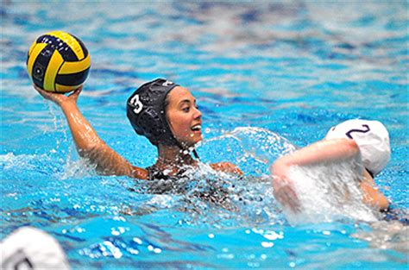

* Continue to concentrate on the development of core techniques
* Specialise in one or two positions
* Develop tactical game play in training in own age group and with the senior teams
* Boys integrate into senior teams in development matches, Girls break into Senior team
* Compete in local leagues and competitions

Continue to develop all skills learned in previous levels

Specialisation of position: Narrowing down positional play to 1 or 2 positions Development of skill relative to position: Centre Forward Centre Back Drivers Goalkeepers

Tactical progression: Defensive tactics: Press, Zones, 6v5 Attack and breaking down defences

Decision-making drills: Counter attack, 1v0 to 5v4 Responsibility/ leadership

External: Regional Academy National Academy

Cooperation with other clubs: Players are encouraged to play for other clubs in the National Age Group competitions, the BWPL and major events that we do not enter ourselves

Joint training sessions and development matches with other clubs

Swimming sessions: Our stronger players attend two or three swimming sessions a week on top of their water polo training

***Players typically U17***

***Training Thursday and Sunday***

Stage 5 - Senior Polo - Training to perform/win

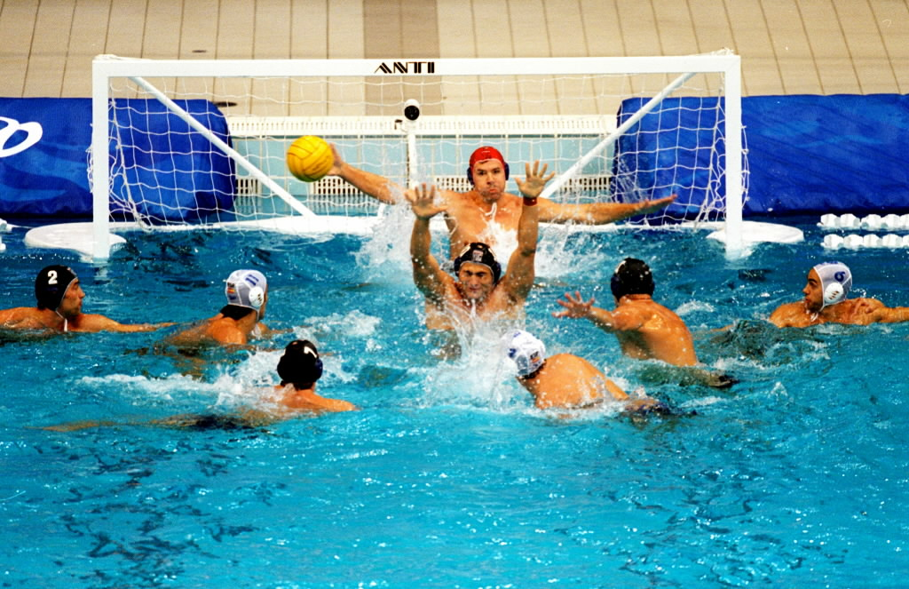

* Play to win
* Specialise in one or two positions
* Techniques and drills relevant to both individual & tactical play
* Integrate younger players in development matches
* Compete in local leagues and competitions

Continue to develop all skills learned in previous levels

Techniques and drills: relevant to both individual & tactical play

Cooperation with other clubs: Players are encouraged to play for other clubs in the BWPL and major events that we do not enter ourselves

Joint training sessions and development matches with other clubs

Swimming sessions: Our stronger players attend two or three swimming sessions a week on top of their water polo training

***Training Thursday and Sunday***

***Players of any age***

[www.tdswim.co.uk](http://www.tdswim.co.uk)

[tauntonwaterpolo@outlook.com](mailto:tauntonwaterpolo@outlook.com)