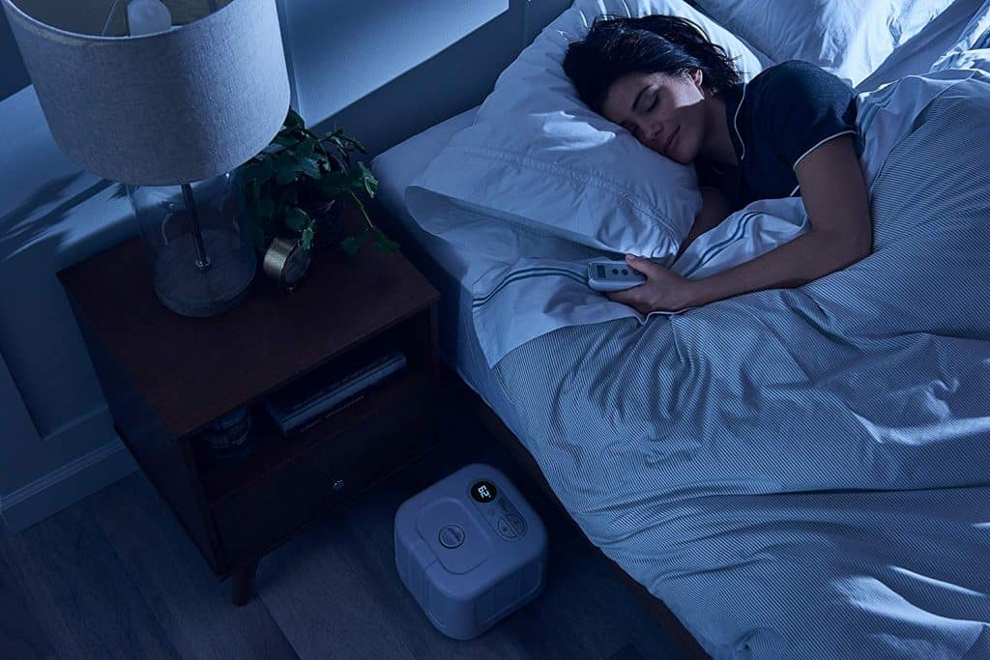
Getting into a routine:

DAILY ROUTINE
  - MAKE IT COUNT
Over the coming weeks and months, getting into a structured routine is going to be vital for all family members. Whether the club swimmers are distance learning, with lessons available online or taking an extended Easter break, it is very easy to fall into bad and unhealthy habits, whether that is going to bed too late, getting up too late or spending 50% of the day in front of a computer or TV screen.
Now is the time to set yourself up with a daily and weekly schedule that is going to work for you!
With swimming training currently on hold, Leisure Centres temporarily closed and the majority of the population going into self-isolation, for your own mental health and well-being, it is important to get outside, take in the fresh air and take yourself off for a jog, run (comfy / suitable footwear) or bike ride (wear a helmet!). Don’t let your hard work and fitness go backwards, after each one of you has worked so hard since the start of the season. Keeping the momentum going through this challenging time and keeping yourselves fit and healthy is going to be paramount as every one of us goes through this period.
Why do we need a routine? There are hundreds of reasons, but I have listed a few below:
- Creates structure in our lives - especially now, when we need it the most
- Allows us to develop good habits and eradicate bad habits
- Helps to foster traits that match our goals and aspirations (know what they are!)
- Makes us more efficient and saves time
- Builds confidence
- Helps to reduce stress and facilitates relaxation – health and well-being
- Sets us up to achieve our goals further down the line
- Gives us the ability to keep track of our progress
- Allows you to get a good night’s sleep – it is the hours before midnight that count!
TIME | ACTIVITY | WHAT DOES IT INVOLVE? | ACHIEVED?
BEFORE 8AM | WAKE UP | NOT LAYING IN BED UNTIL PAST 8AM! | HOPEFULLY!
8AM – 9AM | GETTING READY FOR THE DAY AHEAD | OUT OF BED, SHOWER, BREAKFAST | YES
9AM – 12:30PM | ACADEMIC TIME | TO INVOLVE UP TO 3 SUBJECTS INCLUDING A 30 MINUTE BREAK | FINGERS CROSSED
12:30PM – 1:30PM | LUNCH | EAT HEALTHY – GO OUTSIDE FOR FRESH AIR / ACTIVITY | YES
1:30PM – 3:30PM | ACADEMIC TIME | TO INVOLVE UP TO 3 SUBJECTS | YES
3:30PM – 5:00PM | ACTIVITY TIME | GO OUT FOR A RUN, TAKE A BIKE RIDE, DO SOMETHING! | YES
5:00PM – 9:00PM | DOWN TIME AND FAMILY TIME | WATCH A MOVIE, READ A BOOK, PLAY A BOARD GAME, DINNER WITH THE FAMILY | YES
9:00PM – 10:00PM | BED TIME | GETTING READY FOR BED | HOPEFULLY!
TIME | ACTIVITY | WHAT DOES IT INVOLVE? | ACHIEVED?
BEFORE 8AM | WAKE UP | NOT LAYING IN BED UNTIL PAST 8AM! | YES
8AM – 9AM | LEARN SOMETHING NEW | TAKE TIME FOR YOURSELF TO LEARN SOMETHING NEW | YES
9AM – 12:30PM | CREATIVE TIME | DRAW, CRAFTS, PLAY MUSIC | YES
12:30PM – 1:30PM | LUNCH | EAT HEALTHY – GO OUTSIDE FOR FRESH AIR / ACTIVITY | YES
1:30PM – 2:30PM | HOUSEHOLD CHORES | HELP OUT AROUND THE HOUSE | YES
2:30PM – 4:30PM | QUITE TIME | READ A BOOK OR COMPLETE A PUZZLE | YES
4:30PM – 9:00PM | ACTIVITY, DOWN TIME AND FAMILY TIME | GO FOR A RUN, WATCH A MOVIE, DINNER WITH THE FAMILY | YES
9:00PM – 10:00PM | BED TIME | GETTING READY FOR BED | HOPEFULLY!

