Raise Temperature
- 30 seconds – Jumping Jacks
- 30 seconds – HIGH knees Jogging
- 30 seconds – Jumping Oblique Twist
- 30 seconds – Mountain Climbers
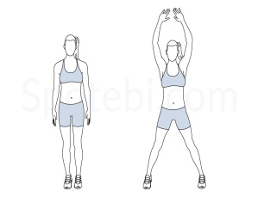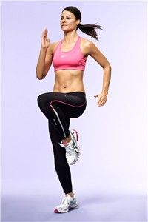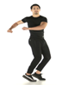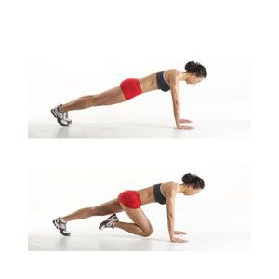

Mobilise Key Joints
- X 20 – Standing T shape, Internal/External Shoulder Rotations (make a fist)
- X 10 – 4 Point Kneeling Thoracic Rotations (on each side)
- X 20 – Spider Man Switches

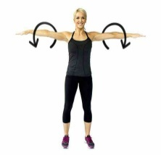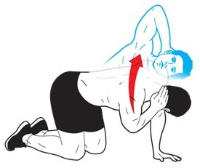

Activate Key Muscles
- X 20 – 4 Point Kneeling Super Man Stretch
- X 10 – Mini Hold Glute Bridges
- X 10 – Walk Outs
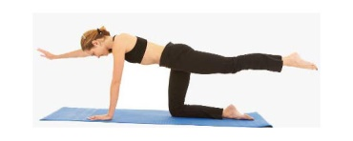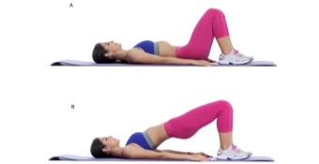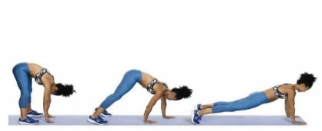

Prime Key Muscles
- X 30/20/10 – Press Up’s (on knees or if technique fails)
- X 30/20/10 – Prisoner Squats
- X 5 –BIG Jump Squats
