Step or Box Spine Drops
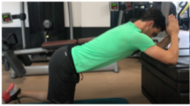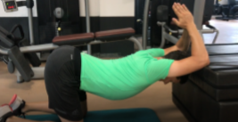
Kneeling with the elbows on a box, step or chair. Lean backwards and downwards to stretch the thoracic spine making a dip in the spine. Finally drop the head to be in line with the spine
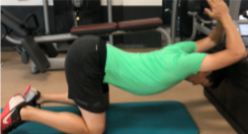

Leant forward, 90° Shoulder Extensions
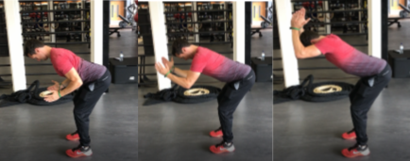
Attach a band around the wrist or squeeze a body width solid object between the palms of your hands. Make sure there is tension and the wrists & elbows are shoulder width apart.
Take up a forward lean hip flexed position. Make sure the back is straight and core tight. Maintain the spine position and take the arms forwards above the head. Make sure the back does not move

Broom Extensions
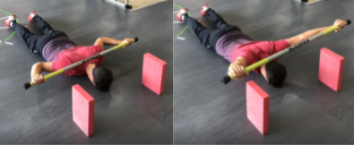
Lying on the front with a dowel behind the neck. Have 2 posts as markers so you know how far to lift. This can be a water bottle, cone or foam block Extend the arms above the head to the outstretched position and make sure they are above the marker Return and repeat

Floor Angels
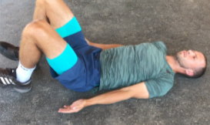
Lying on your Back with the knees bent and back in a neutral position. Keep the back on the floor and do not arch during the exercises.
Slowly move the arms away from the side and up above the head as far as the back allows if the back arches stop and bring the arms back down.
Keep the arms on the floor during the exercise
