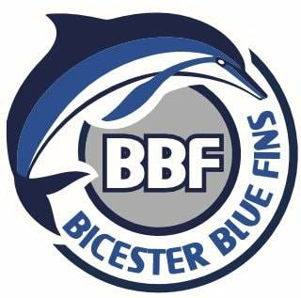

Bicester Blue Fins GDPR Consent form – Please return a hard copy to Craig, Charlotte, Joe or Neil by May 13th.

Name of individual: ______________________________
Lessons/Mini Fins/Squads: _________
Parent /Guardian signature (if required):

___________________________________

Date: _________

Please tick the relevant box(es) below and delete as appropriate.

I am happy for an authorised Bicester Blue Fins representative to take images of me/my child.

I am happy for images of me/my child to be used on Team Unify, team feed, Facebook, Twitter and Instagram.

I am happy for images of me/my child to be used in local newspapers and national press.

I am happy for any video/audio clips to be taken of me/my child and used in promotional material.

I am happy for images of me/my child to be used on print promotional material.

I am NOT happy for Bicester Blue Fins to take or use images of my me/my child.

