COCA Winter Splash – Level 3 (Licence Number TBC)
Under Swim England Laws & Technical Rules

7th & 8th December 2019

The Magnet Leisure Centre, Maidenhead, SL9 8AW

The COCA Winter Splash is a meet promoted by Amersham Swimming Club in partnership with Chesham and Chalfont Otters swimming clubs.

PROGRAMME OF EVENTS

Saturday 7th December
Session 1  (Warm up: TBA; Start: TBA) |  | Session 2  (Warm up: TBA; Start: TBA)
Event 1 | Boys 400m IM | Event 8 | Girls 200m IM
Event 2 | Girls 200m Freestyle | Event 9 | Boys 400m Freestyle
Event 3 | Boys 50m Butterfly | Event 10 | Girls 200m Butterfly
Event 4 | Girls 100m Butterfly | Event 11 | Boys 50m Freestyle
Event 5 | Boys 200m Backstroke | Event 12 | Girls 100m Freestyle
Event 6 | Girls 50m Breaststroke | Event 13 | Boys 200m Breaststroke
Event 7 | Boys 100m Breaststroke | Event 14 | Girls 50m Backstroke
 |  | Event 15 | Boys 100m Backstroke
Sunday 8th December
Session 3  (Warm up: TBA; Start: TBA) |  | Session 4  (Warm up: TBA; Start: TBA)
Event 16 | Girls 400m IM | Event 23 | Boys 200m IM
Event 17 | Boys 200m Freestyle | Event 24 | Girls 400m Freestyle
Event 18 | Girls 50m Butterfly | Event 25 | Boys 200m Butterfly
Event 19 | Boys 100m Butterfly | Event 26 | Girls 50m Freestyle
Event 20 | Girls 200m Backstroke | Event 27 | Boys 100m Freestyle
Event 21 | Boys 50m Breaststroke | Event 28 | Girls 200m Breaststroke
Event 22 | Girls 100m Breaststroke | Event 29 | Boys 50m Backstroke
 |  | Event 30 | Girls 100m Backstroke

VENUE

This gala will take place at The Magnet Leisure Centre, Maidenhead, SL6 8AW which offers an eight lane 25m pool with full electronic timing (AOE) and anti-turbulence lane ropes. A secondary starting strobe is not available at this venue.

Promoter’s Conditions and Competition Rules

The meet is affiliated to Swim England South East region and will be held under Swim England laws and technical rules together with the conditions and rules described herein (“Conditions”).

AGE GROUPS

The age groups are 9, 10, 11, 12, 13, 14, 15, 16+.
Ages are determined by the swimmer’s age on 8th December 2019.
Minimum age for entries is 9 years.

EVENTS

50m/100m/200m all strokes plus 400m Freestyle and 200m/400m IM.
All events are open to all age groups with the exception of the 400 IM which is only for swimmers aged 11 years and above.
Heats will be run with all ages seeded together based on entry times and the slowest swimmers first.
Over the top starts may be used at the referee’s discretion.
For upper qualifying times, refer to the table on the last page of the conditions.
The Promoter reserves the right to amend the programme of events after consultation with the participating clubs and the officials to ensure the smooth running of the meet.

FEES

Entry fees: £6.00 per event (to include the regional levy per event)
Spectator Entry: £4.00 per session, £6.00 for a full day
Day Coach passes: £25 per pass, to include poolside access, meals and refreshments (weekend)

The preferred method of payment is via BACS, refer to the individual or group entry forms for details. Alternatively, payment can be accepted by cheque, made payable to “Amersham Swimming Club”. One combined cheque per club please.

REGISTRATION

Swimmers must SIGN IN before EACH session and before warm up starts. Any swimmer not signed in by this time will be withdrawn from that session and no money will be refunded.

When called for an event, swimmers must report to the competition stewards. Coaches/Team Managers will be provided with heat sheets. To allow for a smooth running of the meet please ensure your swimmers are aware of their heat and lane number when they come to the marshalling area. It is the responsibility of the individual to report to the stewarding area in sufficient time for each event.

The promoter will not be held responsible for a swimmer missing the start of their particular heat.

Promoter’s Conditions and Competition Rules

WARM UP

The pool will be available for warm up at the start of each session. Timings given in the programme of events are indicative and will be confirmed in the meet programme.

Swimmers should swim in the direction indicated by the lane direction cards during warm up or as directed by the announcer. Sprint lanes will be announced.

AWARDS

All awards are on a heat declared winner basis. Medals will be awarded to the top three placed swimmers in each age group for each event. Medals should be collected from the awards table once the event results are available. Please ensure that all medals are collected by the end of the second day as they will not be posted onto clubs.

ENTRIES

The opening date for entries is 12 noon on Saturday 12th October 2019. In the event of the Meet being oversubscribed, entries will be accepted on a ‘first come/first served’ basis. The closing date for entries is 12 noon on Saturday 16th November, or sooner if the meet becomes full.

Entries must fall within the qualifying times and must include date of birth and ASA registration number details. The names and club for each swimmer must be the same as that registered with the ASA. All events will be seeded on submitted times, which may be checked against the British Rankings database.

Club entries must be made using the Hytek Meet Manager software format. The entry file via Hytek will be available from meets@amershamswimmingclub.co.uk. Manual entry forms are also available within this entry pack. There is a £5 supplement per swimmer for Manual entries.

All completed entries should be sent in by email to meets@amershamswimmingclub.co.uk along with the completed Entry Summary Form.

No entries (including manual entries) will be accepted without the completed Entry Summary Form, appropriate entry fees, submitted times and ASA registrations. For all enquires please contact the Promoter on meets@amershamswimmingclub.co.uk.

Details of accepted entries will be posted on the Amersham Swimming Club web site under the “EVENTS” section as soon as possible after the closing date.

The Promoter reserves the right to restrict entries in order to meet allocated pool time or on health and safety grounds. Any entry not accepted will be refunded in full. Refunds will be done via BACS. Any swimmer withdrawing prior to the meet entry closing will receive a full refund. After meet closing and up

Promoter’s Conditions and Competition Rules

to the day before the gala, refunds can only be provided on receipt of proof of injury through a doctor’s certificate or similar.

Time trials may be accepted on the day at the discretion of the Promoter and are used to fill spare lanes if available after seeding is completed. Time trials will have ‘EXH’ (Exhibition) appended to their name in the results and the swim will not count in terms of awards. However, times will count for rankings. Requests for time trails must be submitted before registration closes.

The submission of entries will indicate acceptance of these Conditions. Any circumstances not addressed in the competition rules will be dealt with in accordance with the laws of the sport and at the discretion of the Promoter.

OFFICIALS

All clubs submitting entries are kindly requested to assist in the running of the meet by providing licensed officials. Please provide names and contact details for any willing officials on the entry form or by email to vicechairman@cheshamswimmingclub.org. Expenses and refreshments will be provided.

PARKING

The Magnet Leisure Centre has pay and display car parking on site. Additional parking is available across the road at the Hines Meadow Car park, connected to the Leisure Centre via a pedestrian bridge.

HEALTH AND SAFETY

All participants must observe the rules and safety precautions in operation at the venue.

It is the responsibility of the Coach and/or Team Managers to ensure that all swimmers can execute a competent racing dive. No swimmer should topple into the water in the event of a false start – a proper shallow dive must be performed.

For safety and comfort reasons we request that any large swimming bags are not kept poolside (or in the spectator gallery) but are placed in the lockers provided. The use of lockers will require a padlock and it is possible to bring your own or hire one from the reception.

Possessions and articles must not be left unattended as neither the Promoter or Magnet Leisure Centre will accept any liability for any loss or damage that may occur during the meet.

The Teaching pool, bubble pool, Jacuzzis and slides are out of bounds at all times to all swimmers.

The changing rooms are unisex and will be patrolled during the meet to ensure the safety of all the swimmers. It should also be noted that the Magnet Leisure Centre has security cameras in operation in this area.

Promoter’s Conditions and Competition Rules

Swimmers must wear suitable clothing and footwear when poolside. Prior to leaving the pool area, swimmers must dry off and put on appropriate clothing and footwear.

Behaviour of the swimmers is the responsibility of their swimming clubs at all times. Passes are required for all non-swimmers accessing poolside. This includes coaches, team managers and chaperones. The DBS details of each individual must have been supplied with the Coach/Chaperone Poolside Pass Application form in this entry pack. As a guide, a ratio of 1:10 adult to swimmers (including coach/team managers) should be considered as the minimum requirement.

Everyone attending this Meet must familiarise themselves with the location of the emergency exits, which must be kept clear at all times. There is to be no standing on the stairways. Everyone is asked to observe normal precautions in the pool area when moving around.

GDPR

By submitting entries consent is given to the holding of personal information on a computer. This information/data will be processed for the running of the meet. The Promoter will hold the data for up to 18 months in electronic form after which it will be deleted. Personal data, including submitted and recorded times and age may be made public during the meet. Data will be shared with the ASA for the purpose of uploading times to rankings. All data is collected and stored in accordance with our data protection policy.

VIDEO RECORDING / PHOTOGRAPHS AND MOBILE TELEPHONES

In accordance with the Magnet Leisure Centre’s policy NO photography or video recording is allowed. No cameras, video or digital capturing device (including mobile phones) may be used in the changing area. This policy will be vigorously enforced and any person found to be contravening this policy may be asked to leave the gala without refund. We request that mobile telephones are switched to silent during the competition.

APPEALS

Any appeals must be submitted in accordance with ASA procedures and will be handled by the Promoter and Referees.

CONTACT DETAILS

The promoter of this meet is Lynn Andrews on behalf of Amersham Swimming Club, in partnership with Chesham and Chalfont Otters Swimming Clubs.

For information regarding the meet please refer to the “EVENTS” page at http://www.amershamswimmingclub.co.uk.

Promoter’s Conditions and Competition Rules

For queries and submission of electronic entry files please email openmeets@amershamswimmningclub.co.uk.

Any point not covered by these rules will be at the discretion of the Promoter. Depending on the situation, the Promoter or Referees decision, respectively, will be final.

LOWER QUALIFYING TIMES

There are no lower qualifying times for this meet

UPPER QUALIFYING TIMES
Entry times should be short course, or converted to short course.

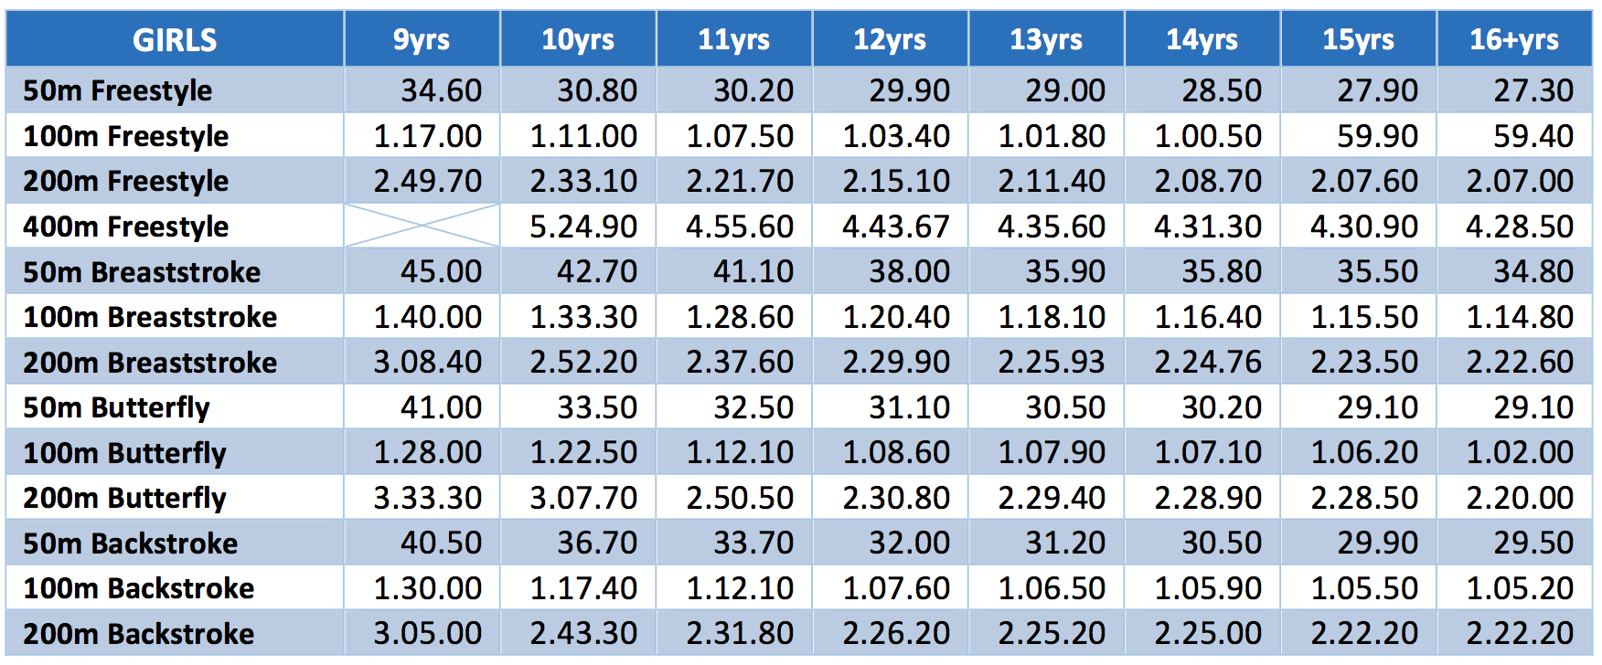

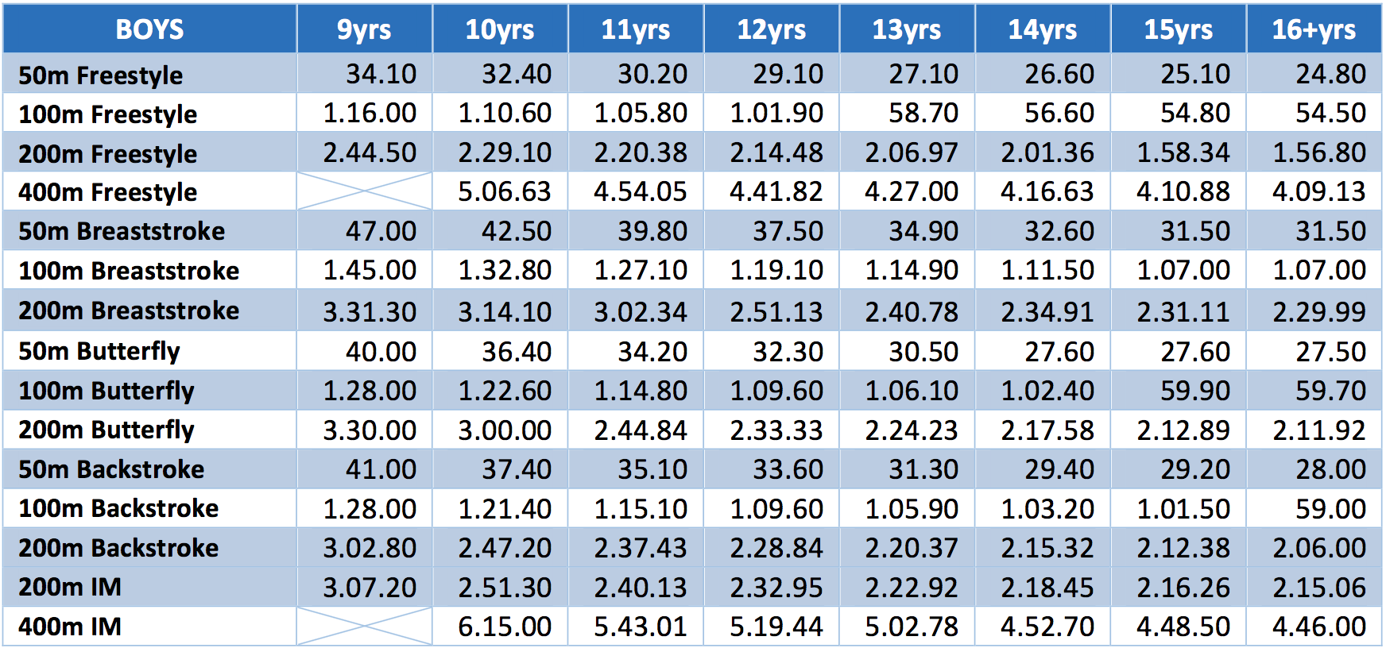

MANUAL ENTRY FORM

Name: Club:
Gender: Club code:
Date of birth: Age as at 08-12-19:
ASA Member ID:
Saturday 7th December
Session 1  (Warm up: TBA; Start: TBA) |  | Entry Time | Session 2  (Warm up: TBA; Start: TBA) |  | Entry Time
Event 1 | Boys 400m IM |  | Event 8 | Girls 200m IM
Event 2 | Girls 200m Freestyle |  | Event 9 | Boys 400m Freestyle
Event 3 | Boys 50m Butterfly |  | Event 10 | Girls 200m Butterfly
Event 4 | Girls 100m Butterfly |  | Event 11 | Boys 50m Freestyle
Event 5 | Boys 200m Backstroke |  | Event 12 | Girls 100m Freestyle
Event 6 | Girls 50m Breaststroke |  | Event 13 | Boys 200m Breaststroke
Event 7 | Boys 100m Breaststroke |  | Event 14 | Girls 50m Backstroke
 |  |  | Event 15 | Boys 100m Backstroke
Sunday 8th December
Session 3  (Warm up: TBA; Start: TBA) |  | Entry Time | Session 4  (Warm up: TBA; Start: TBA) |  | Entry Time
Event 16 | Girls 400m IM |  | Event 23 | Boys 200m IM
Event 17 | Boys 200m Freestyle |  | Event 24 | Girls 400m Freestyle
Event 18 | Girls 50m Butterfly |  | Event 25 | Boys 200m Butterfly
Event 19 | Boys 100m Butterfly |  | Event 26 | Girls 50m Freestyle
Event 20 | Girls 200m Backstroke |  | Event 27 | Boys 100m Freestyle
Event 21 | Boys 50m Breaststroke |  | Event 28 | Girls 200m Breaststroke
Event 22 | Girls 100m Breaststroke |  | Event 29 | Boys 50m Backstroke
 |  |  | Event 30 | Girls 100m Backstroke

Total number of entries =
Total cost of entries (£6 per event) =
Total cost (to include £5 fee for manual entry) =

Manual entries, along with the summary entry form, should be emailed to meets@amershamswimmingclub.co.uk

SUMMARY ENTRY FORM

Club & Code
Contact address
Tel no:
Email:
Total no of entries |  | Total cost of entries @ £6 each
No of swimmers entered manually |  | Manual entry supplement @ £5 each swimmer
No of poolside passes |  | Total cost of passes @ £25
TOTAL COST
Preferred method of entry is via Hy-Tek file accompanied by scanned copie of this form.

BACS payments can be made to:

Amersham Swimming Club
HSBC, Amersham
Sort Code: 40-08-41
Account number: 71075233
PLEASE USE REFERENCE COCA19 followed by your club code for BACs payments

Payment by cheque should be sent to:

Amersham Swimming Club
c/o Chiltern Pools
Bensheim Way
Amersham
HP6 5AH

