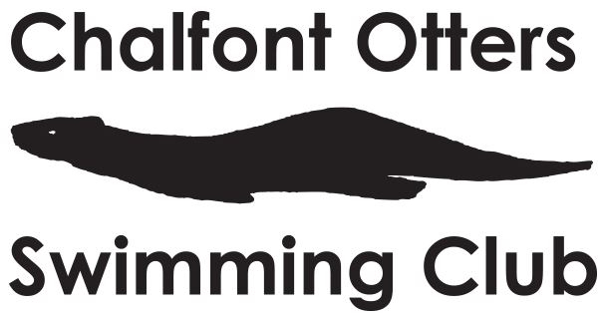

What is the Thames Valley Junior League?
The League aims to promote and develop competitive swimming in children between the ages of 9 and 12. The competition takes place over three rounds and the bottom two teams will get relegated at the end of those three rounds.
Does it matter if I am Team A or B?
No! Both teams will face competition from national, regional or county swimmers, for example in Round 1 our B team faced competition from national level swimmers. It is a privilege to be in either team. This is a hard competition and we need our best and most reliable swimmers, in other words - you.
Should I attend?
Yes, it is important you do. Some clubs make participation in these events mandatory. That is not our ethos! We understand our swimmers have other commitments and would like to be as flexible as possible. What we do ask is that refusal should only be in exceptional circumstances. In these meets, you are competing as part of a team and essentially it is the team that cannot perform at its best without you. If you do accept, but either drop out at the last minute without a suitable reason or fail to turn up without reason, you shall not be selected for another team event.
Our coaches take times for all their swimmers during these events and keep a close eye on performance and behaviour. This is a brilliant opportunity to demonstrate your capability and also gain some competition practice for your individual meets. At the same time, we are keen to develop a "team" spirit and see swimmers supporting each other throughout the meet. We keep an eye on all of this for future meets and development opportunities that may arise for a select few in the future and participation in league events is something we include in our decisions.

April 2021

