Elmbridge Phoenix Swimming Club
ASA Competitive Performance Awards Badge Request

Any questions please contact awards@elmbridgephoenix.com

Swimmer’s Name and Squad

Parent’s name and contact details (email/mobile)

Circular Badges & Certificate  (£3 each) | Number Required | Strokes | (25m/  50m) | Time achieved (min;sec)
Bronze
Silver
Gold
Platinum
Flashes Required (£1 each)
Bronze
Silver
Gold
Platinum
In which gala/s were the times achieved? (Name and date)

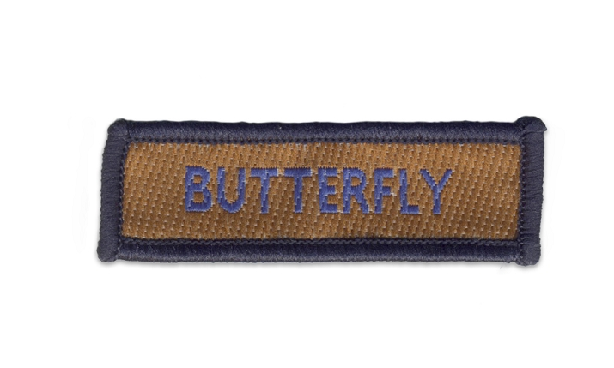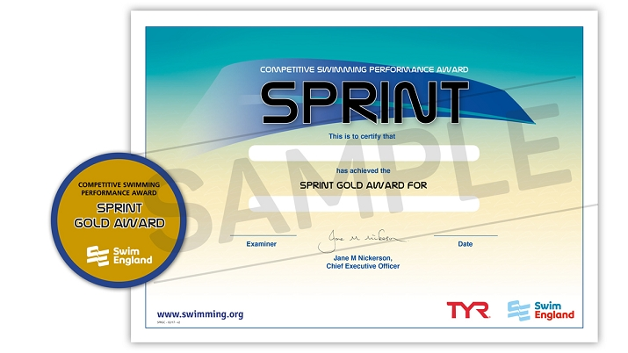
Please put the cash in an envelope with this completed form. Put “ASA Awards” on the envelope and hand in at the Xcel desk. Alternatively, email the completed form to awards@elmbrdigephoenix.com

