SURREY COUNTY CHAMPIONSHIPS 2019
FINAL WEEKEND 23RD-24TH FEBRUARY
LONDON AQUATIC CENTRE

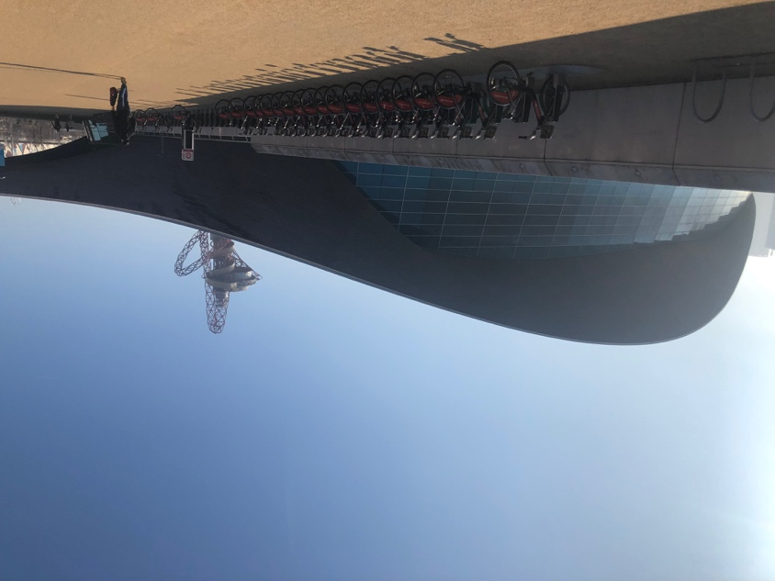

SATURDAY 23RD FEBRUARY
A low, chilly fog hung over the LAC as all the swimmers walked towards the Olympic venue for an 8am warm up.
The final day of individual races were upon us with all the 50M sprint events! Elmbridge had a large number of qualifiers swimming and at 9.30am the racing started.The fastest 8 swimmers in each age group at the end of the preliminary heats, qualified for the final in that age group.

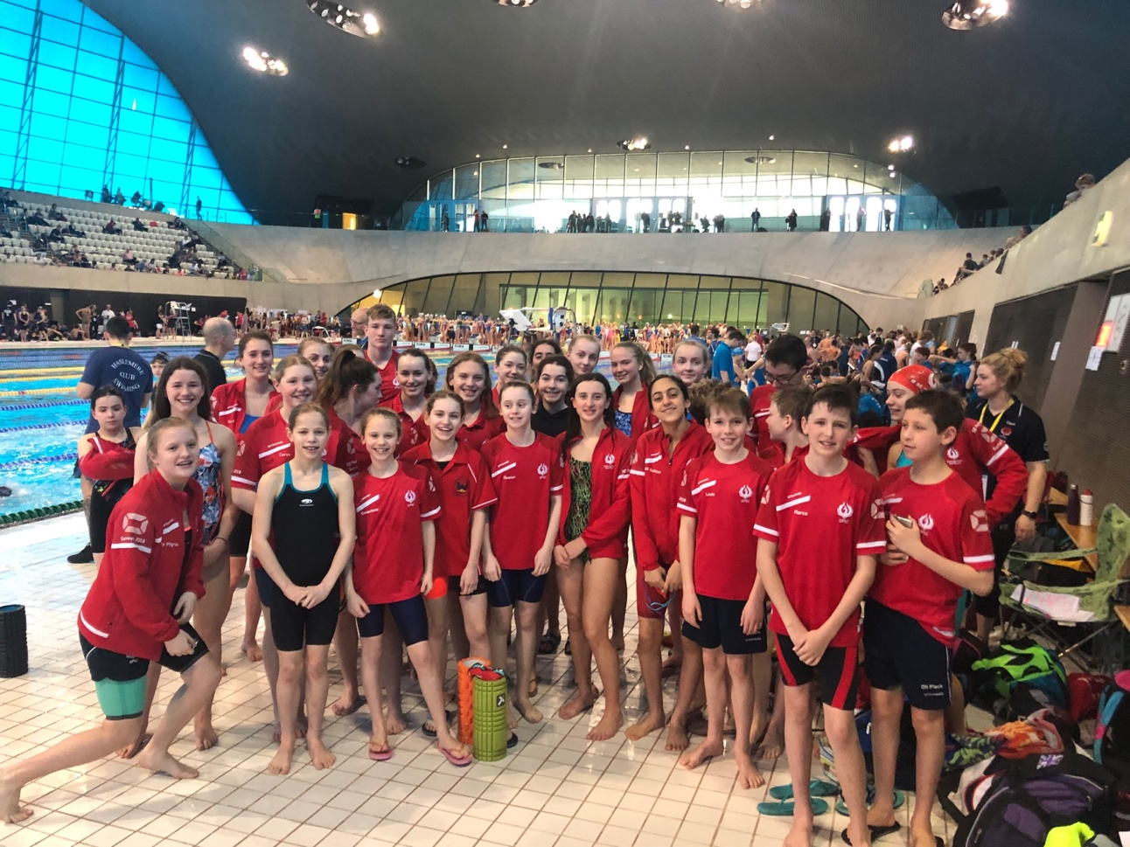

BOYS 50M BREASTSTROKE
10-11 Years
Louis Joll - 49.95
Marco Lenarduzzi - 51.05

14 Years
Thomas Hatchett – 41.99 (PB 0.57)

15 Years
Owen Melson – 40.44

17 & Over
George Berendji - 35.79
George Pullan – 33.16 (PB 0.48)
Morgan Portat – 32.46 – 10th Place

GIRLS 50M BACKSTROKE
10-11 Years
Amy Hempenstall – 43.37
Katie Shaw – 41.24 (PB 1.17)
Myla Donnison – 38.61 (PB 1.30)- 11th Place

12 Years
Ellie White – 38.33
Louisa Cipolletta – 38.54
Sarah Soloman – 40.74

13 Years
Annabel Pilgrim - 36.07
Emily Shaw – 36.61
Kyarra Steele – 35.38

14 Years
Cerys Howells – 36.61

15 Years
Amelie Christian 37.30

16 Years
Ella Young – 35.85
Gemma Fabris – 36.41
Lucy Fabris – 35.76

Niamh Kennedy and Emily Pilgrim swam fast heats, both producing fabulous starts and underwaters. Niamh qualified as 2nd fastest for the final with 31.83 and Emily 6th fastest for the final with 32.60.

17 & Over
Eve Perry – 33.93 – 10th Place

Sarah Lidbetter – swam a very competitive heat and achieved 32.98 and qualified as 6th fastest for the final.

BOYS 50 BUTTERFLY
12 Years
Oli Flack -37.07 (PB 3.34)

14 Years
Jamie Bainbridge – 36.19 (PB 0.87)
Thomas Hatchett - 33.57 (PB 0.80)

Theo Pavlou had a fabulous swim in his heat. He strongly gained a 2 second PB and broke the 30 second barrier with a 29.84 and 4th fastest qualifier for the final later on in the day.

15 Years
Owen Melson – 33.75 (PB 1.16)

17 & Over
George Pullan -28.99
Morgan Portat – 27.58 (PB 0.30) – 10th Place

GIRLS 50M FREESTYLE

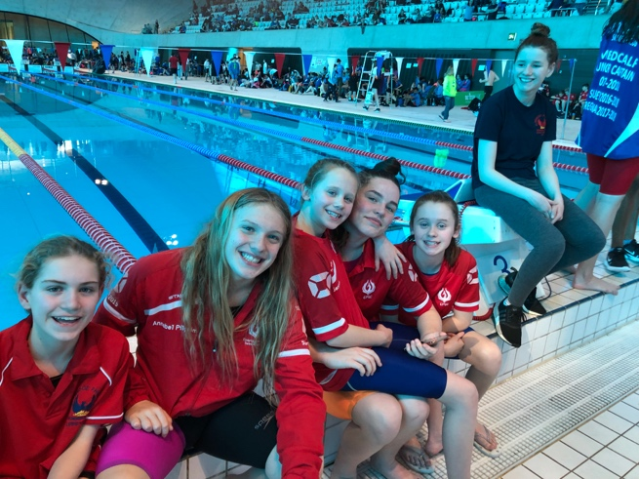

10-11 Years
Amy Hempenstall – 36.65
Genevieve White – 35.21 (PB 1.21)
Isabella Warren – 34.27 (PB 0.39)
Katie Shaw – 34.04 (PB 1.23)
Myla Donnison – 34.64 (PB 1.25)

12 Years
Ellie White – 31.26 – 10th Place
Lousia Cipolletta – 31.04 (PB 0.43) – 9TH Place
Sarah Soliman – 33.86
13 Years
Emily Shaw – 30.95

Annabel Pilgrim and Kyarra Steele swimming in the same heat, produced great LC PB’s to qualify for the final. Annabel as 2nd fastest qualifier with 29.16 and Kyarra 3rd fastest with 29.33.

14 Years
Ketevan Baramidze – 31.91
Cerys Howells – 30.82

15 Years
Amelie Christian 31.70
Julia Rodrigues – 30.61
Katie Coackley – 31.51 (PB 0.04)
Lucy Carrington - 31.40 (PB 0.36 )

16 Years
Ella Young – 30.29
Emily Pilgrim – 29.00 – 10th Place
Gemma Fabris - 32.31
Lucy Fabris – 32.14

Niamh Kennedy swam a really fast heat and qualified as 2nd fastest for the final with 27.97.

Maddie Harris had an outstanding swim in the multi-class event - achieving a PB of 35.97 and winning a Gold medal.

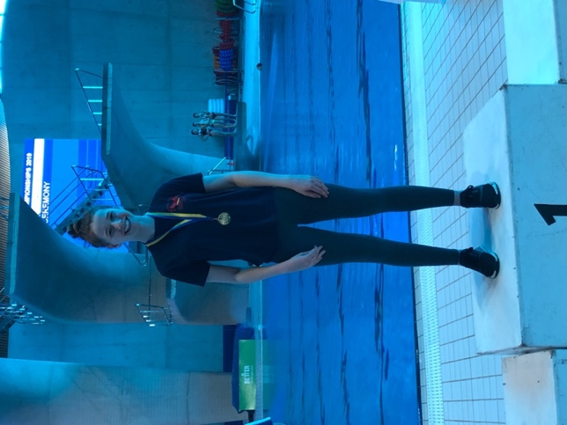

17 & Over
Ellen Portat - 30.14
Millie Fantham - 29.59
Sarah Lidbetter - 29.58
Zoe Bainbridge - 30.93

Eve Perry swam a strong heat and qualified as 4th fastest for the final with 28.26.

THE FINALS
GIRLS 50M BACKSTROKE
Emily Pilgrim and Niamh Kennedy raced in the 16 year old final. Great starts and underwaters yet again by both girls got them on their way. Unfortunately they didn’t quite make the podium this time, but came a very respectable 5th (Niamh) and 7th (Emily).

Sarah Lidbetter was next up in the 17 & Over final. She gained a small PB of 0.09 from her heat time, and moved up a place to 5th with a 32.88. A close final, with only 0.74 splitting 2nd to 5th place.

BOYS 50M BUTTERFLY
Theo Pavlou raced in the 14 year old final. It was his first county final and he swam a great race against some of the top swimmers in the South East. The winning time was a very fast 27.53 and Theo took a very well deserved 6th place ribbon!

GIRLS 50M FREESTYLE
An exciting 13 year old final saw Annabel Pilgrim and Kyarra Steele swim fabulous races. Kyarra came 4th with a PB of 0.29 and a time of 29.04. She was very unlucky not to medal as 0.14 secs split 4th and 3rd place and she should be proud of herself gaining two LC PB’s in one day.
Annabel took the Gold medal with a PB of 0.42 and a time of 28.74. She won on the touch by 0.02 secs to gain her 5th Gold medal at the Surrey’s!

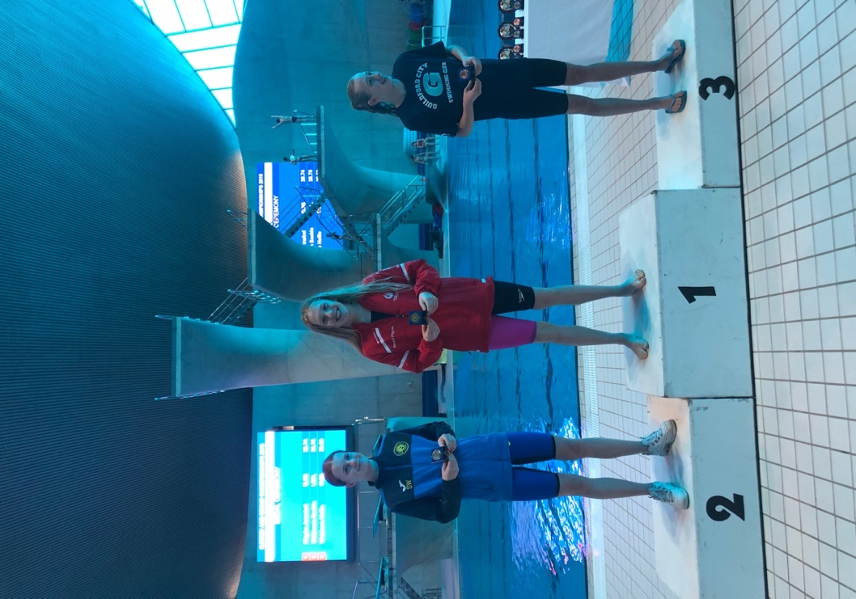

Niamh Kennedy raced in the 16 year old final. A great start and underwater put her out near the front at the start. It was a very close final with less than a second splitting 1st to 5th place. Niamh kept her head down and swam a solid race to win the Silver medal with 27.63!

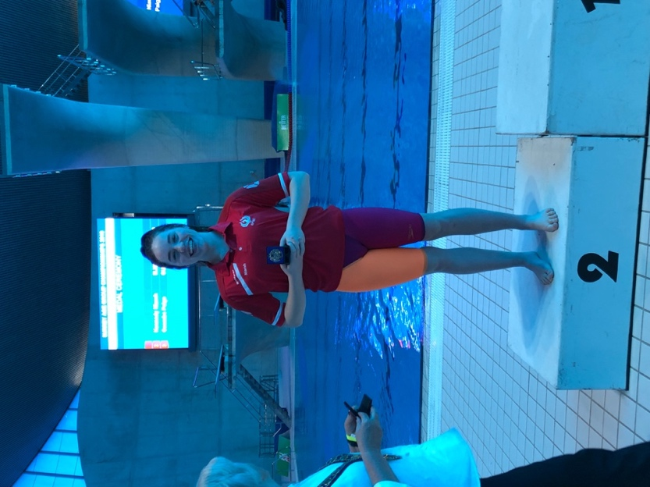

The last 50M free final was the 17 & Over age group. Eve Perry swam a good race and won a 6th placed ribbon.

With a short break, the afternoon session got underway. This was a repeat of the morning session, but boys and girls swimming the opposite strokes to the morning!

GIRLS 50M BREASTSTROKE

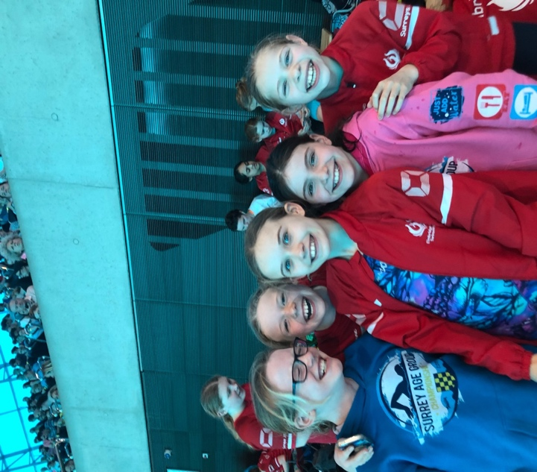

10-11 Years
Genevieve White – 48.87 (PB 0.63)
Myla Donnison – 46.61 (PB 1.67)

Katie Shaw swam a fabulous 43.01 in the heat and qualified as 4th fastest for the evening’s final!

12 Years
Emily Owens – 44.04 (PB 1.15)
Sarah Soliman – 41.51 – 11th Place

Ellie White swam a fantastic heat, accelerating at the 25M mark and breaking 40 secs for the first time. A 38.96 and a 1.45 sec PB gave her the 3rd fastest qualifying time for the final.

13 Years
Emily Shaw – 39.47 – 9th place
Kyarra Steele 39.50 – 10th place

14 Years
Cerys Howells – 44.35

15 Years
Arabella Everitt – 42.11
Julia Rodriguez – 40.56 (PB 1.12)
Lucy Carrington – 39.74 (PB 1.19)

16 Years
Emily Pilgrim – 41.48
Niamh Kennedy – 39.65

Ella Young swam a strong LC PB of 38.02 and qualified as 8th fastest for the final.

BOYS 50M BACKSTROKE
10-11 Years
Louis Joll 40.93 (PB 0.54)
Marco Lenarduzzi - 42.32 (PB 1.80)
Victor Fente-Damers – 43.47

12 Years
Oli Flack – 40.16
Tom Howells 42.30

14 Years
Jamie Bainbridge – 40.94
Theo Pavlou -35.03
Thomas Hatchett – 34.51 – 12th place

17 & Over
George Pullan – 30.15 - 11th place.

Morgan Portat swam a strong heat and qualified 6th fastest for the final with a brilliant 28.87.

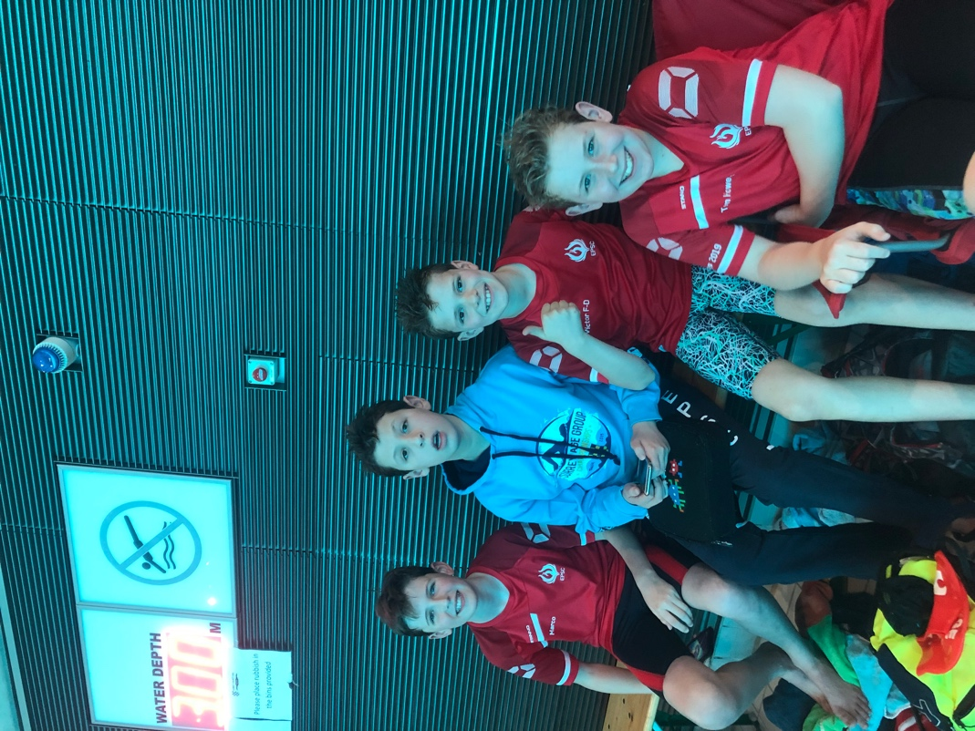

GIRLS 50M BUTTERFLY
10-11 Years
Amy Hempenstall – 40.07 (PB 0.84)

12 Years
Ellie White – 34.59 (PB 0.51) – 9th place
Louisa Cipolletta swam a very determined and fast heat time of 32.42 to gain her 3rd fastest qualifier place in the final.

13 Years
Annabel Pilgrim – 32.88 (PB 0.29) – 11th Place
Emily Shaw – 32.86 (PB 1.33) – 10th Place

Kyarra Steele swam a great heat with a 0.88sec PB of 32.88 to bag the last qualifying spot for the final.

14 Years
Cerys Howells – 33.96

15 Years
Amelie Christian – 34.93 (PB 0.53)
Elizabeth Zhiltsov – 34.20
Julia Rodrgues – 33.36 (PB 0.90)

16 Years
Ella Young – 34.50 (PB 1.10)
Emily Pilgrim – 32.02 (PB 0.50) – 10th Place
Lucy Fabris – 35.36 (PB 0.47)

Niamh Kennedy swam herself into another 50M final with a 31.35 and 8th fastest qualifier.

17 & Over
Ellen Portat – 32.47
Eve Perry – 32.34
Millie Fantham 32.78 (PB 0.16)
Zoe Bainbridge – 34.76

Sarah Lidbetter swam a strong, solid LC PB of 31.26 to gain a 7th fastest qualifying position for the final.

BOYS 50M FREESTYLE
10-11 Years
Louis Joll – 37.21
Marco Lenarduzzi - 34.87 (PB 1.13)
Victor Fente-Damers – 37.87

12 Years
Oli Flack 34.34 (PB 0.30)
Tom Howells – 35.29 (PB 0.64)

14 Years
Theo Pavlou – 28.48 ( PB 0.76) - 10th place
Thomas Hatchet - 31.41 (PB 1.00)

15 Years
Owen Melson – 28.97 (PB 0.57)

17 & Over
George Berendji – 27.83
George Pullan - 26.36
Morgan Portat - 25.98

Rory Burdin swam an awesome heat and his fastest LC time of the year with 23.63 to give him the fastest qualifying time into the evening’s final.

FINALS

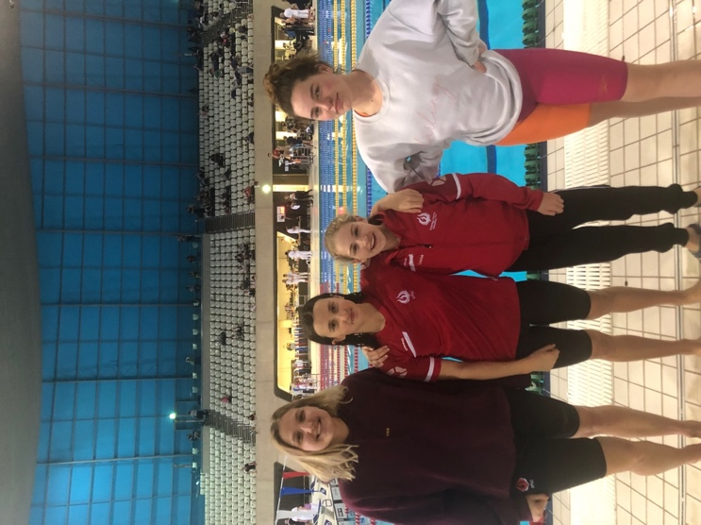

Girls 50M Breaststroke
Katie Shaw was in the first final – 10-11 year olds. She swam a good race and looked strong, finishing in 5th place with 43.65.

Ellie White was next in the 12 year old final. She swam another great race, accelerating again at the 25m stage and achieving another PB of 0.71 seconds to touch in for a Bronze medal!

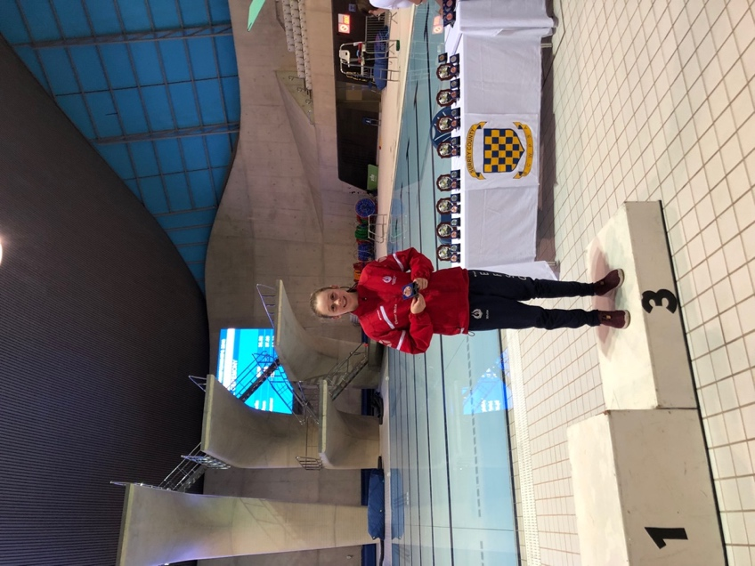

Ella Young swam in the 16 year old final. A similar time to her heat time, she achieved a well deserved 8th place ribbon.

Boys 50M Backstroke
Morgan Portat swam a great backstroke final. A small PB of 0.08 gained him a 6th place. A close final and only 0.65 sec between 2nd and 6th place!

Girls 50M Butterfly
Louisa Cipolletta went into the 12 year old final as 3rd fastest qualifier. She swam with determination and with 15m to go, it was a very close call with 2nd to 7th place all pretty level. Lousia kicked hard and touched in for a fantastic Silver medal with another 0.33 sec PB of 32.09.

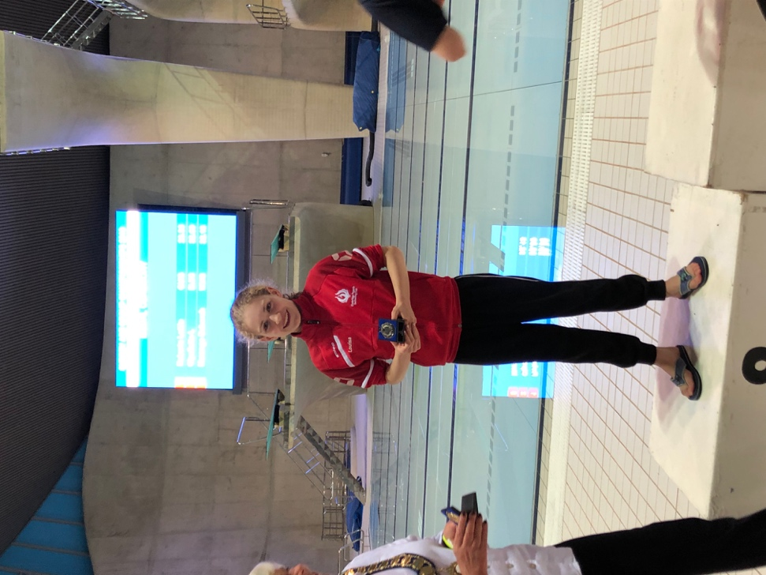

Kyarra Steele was up next in the 13 year old final. She swam a solid race and gained an 8th place ribbon.

Niamh Kennedy swam the 16 year old final. She had a great start and swam the furthest underwater start compared to the other 7 swimmers. Unfortunately, she just missed coming up before 15M and was sadly DQ’d.

Boys 50M Freestyle
Rory Burdin went into the 17 & Over final as fastest qualifier and was on a mission! There was some very strong opposition and he swam an outstanding race and although only 0.02 off his heat entry time, he hung on and touched in for the Gold medal!

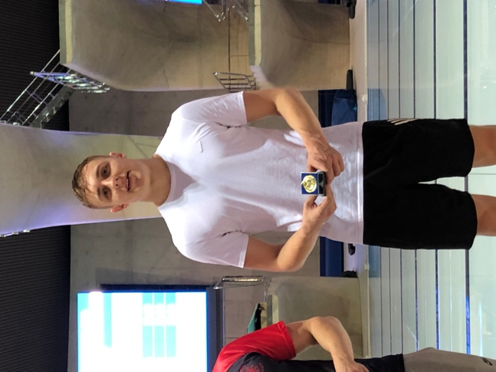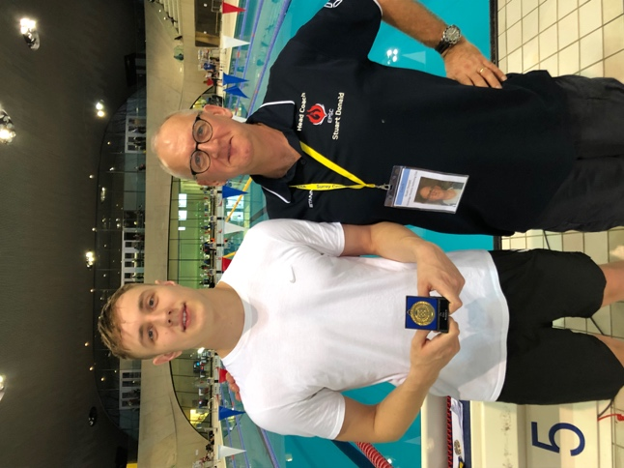

SUNDAY 24TH FEBRUARY
The final day of the Surreys were the exciting team relays!
A slightly later start time of 10am gave our swimmers at bit of extra time in bed ready for the competition!
The relay races are all heat declared winners and only medals are given for 1st to 3rd place (no ribbons up to 8th place like the individual events).

MORNING SESSION

In addition to watching the exciting relay races, we were also treated to Tom Daley practising his diving for an hour!

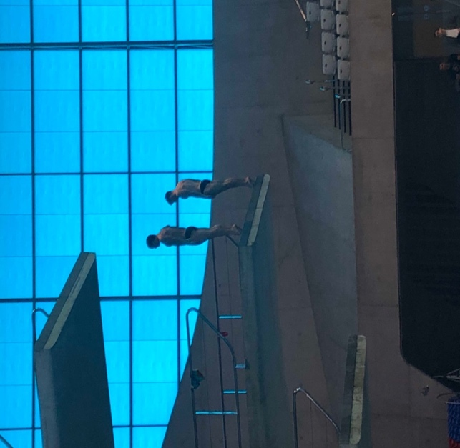
Girls 16 & OVER - 4 X 100M FREESTYLE
With an A and a B team, Elmbridge had the fastest 16 & Over girls at the club racing! Both teams were in the final heat against some of the big guns of relays such as Guildford City, Dulwich Dolphins, University of Surrey and Leatherhead.

The B team consisted of Zoe Bainbridge, Sophia Fente-Damers, Ellen Portat and Millie Fantham. They swam a competitive race and Millie Fantham swam a fast 4th leg with a LC PB of 1.03.33. Their final time was 4.28.36 and a 13th place overall.

The A team consisted of Gracie Moylan, Niamh Kennedy, Emily Pilgrim and Eve Perry. A solid 1st leg by Gracie had them in 5th place at the takeover. Niamh pulled the team back to 2nd place with a sub 1 minute leg of 59.78. Emily then swam a LC PB of 1.00.58 to pull the team into 1st place by the final takeover. Eve then held the lead with a determined 59.84 final 100m to win Gold! A fantastic result of 4.02.29 saw them 2 seconds clear of the next team and also involved beating Guildford A and B, Dulwich Dolphins and Leatherhead! They also won a huge Trophy – The Elsie Annison Trophy!

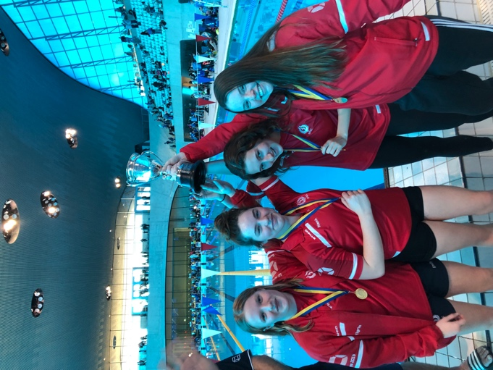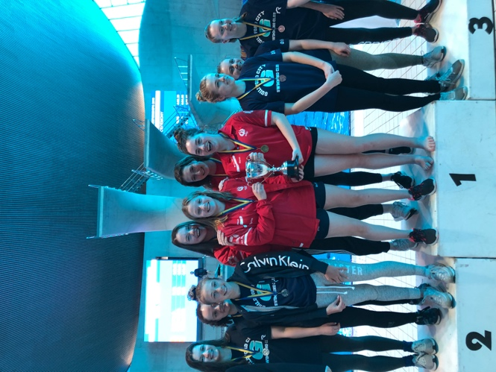

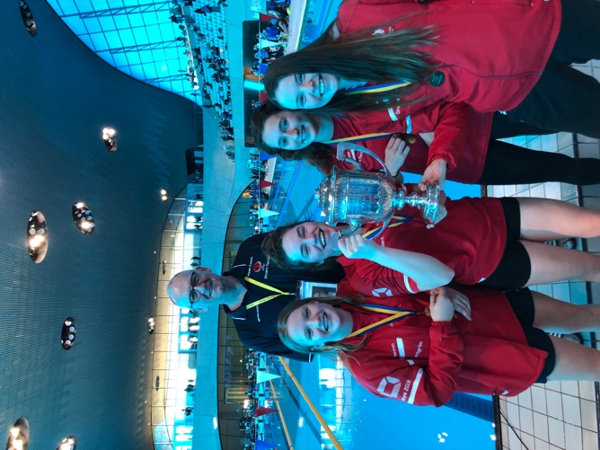

However, they were handed a smaller trophy on the podium and then Surrey ASA realised the mistake so gave them the correct much larger trophy!
BOYS 16 & OVER 4X100M MEDLEY
There were strong performances from all 8 swimmers.

Elmbridge A
Morgan Portat – back – 1.03.22
Matthew O’ Sullivan – breast- 1.14.57
Glen Melson – fly – 1.02.00
Rory Burdin - free- 55.20

8th Place 4.14.99

Elmbridge B
George Pullan – back - 1.05.44
George Berendji – breast – 1.21.46
Seb Leather – fly – 1.03.30
Dean Blackman- free – 1.00.45

13th Place 4.29.65

GIRLS 12-13 4X50 FREESTYLE
Kyarra Steele, Ellie White, Louisa Cipolletta & Annabel Pilgrim all PB’d in each leg of their race. Kyarra swam a solid 29.06 to get the team off to 2nd place behind Guildford City A. Ellie then broke 30 secs to maintain the 2nd place. Louisa held on in 2nd with a fabulous 30.15 and then Annie thundered home with 27.90 to touch the team in for a Silver medal behind a very strong Guildford team. A 1.57.03 was a very fast relay time!

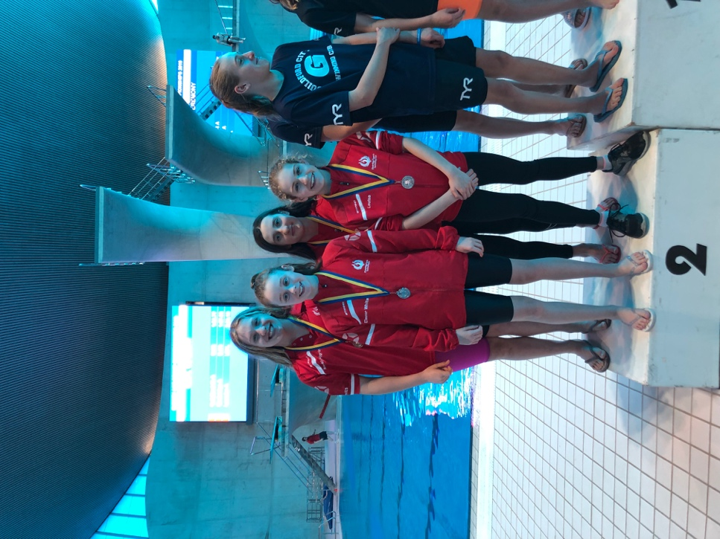

BOYS 12-13 4X50M MEDLEY
Rohan Shearer, Carter Carroll, Rafael Fente-Damers & Tom Howells. All swam great 50’s!
Rohan 32.98 backstroke
Carter 49.39 breast
Raf 30.6 fly
Tom 33.46 freestyle

12th place with 2.26.43.

GIRLS 4X200 FREESTYLE
A Team – Gracie Moylan 2.13.04
Sara Fente-Damers 2.17.19
Emily Pilgrim 2.14.40
Eve Perry 2.11.77
4th Place 8.56.40

B Team - Ellen Portat 2.27.31
Katie Coackley 2.23.48
Cerys Howells 2.22.86
Annabel Pilgrim – 2.16.54
11th Place 9.30.19

BOYS 10-11 4X50 FREESTYLE
Marco Lenarduzzi 35.22
Tom Mair 36.54
Victor Fente-Damers 36.87
Louis Joll 36.77

12th Place 2.25.40.

GIRLS 10-11 4x50 MEDLEY
A good strong swim by all 4 girls –
Myla Donnison backstroke 38.34
Katie Shaw breaststroke 42.83
Amy Hempenstall -Fly 38.74
Genevieve White -free 34.44

They came 4th with 2.24.35 – yet so close (0.67secs) to winning a medal.

BOYS U16 4X100 FREESTYLE
A closely fought relay by Rafael Fente-Damers, Owen Melson, Theo Pavlou and Nick Moylan. All swam great splits, Raf 1.02.17, Owen 1.03.80, Theo 1.00.82 and Nick 1.02.01 to come in 7th place with 4.08.80.

GIRLS U16 4X100 MEDLEY
Another great relay swim from Elmbridge!
Cerys Howells – backstroke 1.17.21
Emily Shaw – breaststroke 1.24.07
Sara Fente-Damers – fly 1.10.54
Katie Coackley – free 1.06.25

9th Place with 4.58.07

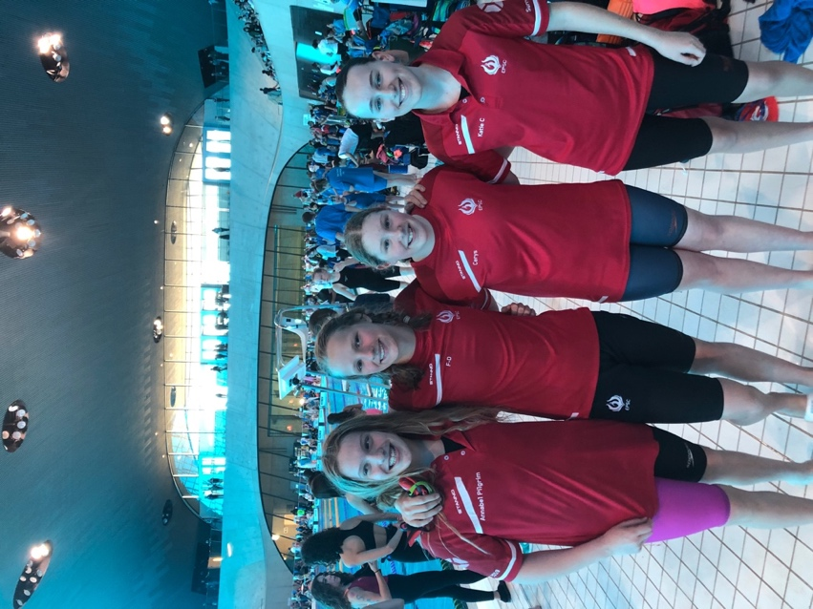

AFTERNOON SESSION

BOYS 16 & OVER 4X100 FREESTYLE
A superb swim from the whole team - Seb Leather, Morgan Portat, Glen Melson and Rory Burdin.
Seb swam a great first 100M with a 55.24 putting them in 4th place at the first takeover. Morgan held onto 4th place and then Glen swam a brilliant 53.13 to pull the team back to 3rd place with 0.80 secs between 1st and 3rd place at the final takeover. Rory swam a 51.21 to touch in for Gold with a 3.36.09 for the team. An exciting relay and a well deserved Wilkinson Trophy went to the team too.

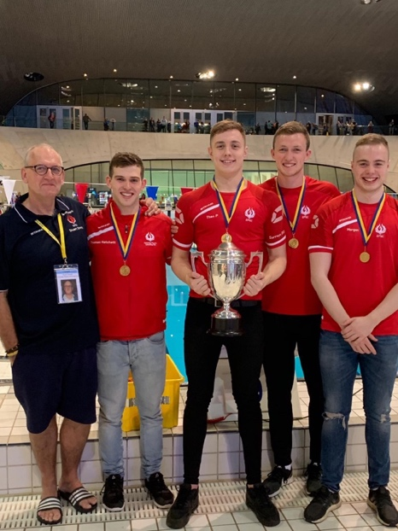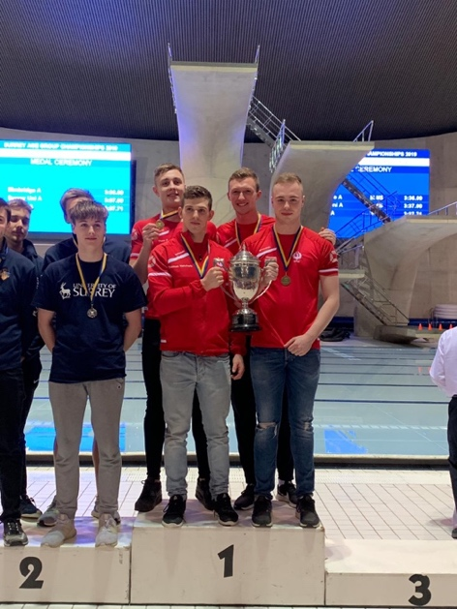

GIRLS 16 & Over 4X100 MELDELY
A TEAM – Emily Pilgrim -backstroke - 1.10.61
Ella Young – breaststroke - 1.24.01
Gracie Moylan – fly – 1.07.80
Eve Perry – freestyle – 1.00.75

6th Place 4.43.17

B TEAM - Niamh Kennedy – backstroke - 1.11.10
Zoe Bainbridge – breaststroke – no splits given
Ellen Portat – fly – no splits given
Millie Fantham – free – 1.02.79

8th Place 4.55.81

BOYS 12-13 4X50 FREESTYLE
Rohan Shearer , Tom Howells, Carter Carroll, Rafael Fente-Damers swam a 2.07.34 to come in 14th place.

GIRLS 12-13 4X50 MEDLEY
Ellie White, Emily Shaw, Kyarra Steele and Annabel Pilgrim all swam great legs.
Ellie 37.94 back
Emily 37.80 breast
Kyarra 32.31 fly
Annabel 28.03 free

6th Place with 2.16.08

BOYS 4X200M FREESTYLE
Seb Leather 2.09.00
Morgan Portat 2.10.45
Glen Melson 2.09.19
Rory Burdin 1.58.84

6th place with 8.27.48.

GIRLS 10-11 4X50M FREESTYLE
Isabella Warren - 34.62
Myla Donnison - 35.32
Genevieve White - 34.82
Katie Shaw – 33.42

7th Place 2.1.8.18

BOYS 10-11 4X50 MEDLEY
Victor Fente-Damers – back – 43.63
Marco Lenarduzzi – breast – 53.50
Louis Joll – fly - 42.11
Tom Mair – free 36.47

12th Place 2.55.72

GIRLS U16 4X100M FREESTYLE
Sara Fente-Damers – 1.02.34
Katie Coackley – 1.06.11
Cerys Howells – 1.05.51
Annabel Pilgrim – 1.02.89

5th Place 4.16.85

BOYS U16 4X100M MEDLEY
Thomas Hatchett, Theo Pavlou, Owen Melson & Nick Moylan all swam a good race, but unfortunately the team were disqualified.

Another fantastic weekend of swimming from Elmbridge with loads of PB’s, medals and ribbons won, plus many Regional Qualifying Times gained! Well done to all the medallists and finalists, but also congratulations to all the swimmers from Elmbridge who qualified. Surrey is one of the hardest counties to qualify for and so just taking part in the Championships is an achievement in itself!
Great commitment was shown from all the swimmers who came to represent the club, especially for the relays whereby many were in one relay and spent the day at LAC supporting the team.

Elmbridge came 7th overall in the 2019 Surrey’s medal table with 14 Gold, 6 Silver and 4 Bronze Medals which is a great result against some of the much larger clubs of Surrey.

Thanks once again to all the coaches who had another long weekend! However, they were all delighted with the overall performance of the Elmbridge swimmers!

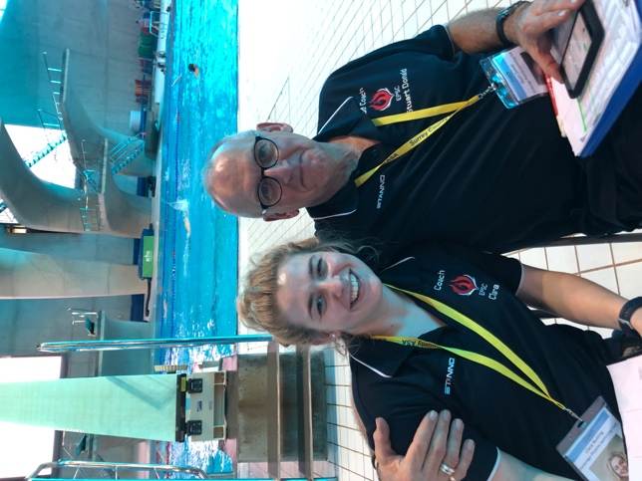

Head Coach, Stuart Donald said, “Fantastic efforts from all swimmers and great results across all the age bands!”

SUMMARY OF MEDALS & RIBBONS WON AT 3RD WEEKEND

GOLD MEDALS
Annabel Pilgrim - 50M Freestyle
Maddie Harris – 50 Freestyle
Rory Burdin – 50 Freestyle
Emily Pilgrim/Eve Perry/Gracie Moylan/Niamh Kennedy – 4X100M Freestyle Relay 16 & Over Girls
Glen Melson/Morgan Portat/Rory Burdin/Seb Leather – 4X100M Freestyle Relay 16 & Over Boys

SILVER MEDALS
Louisa Cipolletta – 50 Butterfly
Niamh Kennedy – 50 Freestyle
Annabel Pilgrim/Ellie White/Kyarra Steele/Louisa Cippolletta – 4X50M Freestyle Relay 12-13 Years

BRONZE MEDALS
Ellie White – 50 Breaststroke

4th PLACE
Kyarra Steele – 50 Freestyle

5th PLACE
Katie Shaw – 50 Breaststroke
Niamh Kennedy – 50 Backstroke
Sarah Lidbetter – 50 Backstroke

6th PLACE
Eve Perry – 50 Freestyle
Morgan Portat – 50 Backstroke
Theo Pavlou – 50 Butterfly

7th PLACE
Emily Pilgrim – 50 Backstroke

8th PLACE
Ella Young – 50 Breaststroke
Kyarra Steele – 50 Butterfly

