Surrey County Championships 2019
Weekend 2
9th-10th February London Aquatic Centre – Stratford

The 2nd weekend of the Surrey Championships got underway at the London Aquatic Centre in Stratford. What a venue! What a treat for our swimmers to race at the London 2012 Olympic Pool! What a treat for the spectators too – hundreds of seats to choose from and great views of the pool (unlike Surrey Sports Park!)

Saturday 9th February

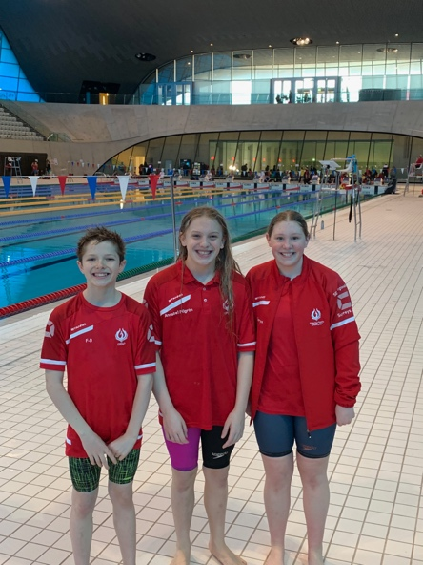
It was an early 8am start for our hardcore 1500M freestyle swimmers - Annabel Pilgrim, Cerys Howells and Rafael Fente-Damers! This is a difficult race being 30 lengths of the 50M pool and it was just tiring watching i

Cerys and Raf had never raced this distance before and qualified with their 800M freestyle times. All 3 swimmers did exceedingly well! Cerys swam a very strong 19.22.84 and came 5th in the 14 year old age group.

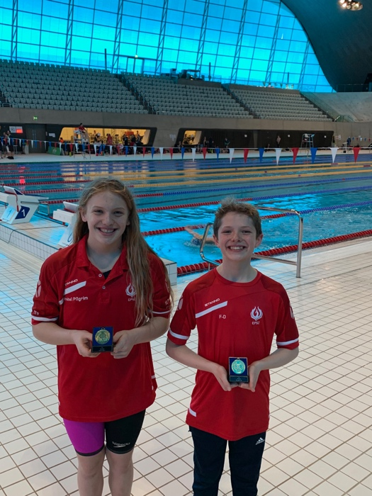

Annabel swam a 1 minute 21 sec PB to break 19 minutes with an 18.57.51 even after losing her hats during the race! She won Gold – 20 seconds ahead of her 13 year old counterparts.
Likewise, Rafael won Gold in the boys 13 year old age group with a 32 second gap between 2nd place and a brilliant time of 18.24.04. Two County Champions to start the weekend off!

The next event was not an easy event either! The girls 400M IM. Annabel Pilgrim, Ellie White, Emily Pilgrim and Zoe Bainbridge all competed for EPSC. Alas, there were no huge PB’s or medals but all girls competed very well and also did well to qualify in the first place!

More EPSC swimmers arrived for the afternoon session with the girls 100M fly, boys 100M back and girls 200M breaststroke.

GIRLS 100M FLY HEATS

Louisa Cipolletta (12 years) swam a fabulous heat with a PB of 1.17.83 and qualified as 7th fastest for the evening final. Annabel Pilgrim (13 years) also swam a long course PB of 1.16.28 but just missed qualifying for the final. Sara Fente-Damers dominated in her heat and qualified as 2nd fastest 14 year old with an impressive 1.10.46.

BOYS 100M BACK HEATS

Thomas Hatchett (14 years) swam a great race and a 3.5 second LC PB of 1.15.11.
George Pullan (17 & Over) swam a 1.04.92 and just missed qualifying for the final by less than half a second.
Morgan Portat (17 & Over) swam a comfortable 1.02.77 to qualify as 5th fastest for the final.

GIRLS 200M BREASTSTROKE

Katie Shaw (10-11 year old age group) swam an outstanding race and managed a 7 second PB with 3.23.03 to win herself a Bronze medal! A very happy smiling winner!
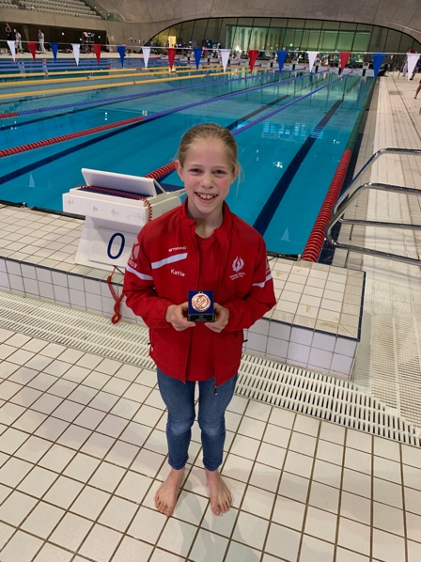

Her older sister Emily Shaw (13 years) also swam a great race with an 8 second long course PB of 3.02.65. She came 5th and was very unlucky not to medal as there was less than a second between 3rd and 5th place.
Ella Young (16 years) swam a strong race and managed a well deserved 2 second LC PB to claim 5th place with 3.02.85.
Sarah Soliman (12 years), Ellie White (12 years) and Kyarra Steele (13 years) also competed and swam good races too!

THE FINALS

BOYS 100 BACK FINAL
Morgan Portat’s competitive spirit saw an exciting 17 & Over final. At the 50M stage, Morgan turned in 5th place. With 15 metres to go, 4 swimmers were virtually level and you couldn’t call it! Morgan won on the touch and claimed a very well deserved Bronze medal and a long course PB of 1.02.19. A fabulous result!

GIRLS 100 FLY FINAL
Louisa Cipolletta really gave her all in the 12 year old final. She PB’d again and came in 5th place. Overall a 6 second PB from her last LC 100 Fly time. A very good result!

Sara Fente-Damers (14 years) had an entry seed of 6th place but gave another outstanding fly swim. She turned at 50M in 4th place and then pushed herself for the 2nd length. It was very close between 4 swimmers up until the final flags whereby the winner just nudged ahead and Sara touched in for a Silver medal with yet another PB of 1.09.26.

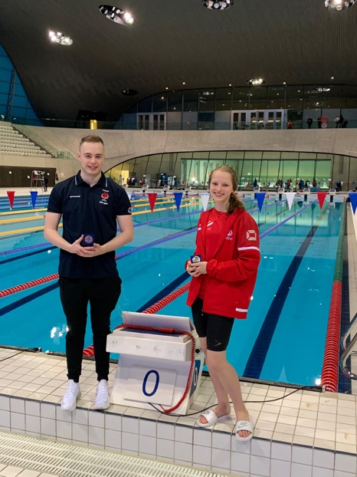

Overall, Saturday’s successful swimming gave Elmbridge two Golds, one Silver and two Bronze medals to add to their collection! Well done Annabel, Katie, Morgan, Raf and Sara!
A surprise poolside visit by Tom Daley (unfortunately not in his speedos) was another highlight of Saturday at the LAC! He was interviewed over the microphone and gave some encouraging words to the swimmers!

Sunday 10th February
Sunday morning saw another early start for our long distance swimmers! The 800M freestyle saw Annabel Pilgrim and Cerys Howells racing again! Annabel in an early heat swam a PB of 9.53.59. She had to wait for all the other 13 year olds to race before she knew the final result. A Silver medal to add to EPSC’s tally!

Cerys in the 14 year old category swam a very good 10.07.50 – an 11 second PB from the last time she had raced an 800 free Long course. She came in a good 7th place in a girls age group with the largest number of qualifiers at this distance.
The next session saw the boys 400IM. Our only entrant Thomas Hatchett in the 14 year old age group swam a fabulous 5.47.01. His first ever long course 400IM race and he produced an equivalent 15 second PB from his SC entry time.
The final session of the day included the boys 100 fly and the girls 100 back.
BOYS 100M FLY HEATS
6 of our boys competed in this event - Rafael Fente-Damers (13 years), Nick Moylan (14 years), Theo Pavlou, (14 years), Thomas Hatchett (14 years), Matthew O’Sullivan (16 years) and George Pullan (17 & Over ).
Raf swam in as 4th fastest qualifier with a 1.10.13 for the final. Nick (14 years) swam in as 3rd fastest qualifier with a PB of 1.06.13 and Matt 6th fastest qualifier for the 16 year olds final.
Theo swam a very good 1.15.32 and Thomas in his 3rd event of the weekend swam another PB of 1.14.96. Both great swims, but not quite enough on this occasion to make the top 8 for the final.
GIRLS 100M BACKSTROKE HEATS
The girls 100 M backstroke heats saw Louisa Cipolletta (12 years), Annabel Pilgrim (13 years), Sara Fente-Damers (14 years), Maddie Harris (16 years), Emily Pilgrim (16 years) and Gracie Moylan (17 & Over) all race.
Louisa PB’d with a 1.21.37 but just missed qualifying for the final.

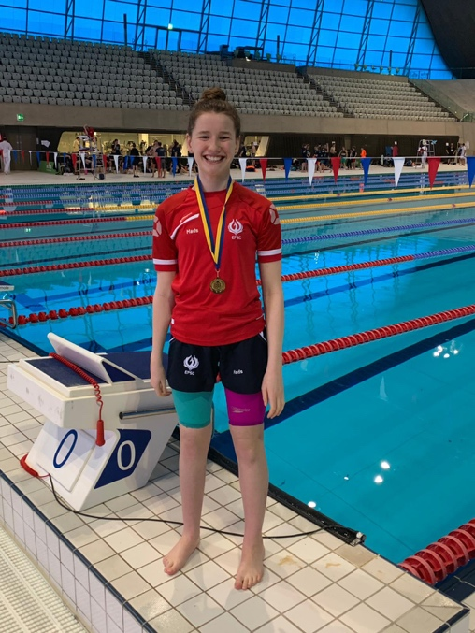
Maddie Harris swam a strong race and kicked well with both legs for both lengths to earn herself Gold in the Multi- Class event with a 1.40.32! Her fastest LC 100M backstroke in 8 months. The Multi-Classification events are Heat Declared Winners and so do not swim a final as well.

Annabel, Sara Emily and Gracie all qualified for the finals in their age groups.
Annabel as 7th fastest, Sara 4th fastest, Emily 4th fastest and Gracie 5th fastest.

THE FINALS
GIRLS 100M BACKSTROKE
First to race was Annabel in the 13 year old age group. A good LC PB of 1.14.22 saw her claim 7th place.
Sara in the 14 year old category also managed another PB of 1.11.63 to win 5th place.
Emily in the 16 year old age group swam a 1.10.12 and was nudged into 5th place also.
Finally Gracie in the 17 & Over category swam a 1.10.45 and also won a ribbon in 6th place.

BOYS 100M BUTTERFLY
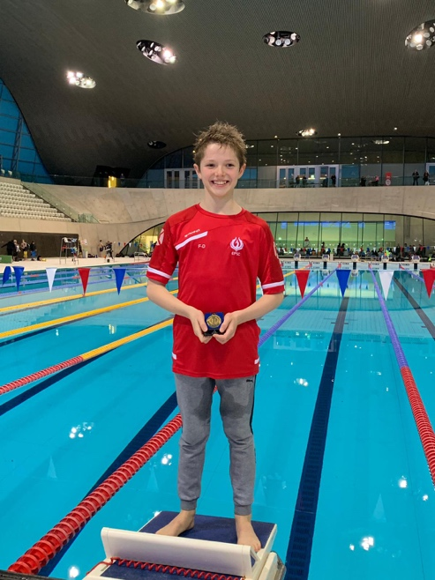
Raf was the first boy up for the finals in the 13 year old age group. He swam a really fast first 50M of 31.35 and turned in the lead. The two boys either side of him, who had arm lengths spanning the whole lane were catching Raf with 25M to go! Raf pushed harder and kicked harder to touch in for his 6th GOLD medal of the championships with a brilliant PB of 1.08.19. Two seconds faster than his 4th place final entry time!

Nick Moylan was next up in the 14 year old final. He swam a strong race and won a 4th place ribbon with a 1.06.68. There was a strong field of 14 year old fly swimmers in this final and Nick did extremely well. He also achieved an automatic SE Regionals Qualifying time!
Matthew O’Sullivan swam the 16 year old final and his first 50M of 28.62 meant he turned in 3rd place. However, the size and strength of some of the opposition pushed Matt into a final 6th place with a 1.02.59.

Overall, another fabulous weekend of racing from Elmbridge! Head Coach Stuart was proud of all our swimmers yet again and with his head held high, he enjoyed his evening motorbike ride home over the illuminated Tower Bridge!
Thanks to both Stuart and Glen for their hard work over the long 2 days – successful swimming, making the finals and making the podium adds another few hours onto the day!
All swimmers should be proud of their achievement in not only competing at the Surrey’s but actually qualifying for them! Qualifying times are aimed at the top 24 swimmers in the County. Surrey is a very large county and incorporates many London clubs. Qualifying times are some of the toughest when compared to other counties. So medalling is an outstanding achievement but for all our swimmers at Surreys – just getting to Surreys is a great achievement – medallist or not!
We look forward to the final weekend of competition at the London Aquatic Centre on 23rd/24th February. Bring on the 50’s and the ever exciting relay races!! Warm up starts bright and early at 8am on the Saturday morning for the 50’s! The Surrey 2019 Hoodies and T-Shirts are also on sale as you go into LAC and they have new colours and sparkly options this year!
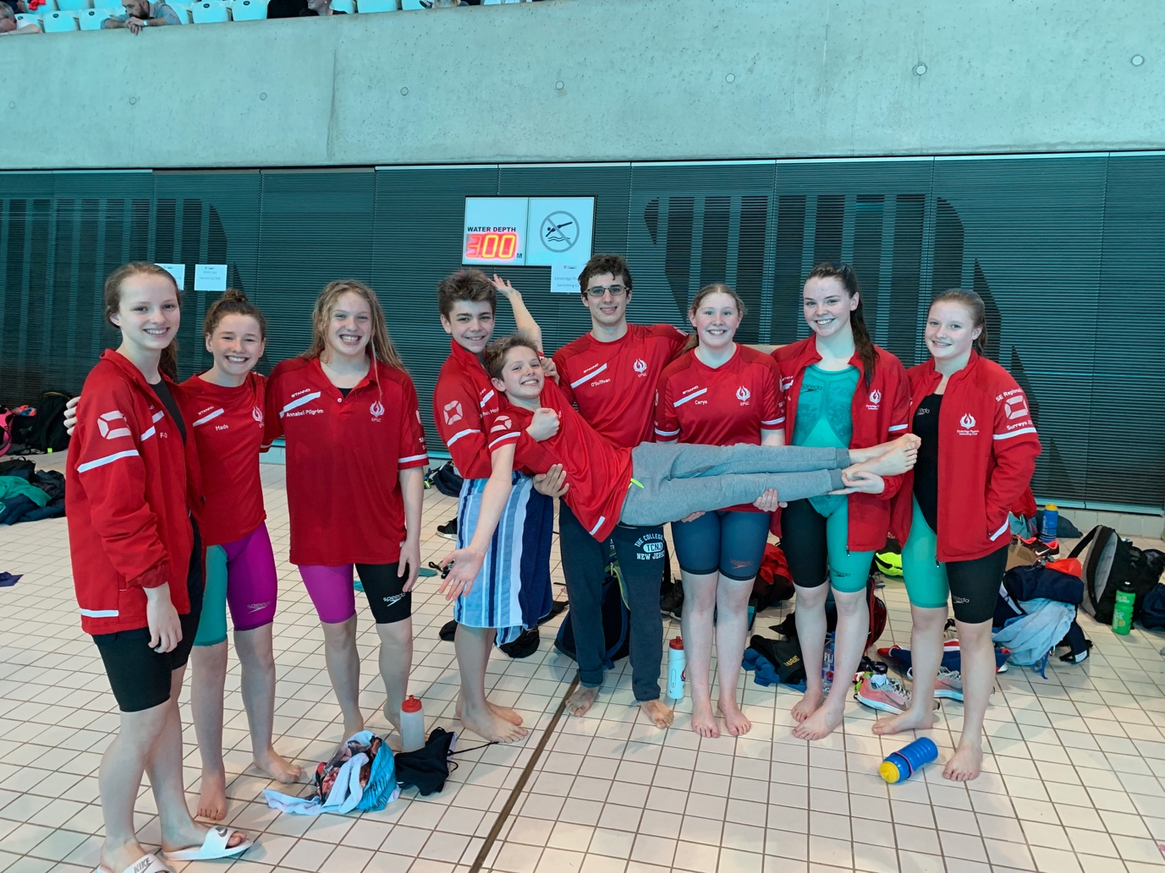

SUMMARY OF MEDALS AND RIBBONS WON AT WEEKEND 2
GOLD X4
Annabel Pilgrim x1 - 1500M free
Maddie Harris x1 – 100M back (MC)
Rafael Fente-Damers x2 – 1500M free & 100M fly

SILVER X2
Annabel Pilgrim x1 – 800M free
Sara Fente-Damers x1 – 100M fly

BRONZE X2
Katie Shaw x1 – 200M Breast
Morgan Portat x1 – 100M back

4th Place X1
Nick Moylan x1 – 100M fly

5th Place X6
Cerys Howells x1 – 1500M free
Ella Young x1 – 200M breast
Emily Pilgrim x1 – 100M back
Emily Shaw x1 – 200M breast
Lousia Cipoletta x1 – 100M fly
Sara Fente-Damers x1 – 100M back

6th Place X2
Gracie Moylan x1 – 100M back
Matthew O’Sullivan x1 – 100M fly

7th Place X2
Annabel Pilgrim x1 – 100M back
Cerys Howells x1 – 800M free
TOTAL =
4 County Champions
8 medals
11 ribbons with 4th to 8th place finishes!

