Monday - Lower Body
30 seconds on each exercise, 30 seconds rest - Repeat x 6 times
1. Star Jumps/Jumping Jacks
https://www.youtube.com/watch?v=c4DAnQ6DtF8
- Stand straight with your feet together and hands by your sides
- Jump up, spread your feet and bring both hands together above your head.
- Jump again and return to the starting position
- Repeat for 30 seconds

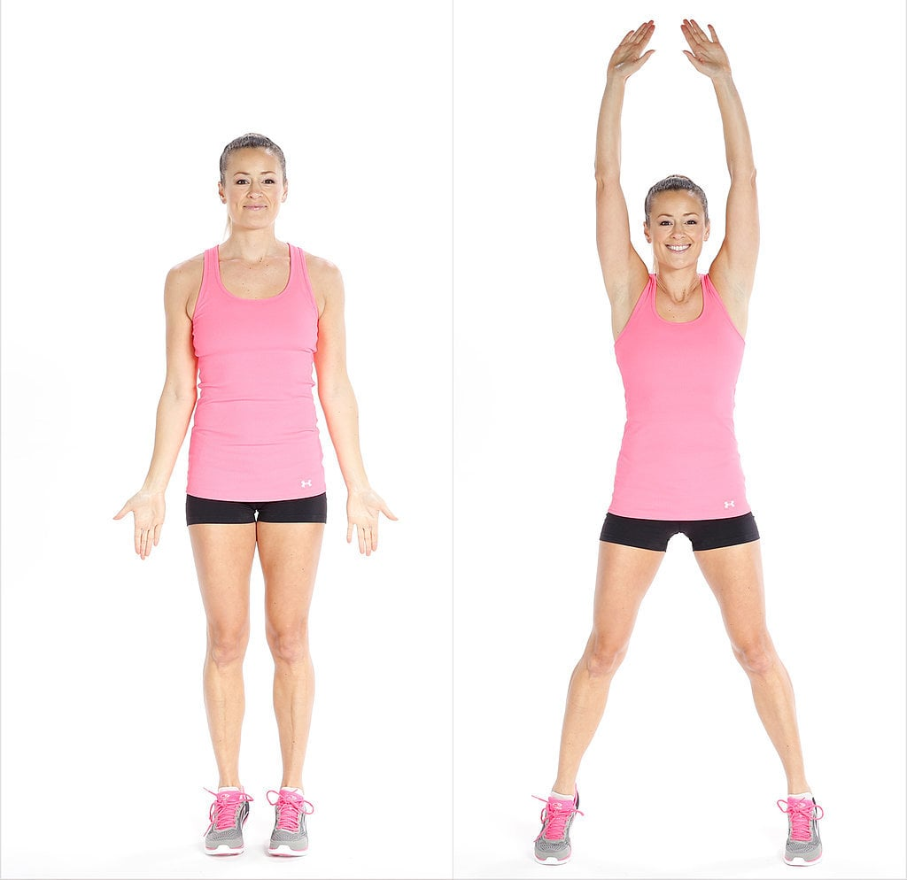
2. Squats
https://www.youtube.com/watch?v=aclHkVaku9U
- Stand with your feet shoulder width apart.
- Bend your knees, press your hips back and stop the movement once the hip joint is slightly lower than the knees.
- Do not let your knees extend beyond your toes
- Press your heels into the floor to return to initial position
- Repeat for 30 seconds
To make it more challenging stay down in the squat for 3 seconds
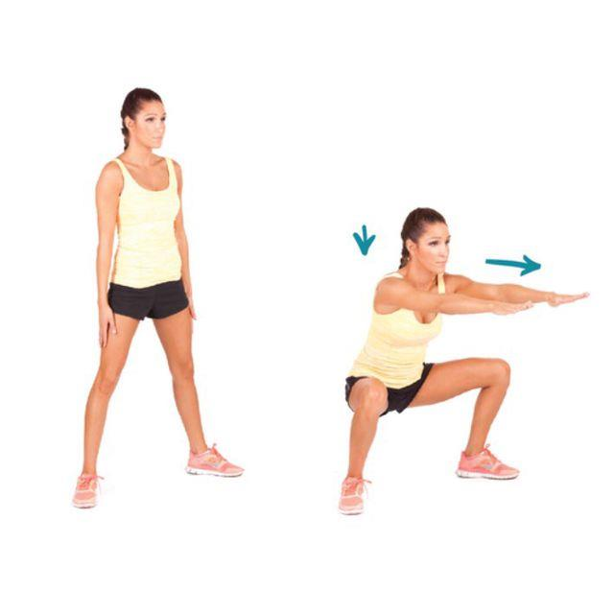
3. Lateral Lunge
https://www.youtube.com/watch?v=6ftkR-Zcl0A
- Stand with your feet hip-width apart
- Step out to the side with your left leg, bend your left knee and push your hips back.
- Hold the lunge for 3 seconds
- Return to the starting position and repeat the movement with the right leg.
- Keep alternating legs until the 30 seconds is up
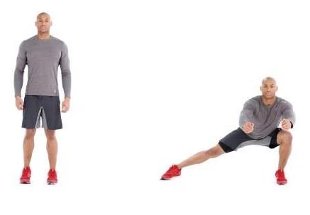

4. Skipping with a rope
- Hold the rope while keeping your hands at hip level
- Rotate your wrists to swing the rope and jump
- Jump with both feet at the same time
- Engage your abs, keep the upper body straight, knees slightly bent and jump on the balls of your feet.
- Repeat for 30 seconds

