NUTRITION & HYDRATION TO AID COMPETITON & RECOVERY
Swimming requires massive amounts of energy, whether it’s an elite-level practice or an age group practice. Because of this high energy expenditure, swimmers need to take the right steps to replenish the nutrients lost.
Competitive swimmers can burn up to 5,000 calories in four hours, depending on the intensity of the workout. Thus, swimmers can burn approximately 40 percent of their daily energy during this time. Because of this incredible energy expenditure, proper nutrition is essential to rebuilding and recovering.
Protein repairs and rebuilds the muscles after the stresses of training in addition to warding off soreness. The building blocks of proteins are amino acids, which are the main components of muscular growth and repair, protein also supports and boosts the immune system as well as quenches those annoying hunger pangs that plague swimmers during practice. Some sources of protein are lean meats, fish, eggs, and low-fat dairy.
Swimmers should also drink water often to stay hydrated, sipping on their water bottles throughout the day to replenish sweat loss (yes, it is possible to sweat in the water). Many athletes don’t think about replacing electrolytes and other minerals lost in sweat, most notably sodium and potassium. While most athletes consume enough sodium in a normal diet, you can sprinkle some salt and glucose to your beverage for absorption and replenishment.
A properly fuelled body will result in better performance during practice and competition. Nutrition is everything.”
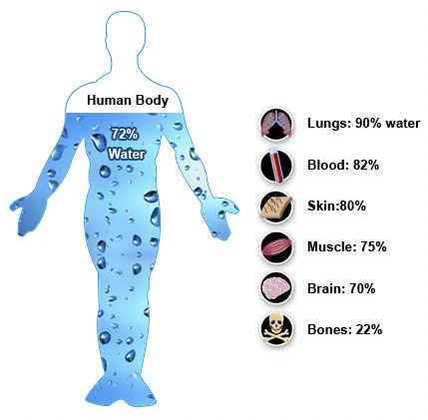
Consequences of Dehydration:
􏰁 Decrease in Digestive Rate
􏰁 Decrease in Stroke volume
􏰁 Increase in heart rate
􏰁 Increase in perception of effort 􏰁 Increase in body temperature 􏰁 Decrease in concentration
􏰁 Increase in tiredness
Overall result will be REDUCTION IN SPEED

While drinking enough water may seem like a simple action, it impacts virtually every aspect of sports performance.
Staying hydrated increases energy, improves movement, recovery and agility, thermoregulation, and aids in mental clarity and activity – all of which can improve physical performance and reduce the risk of injuries.

Tips to help meet fluid requirements
- carry a water bottle with you at all times
- drink 250ml with every meal
- consume a small amount of fluid before and after all heats and races.
- aim for clear urine
NUTRITION BEFORE RACES (2- 4 Days Before)
PASTA – with tomato-based sauce, vegetables and cheese and chicken, tuna or lean beef
CHICKEN WRAPS – tortillas filled with roast chicken, coleslaw and dressing
MEATBALLS – with veg and steamed rice
STIR-FRY – lean chicken / pork or beef with lots of vegetables in a soy sauce (not spicy) with noodles or rice
PIZZA – base topped with cherry tomatoes, basil, lean ham and mozzarella
LASAGNE – pasta sheets with lean beef, pork, or chicken, tomatoes, spinach and reduced fat cheese & side salad
JACKET POTATO – baked potato with baked beans & cheese; or tuna & sweetcorn; or Bolognese filling & side salad

BREAKFAST BEFORE COMPETITION
Bowl of oats with fruit and nuts
Peanut or Almond butter on toast topped with sliced banana
Pancakes topped with fresh fruit and yoghurt or peanut butter
Baked beans on toast with cheese
Scrambled egg on toast
Creamed rice with stewed apple
0 – 1 h BEFORE COMPETITION
- 3 – 4 plain crackers
- Small handful of popcorn
- 100% Freshly squeezed fruit juice or Smoothie
- Carbohydrate drink
- Ensure you are properly fuelled between races BUT not too full to race
- Eat the right snack at the right time
- Immediately after a race, drink few mouthfuls of sports drink before you cool down
CONSIDER HOW LONG BEFORE NEXT EVENT:
- If there is less than 45 min before next race, stick to fluids only – carbohydrate drink and water
- If there is more than 45 minutes, consider a light snack e.g. handful of salted crackers, small bites of granola bar, handful of low sugar cereal, fruit bread slice, canned peach slices, sports bars

SMY Feb 2020

