RRSC COACHES CHALLENGE

14 Day Plank Challenge

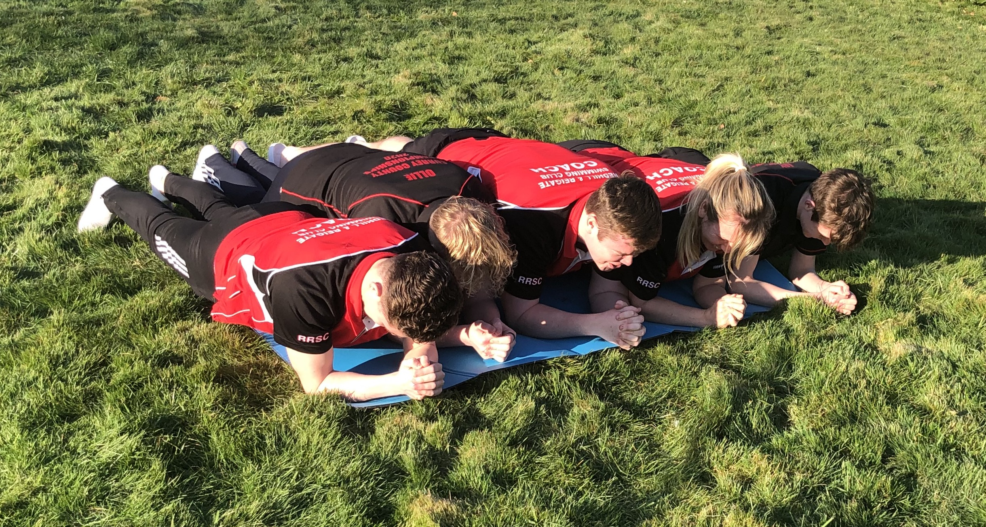

DAY 1 | 30 Seconds | DAY 8 | 60 Seconds
DAY 2 | 30 Seconds | DAY 9 | 90 Seconds
DAY 3 | 40 Seconds | DAY 10 | 90 Seconds
DAY 4 | 40 Seconds | DAY 11 | 120 Seconds
DAY 5 | 50 Seconds | DAY 12 | 120 Seconds
DAY 6 | 50 Seconds | DAY 13 | 150 Seconds
DAY 7 | 60 Seconds | DAY 14 | As long a possible

PRIZES FOR LONGEST PLANK HELD IN EACH AGE GROUP
PRIZE FOR LONGEST OVERALL PLANK HELD
All entries must be verified by a parent or adult and set to tina@rrsc.org.uk

