Thursday – Lower Body
30 seconds on each exercise, 30 seconds rest - Repeat x 6 times
1. Star Jumps/Jumping Jacks
https://www.youtube.com/watch?v=c4DAnQ6DtF8
- Stand straight with your feet together and hands by your sides
- Jump up, spread your feet and bring both hands together above your head.
- Jump again and return to the starting position
- Repeat for 30 seconds
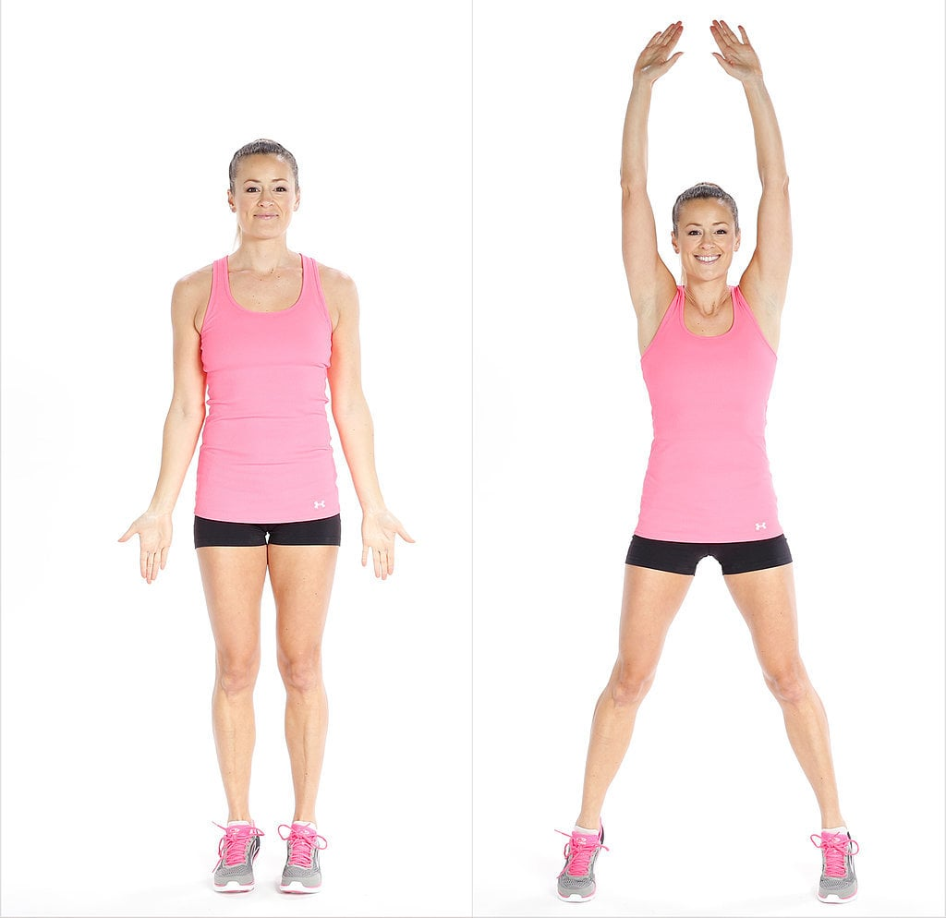

2. Jump Squats
https://www.youtube.com/watch?v=QQWsscOgGkU
- Stand with your feet shoulder width apart.
- Bend your knees, press your hips back as if you were going to sit back on a chair.
- Do not let your knees extend beyond your toes
- Pushing through the heels, jump straight up
- Land with your knees slightly bent and go back into the squat position
- Repeat for 30 seconds

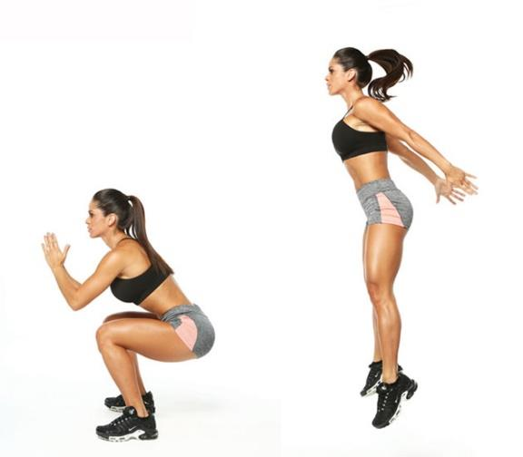
3. Glute Bridges
https://www.youtube.com/watch?v=_leI4qFfPVw
- Lie on your back with your hands by your sides and your knees bent
- Lift your hips off the mat, while keeping your back straight
- Hold for 3 seconds
- Return to starting position and repeat until the set is complete
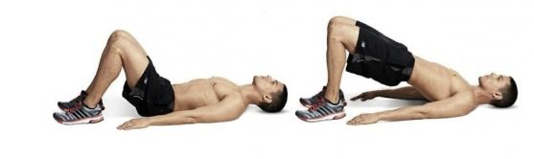

4. Plank with Arm Raise
https://www.youtube.com/watch?v=a1_fRyavWdA
- Start in a plank position with your body in a straight line
- Keep your spine, head and neck in a neutral position and squeeze your core and glutes
- Extend one arm and hold for 3 seconds, return to starting position and repeat on other side.
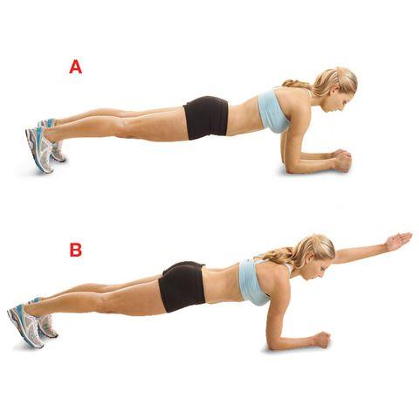
5. Side Plank
https://www.youtube.com/watch?v=IkMmABQ9SkM
- Lie on your side with your body fully extended
- Lift your body off the ground and balance your weight between the forearm and the side of the foot
- Keep your body in a straight line and hold for as long as you can
- Hold for 15 seconds and change sides

